The School of Public Policy Publications - Guide for Reviewers

Double-Blind Review Process

For SPPP Research Papers, the editors will request reviews from at least two external peers. Reviewers are asked to advise the commissioning editor/s whether it meets a high intellectual standard, with specific attention paid to the authors’ analysis of data and review of the literature relevant to the particular policy issue. To facilitate the process, we ask reviewers to provide an anonymous report (see instructions in the Appendix below on how to make review reports anonymous). The report’s structure can vary, but it should include all key elements of the reviewer’s evaluation. The report can provide general comments on the appropriateness of the paper for publication by SPPP (including readability and accessibility by a broad audience) and specific comments on its organization, methodology, and soundness as well as the substantive significance of its results and conclusions.

We provide the following rubrics as areas reviewers may wish to touch on in their review. Using these rubrics as guides, we ask reviewers to create an anonymous, detailed report that will be sent to the editors and will also be shared with the authors.

- Have the authors defined their topic and approach appropriately?

- Is their treatment of the topic innovative and engaging?

- Is the paper’s policy relevant and does it contribute to current policy debates?

- Are the methods appropriate and rigorous?

- Are the discussion and conclusions well balanced and adequately supported by the data?

- Have the authors used a clear and understandable style in making their argument and presenting their data?

- Are there any substantive issues? These might include background literatures or analyses that you feel are missing or underrepresented.

- Are there any technical and/or formatting issues? These might include copy-editing requirements or missing labels on figures.

- If you are asked to cut this paper for clarity and brevity what would be your suggestions?

To expedite the publication process, we ask reviewers to complete their review either within three weeks of receiving the paper, or within the specific time frame requested by the editors. Additional time may be requested by the reviewer when first accepting the request for review. Reviewers unable to provide a timely report either due to other demands or a mismatch in expertise are requested to inform the editor handling the peer-review process as soon as possible. Suggestions for alternate reviewers are always appreciated.

Reviewers will also have the opportunity, using the online publishing platform, to communicate directly and confidentially with the editors. Topics you may wish to raise to editors might include not only your general opinion of the manuscript, but any specific concerns you might have regarding a conflict of interest or suspicions of duplicate publication, fabrication of data or plagiarism.

Visual Guide on How to Submit the Review through the Online Editorial System

This guide assumes you have received a review invitation email from The SPPP online publication platform, which includes the paper title and abstract, as well as the journal's URL and a username and password for you to log into the journal. If the URL link does not work, follow below steps:

- Navigate to the SPPP website (https://journalhosting.ucalgary.ca/index.php/sppp/login) and log in to your account using the username and password previously provided. If you do not remember this information, please follow these steps to reset your password:
  - Click on login and then click on “Forgot your password” as shown below:

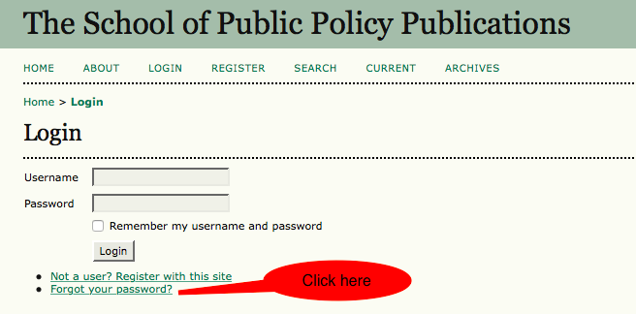

- Then enter your academic/university email address in the box; you will receive an email prompting you to reset your password.

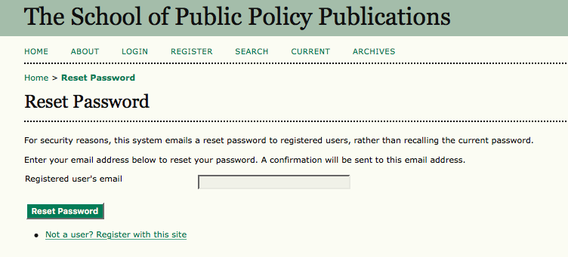

- Once logged in to your profile, click on ‘Reviewer’ (required if you have more than one role, i.e.: section editor, reviewer, author) to be taken to the review dashboard.

- In your review dashboard you can see any active submissions. Click on the title of paper (see below).

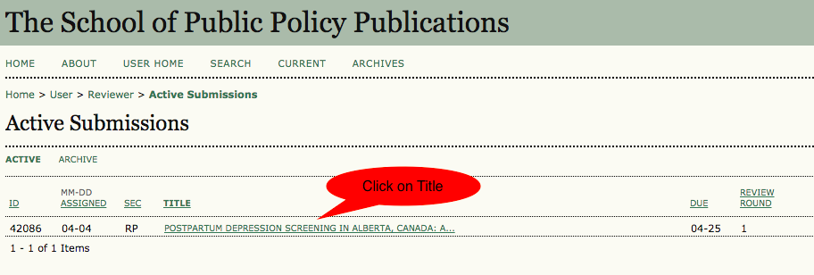

- Notify the relevant editor as to whether you will undertake the review or not by clicking on one of the two links as shown in the screen shot below:

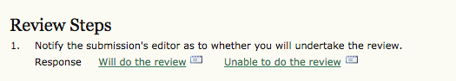

Important Note: If you are willing to review the paper, you need to click on the ‘Will do the review’ link.

- Complete the five review steps described in the portal as shown below:
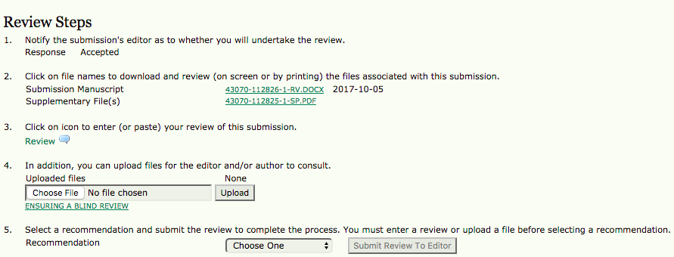

Note:
Step 3 is optional; you can skip it if you want. But, please make sure to complete either step 3 or step 4 to be able to submit your review to editor.

- In the final step, the system prompts you to send an email to the section editor to inform him/her of your review completion.

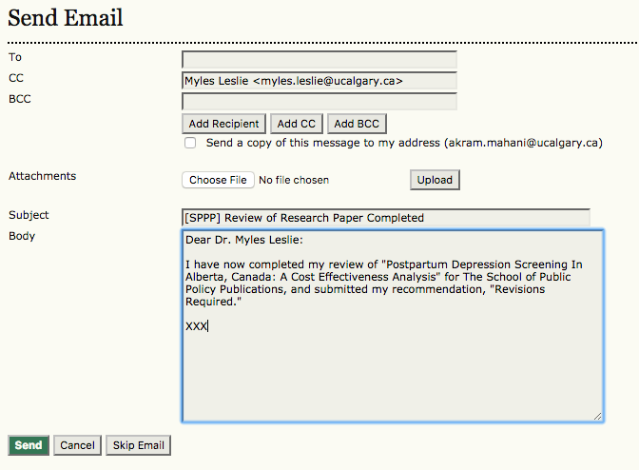

Note: If you have any questions about the online publication platform or SPPP processes, please contact spppublications@ucalgary.ca.
Appendix

How to Make Review Report/s Anonymous in Word Document
In Windows:
1. Go to “File”
2. Select “Info”
3. Click on “Check for Issues”
4. Click on “Inspect Document”
5. In the “Document Inspector” dialog box, only select/tick the check box “Document Properties and Personal Information”. Make sure other boxed are un-ticked.
6. Click “Remove All”
7. Click “Close”
8. Save the document
In Mac:
1. Go to “Word”
2. Select “Preferences”
3. From “Personal Settings” at the bottom click on “Security”
4. In “Privacy options” make sure to tick “Remove personal information from this file on save”
5. Click “OK”
6. Save the document

