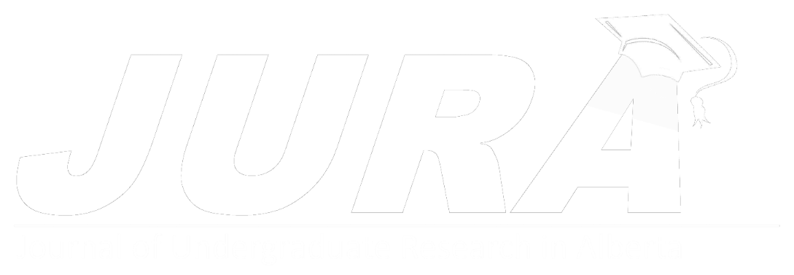

e: [jura@ucalgary.ca](mailto:jura@ucalgary.ca)

w: [ucalgary.ca/jura](http://ucalgary.ca/jura)

**Permission to Publish Form**

1. The Journal of Undergraduate Research in Alberta (JURA) does not claim ownership of copyright or literary property of publication. The publishing party assumes all responsibility for securing permission to publish from their supervisor.
2. Subsequent to being published in JURA, articles may be submitted to other journals, excluding other undergraduate journals. Authors must be aware, however, that journals may refuse articles submitted or accepted elsewhere (including to JURA).
3. Copies of publications will be made available on the website ([ucalgary.ca/jura](http://ucalgary.ca/jura)), indexed on Google Scholar, and as part of the National Libraries of Canada.

**In signing this form, both author and supervisor(s) agree to the conditions stated above.**

Author: Click or tap here to enter text. Signature: ______________ Date:Click or tap to enter a date.

Supervisor: Click or tap here to enter text. Signature: ______________ Date:Click or tap to enter a date.

We request that you supply up to 4 **recommended reviewers** for your publication. This is not required but will help facilitate the review process.

Please consult the website for more information about recommending reviewers and our Conflict of Interest policy (last updated August 2020).

|  |  |
| --- | --- |
| Reviewer Name | Contact E-mail |
| Click or tap here to enter text. | Click or tap here to enter text. |
| Click or tap here to enter text. | Click or tap here to enter text. |
| Click or tap here to enter text. | Click or tap here to enter text. |
| Click or tap here to enter text. | Click or tap here to enter text. |