SKIN DERIVED SCHWANN CELL TRANSPLANT AND IL6 NEUTRALIZATION
FOLLOWING NERVE INJURY
Prajay Shah¹, Jo Anne Stratton^{1,2}, Ranjan Kumar^{1,2}, Joey Grochmal^{1,2}, Yuval Shapira², Gui Fang Guo^{1,2} & Rajiv Midha^{1,2}
¹Hotchkiss Brain Institute, ²Department of Clinical Neuroscience, University of Calgary
rajmidha@ucalgary.ca

INTRODUCTION
Schwann cells (SCs), the glial cells of the peripheral nervous system, are highly plastic and are thought to be the key players in successful regeneration following nerve injury. Recently, the use of Schwann cell therapy, including therapies using SCs derived from skin (SKPSCs), has shown much potential for improving clinical outcomes after nerve injury. One of the primary mechanisms by which SKPSCs appear to enhance recovery is via the regulation of cellular responses responsible for the clearance of debris [1]. Indeed, strong evidence shows factors (ie. cytokines) released by SCs post-injury play vital roles in recruiting and regulating macrophages, the chief phagocytic cells responsible for clearing debris. In particular, interkeukin-6 (IL6), a pleiotropic cytokine upregulated after nerve injury, is thought to play an important role in macrophage recruitment and phenotype regulation, important for successful regeneration [2,3]. Even with this thought-to-be beneficial role that IL6 appears to play, others have demonstrated that IL6 can play deleterious roles in the nerve as well, for example causing extensive demyelination following its administration in uninjured nerves [4]. The dichotomous nature of IL6 in the nerve is context specific, highly complex and yet to be fully understood. Because we have recently identified IL6 as being expressed by SKPSCs at levels 20x higher than most other cytokines, and this cytokine is notorious for being a potent regulator of the immune system, we set out to determine the complex role of IL6 following SKPSC transplant in the injured nerve.
METHODS
We used an antibody against IL6, either in the presence or absence of SKPSC transplants to assess whether IL6 neutralization resulted in altered functional and histological outcomes. We performed crush injury in the sciatic nerves of adult Lewis rats and immediately treated each nerve with either: media+IgG, media+α-IL6, SKPSCs+IgG or SKPSCs+α-IL6, followed by IgG or α-IL6 injections at day 1, 3 & 6 post-injury (n=6-8 per group). SKPSCs, previously derived and characterized from adult Lewis rats, were administered at 500,000 per nerve with both antibodies administered at 0.08μg/nerve (sourced from R&D). We used compound muscle action potential (CMAP) analysis and muscle weight assessments to determine gastrocnemius muscle reinnervation and immunohistochemistry to assess cellular responses within treated injured sciatic nerves.
RESULTS
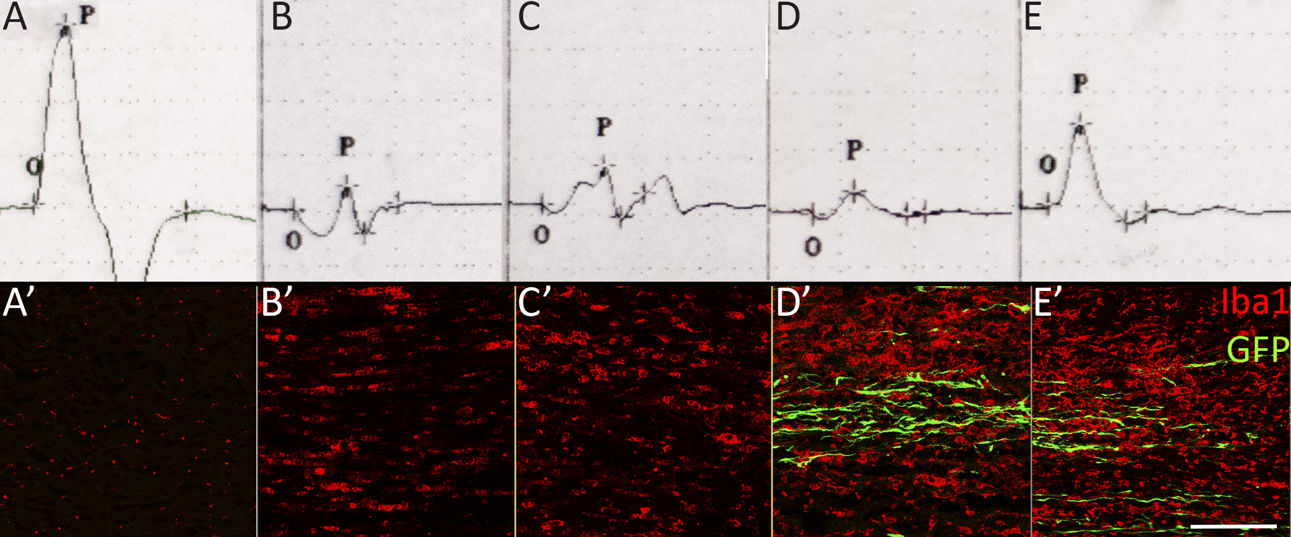
Peak CMAP amplitudes were highest with SKPSC+α-IL6 treatment (9.01mV max), compared to SKPSCs+IgG (2.93mV max), media+α-IL6 (6.28mV max) and media+IgG (4.46mV max) treatment controls at 4 weeks post injury (Fig 1A-D). Muscle weights were 10-20% higher in the SKPSCs+α-IL6 treated group compared to controls. We demonstrated that SKPSC transplant enhanced macrophage densities compared to media controls at 1 week post-injury, although there was no observable difference between SKPSCs+α-IL6 & SKPSCs+IgG treated groups (Fig1 A’-D’).

Figure 1. A-E) CMAP readings of the gastrocnemius muscle at 4 weeks post nerve injury. Representative CMAP traces from an uninjured nerve (A) or injured nerves treated with either media+IgG (B), media+α-IL6 (C), SKPSCs+IgG (D) or SKPSCs+α-IL6 (E) demonstrating an observable increase in peak CMAP amplitudes (P) following SKPSCs+α-IL6 treatment compared to injured controls. A’-E’) Representative immunohistochemical images demonstrating the presence of Iba1+ macrophages (red) in the proximal stump of an injured nerve (A’) or the distal stump of injured nerves at 1 week post-crush injury, treated with or without GFP+ SKPSCs (green) and antibody. Note the increase in the density of Iba1+ cells in SKPSCs+IgG (D’) and SKPSCs+α-IL6 (E’) treated groups compared to media+IgG (B’) and media+α-IL6 (C’) groups assessed at 3mm distal to the crush site. Scale bar = 250 µm.
DISCUSSION AND CONCLUSIONS
Interestingly, IL6 neutralization+SKPSCs had no effect on macrophage densities compared to controls suggesting that the observed functional benefits of SKPSCs+α-IL6 treatment is not due to early effects on macrophages densities post-injury. Future experiments will interrogate the long-term and complex role of IL6 and SKPSCs on the injured nerve.
REFERENCES
1.) Khoung H, et al. Exp Neuro. 254: 168-179, 2014; 2.)Tofaris GK, et al. J Neurosci. 22(15): 6696-6703, 2002; 3.) Zhong et al. J Neurosci. 19(11): 4305-4313, 1999; 4) Deretzi et al. Immunology 97(4): 582-587, 1999

