Aging is Associated with Reductions in Fascicle Length, Sarcomere Length and Serial Sarcomere Loss
ABSTRACT
Introduction: Aging is associated with decreased active force production leading to muscle weakness and subsequently decreased muscle performance. Aging also affects the muscle’s passive force properties; whereby in old age passive muscle force has been shown to be elevated above that of young, which may be related to increased muscle stiffness with age. The purpose of this study was to investigate potential structural property changes that occur in aged muscle that may contribute to increased passive force.
Methods: The muscle length where peak force occurred (i.e. plateau of the force-length relationship (FL); L₀) was determined for the medial gastrocnemius muscle (MG) of young (n = 9) and old rats (n = 8) rats. Muscles were fixed at L₀ in 10% formalin, fascicle length, sarcomere number and the sarcomere length were compared at L_{0.}
Results: Muscle from old rats showed a reduction of ~14% in fascicle length, ~4% in sarcomere
length and ~10% in sarcomere number, (P < 0.001).
Discussion: Shorter fascicle lengths and reduced sarcomeres in series in muscle from old rats may explain increased passive forces in older individuals. Reduced sarcomere number in series would lead to overstretched sarcomeres, leading to increased tension on sarcomere passive force structures and sarcomeres operating on the descending limb of FL relationship.
KEY WORDS: Aging, fascicle, sarcomere, passive force, skeletal muscle
INTRODUCTION
With natural human aging, there is a loss of muscle mass and alterations to the structural components of the human muscular system that results in impaired contractile function and performance [1, 2]. Muscle weakness associated with old age contributes to declines in muscular function and is associated with impairments in activities of daily living [3]. On the other hand, older adults maintain force production during lenthening contractions better (i.e. eccentric contraction) relative to other contraction modes and compared with young [1]. The age-related maintenance of eccentric strength is evident in humans as well as in reduced muscle preparations [1]. In addidion to many of the mechanisms proposed for the preservation of eccentric strength, alterations to the structural properties of the muscle fascicle leading to elevated passive force have not been investigated [4, 5]. A potential unexplored mechanism for increased passive force in old age could be decreased muscle fascicle lengths owing to either a decrease in the number of sarcomeres in series and differences in sarcomere length [6]. Thus for a given amount of stretch, the fascicles and sarcomeres of muscles from old and young may experience divergent length changes for a given displacement or joint angular rotation.
The purpose of this study was to compare skeletal muscles of young and old rats to determine fascicle length, sarcomere numbers and the sarcomere length at which peak force is obtained (i.e. plateau of the force-length relationship; L₀) of the medial gastrocnemius muscle (MG). It was hypothesized that fascicle length in old would be shorter compared with young owing to lesser sarcomeres in series, however, the sarcomere length at L₀ in old will remain unaltered as compared with young.

METHODS
Two groups of Fisher344x Brown Norway hybrid rats (n = 17) were used in this experiment, a young cohort (7-8 months ≈ 20 human years) (n = 9) and very old cohort (30-35 months; ≈75-80 human years) (n = 8). The MG from the right leg was surgically isolated, attached to a muscle puller and force transducer. For whole muscle activation, the tibial nerve was isolated and electrically stimulated via a nerve cuff. The L₀ was determined by performing a standard force-length relationship. Contractions were evoked at 200 Hz of 250 ms duration separated by 2 min rest across 1 mm increments in muscle length from -4 mm to +4 mm.
The animals were then sacrificed and the hind limb was immediately placed in a 10% Formalin (fixative) solution at the muscle length corresponding to L₀. After a 1 h period of fixation, the MG muscle was firmly secured to a wooden applicator stick at L₀ and allowed to fix for a 2 week period in a 10% Formalin solution. The muscles were then dissected into 4 lengthwise sections medial and lateral of the center of each MG muscle belly. After a 30% nitric acid digestion process, 5 individual fascicles from each muscle section were isolated and placed on slides for sarcomere length measurement at 5 locations along the fascicle by laser diffraction. In this method, the laser beam (1mm wide, λ=630 nm) penetrated through the thin actin filaments, but not the thick myosin filaments, creating a superposition of gratings of aligned myofibrils [7]. The first order diffraction distance was used to mathematically determine the average sarcomere length in the measured area (Fig. 1).
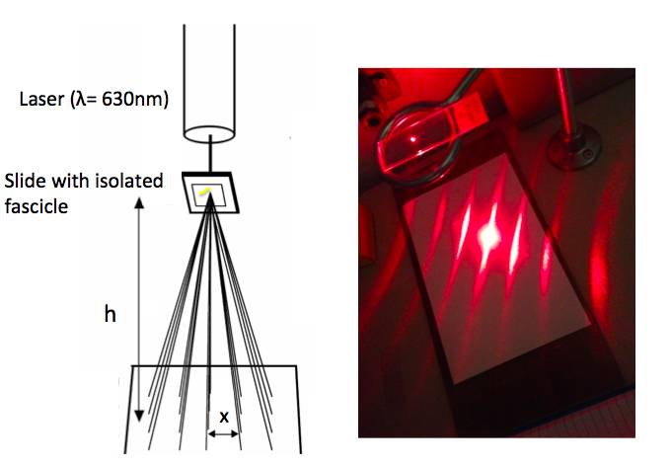

Figure 1. Laser diffraction experimental setup for sarcomere length measurements. First order diffraction distance indicated by ‘x’.

Fascicle length measurements were taken using a Matrox Inspector camera and software. Serial sarcomere number was calculated by dividing the fascicle length by the average sarcomere length. In total 20 fascicle length and 100 sarcomere length measurements were obtained from each muscle, which resulted in a total of 340 fascicle length and 1700 sarcomere length measurements. Comparisons between age groups were performed using unpaired bilateral Student’s t tests. The level of significance was set at P<0.05.
RESULTS
A reduction in muscle fascicle length of ~14% was observed in the old rats (average = 11.3 ± 2.0 mm) when compared to young rats (average = 13.1 ± 2.0 mm), P< 0.001. There was a reduction in average sarcomere length of ~4 % observed in the old rats (average = 2.22 ± 0.12 μm) versus the young rats (average = 2.31 ± 0.08 μm), P< 0.001. The MG of old rats showed ~10% fewer sarcomeres in series (average = 5092 ± 902 sarcomeres) when compared to young rats (average = 5683 ± 846 sarcomeres), P< 0.001 (Fig. 2).
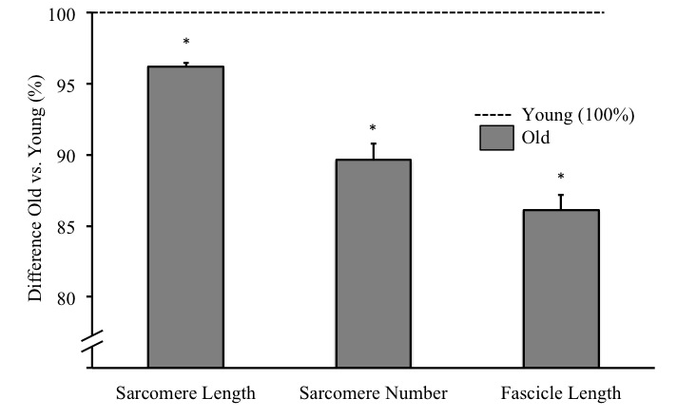

Figure 2. Percent difference in sarcomere length, sarcomere number and fascicle length from the MG of young rats (100%) vs. old rats measured at L₀. Bars indicate standard error. Significance indicated by * (P<0.05).
DISCUSSION
The goal of this study was to determine whether there were differences in fascicle length, sarcomere length and sarcomere numbers at L₀ in the MG muscle of young and old rats. The muscles from old rats had shorter fascicle lengths owing to less sarcomeres in series, as well as shorter average sarcomere lengths. The shorter average sarcomere lengths found in the old rat MG muscle compared with young were unexpected as the muscle length of each animal was fixed at the unique L₀ (Fig. 2). Since sarcomeres have an optimal length for force production based on the overlap of thick (myosin) and thin filaments (actin) and vertebrates exhibit very little range for this optimal sarcomere length, no change was expected in sarcomere length [5].
One possible explanation for the shorter sarcomeres at L₀ could be related to a reduced myosin concentration, which has been reported previously for the soleus muscle of aged rats [8]. Although speculative, the lesser myosin content could shift the sarcomere force length (FL) relationship to shorter lengths to possible increase the availability of cross-bridges and thus maintain for optimal overlap [9]. A second, and perhaps more plausible explanation for the shorter average sarcomere length in old compared with young could be owing to an age-associated shortened actin filament length. Since the thick myosin filament is regulated more stringently and is highly uniform in skeletal muscle compared to the thin actin filament, actin filament lengths could also be altered in old age, leading to shorter sarcomeres [10]. A proposed mechanism of actin length regulation is based on capping proteins, which determines thin filament binding properties and sarcomere length. These capping properties are down regulated with age leading to shortening of the thin filament and ultimately reduced sarcomere length [10,11]. Since peak muscle force is dependent on an optimal overlap of actin and myosin filaments to maximize cross bridge formation, shorter thin (actin) filaments, therefore shorter sarcomeres, would cause L₀ to occur at a reduced sarcomere length in old age.
Another possible explanation for the shorter sarcomere length in muscle from old rats may be related to a limitation of the study where the L₀ was measured at an optimal active contraction, but the muscles were fixed in a passive state. The shorter sarcomeres in old muscle could therefore be due to factors such as the series elastic property differences in young and old muscles, which play a role in passive length. Due to this limitation, it was unknown as to whether sarcomere length was altered as it entered the passive state or whether the difference was indeed due to an age related alteration to the sarcomere structure.
An important point must be made regarding the range of sarcomere lengths on the plateau of the FL relationship. For rat skeletal muscle, assuming an actin length of 1.13 μm and a myosin length of 1.53 μm, one would presume maximal force would be obtained at sarcomere lengths between 2.26 µm and 2.43 µm, which corresponds to the sarcomere length observed in the present study (Fig. 2) [12]. Since, there is not a single sarcomere length of maximal force production but a range of lengths covering approximately 7% of optimal SL, therefore the ~ 4% range in this experiment could be all on the plateau region of the sarcomere FL relationship [9].
In line with the hypothesis, the age related reduction in fascicle length of ~14% observed in this experiment (Fig. 2) was consistent with previously published findings of a 10-17% reduction in fascicle lengths in humans [2, 13] and rats [6]. The reduction in fascicle length was associated with a lower total sarcomere number in series for the old age cohort (Fig. 2). The lower sarcomere number in the old rats occurred despite shorter sarcomere lengths. Therefore the reduction in fascicle lengths at L₀ in the old rats was large enough to reduce serial sarcomere number.
Serial sarcomere number is important when considering the sarcomere FL relationship [9]. For example, if the limbs of young and old were at matched joint angles such as occurs in vivo, assuming a given joint angular displacement produces a similar sarcomere excursion across age, the shorter fascicles in the old rats would mean the sarcomeres would be stretched to longer lengths. Based on the sarcomere FL relationship, this would mean at the sarcomere level, older adults may be operating further on the descending limb of the FL relationship thus generating less active force but more passive force ultimately contributing to muscle weakness throughout a functional range of motion. Additionally, during stretch, where aged muscle sarcomeres are being pulled to relatively longer lengths, passive force producing elements such as the giant protein titin may play a larger role in contributing to increased passive tension and the age-related maintenance of eccentric strength in muscles from older adults [1]. Moreover, it has been proposed that increased tendon compliance with old age may have a compensatory effect, where the shorter fascicles and fewer sarcomeres of aged muscle are stretched less. The age-related increase in tendon compliance in older age would assist in maintaining the sarcomere filament overlap to be closer to the optimal force production length [14], this is an area of future investigation.
CONCLUSIONS
The results of this study were in accordance with the hypothesis that as individuals age, not only are sarcomeres lost in parallel but are also lost in series, resulting in shorter fascicles. But quite unexpectedly average sarcomere length was shorter at L₀ in the old compared with young muscle. These results may help to explain the increased passive force of muscles of older individuals.

REFERENCES
- Power, Dalton & Rice. J Sport Health Sci. 2:215-226, 2013.
- Narici, Maganaris, Reeves, & Capodaglio, J Appl Physiol. 95:2229-2234, 2003.
- Li et al. J Gerontol. 58:283-290, 2003.
- Roig, et al. (2010). Exp Gerontol. 4:400-409, 2010
- Burkholder & Lieber. J Exp Biol. 204:1529-1536, 2001.
- Hooper. J Gerontol. 27:121-126, 1981.
- Lieber et al. (1984). Biophys. J 45:1007-1016, 1984.
- D’Antona et al. J. Physiol. 552:499–511, 2003.
- Hill, Proc R Soc Lond B Biol Sci. 141:104-117, 1953.
- Piec et al. FASEB 19:1143-1145, 2005.
- Gokhin, et al. Am J Physiol, 302:C555-C565, 2012
- Ter Keurs, Luff, Luff. Adv in Exp Med and Bio. 37: 511-525, 1984.
- Power, G., et al. Physiological reports. 1:1-8, 2013
- Thom, et al. Eur J Appl Physiol. 100: 613-619, 2007

ACKNOWLEDGEMENTS

Funding for this summer project was provided through University of Calgary PURE Awards. Also, I am grateful to Rebecca Levicek for her assistance in this project. G.A. Power is supported by a Banting postdoctoral fellowship (Canadian Institutes for Health Research; CIHR) and Alberta Innovates Health Solutions (AIHS).

