Supplementary Material
Table. 1. Summary regarding properties of each partition. Values were obtained from the GARLI (Zwickl, 2006) console output. m = number of sequences, n = number of total sites.
Gene partition | m | N | constant characters | uninformative variable | parsimony informative
CO1 (1) | 74 | 538 | 297 | 53 | 188
CO1 (2) | 74 | 538 | 400 | 50 | 88
CO1 (3) | 74 | 538 | 77 | 59 | 402
28S | 69 | 1854 | 1577 | 107 | 170
16S | 57 | 434 | 226 | 47 | 161
12S | 49 | 149 | 78 | 24 | 47

1.1 Phylogenetic methodology
Gaps were constantly treated as missing data. Molecules were analyzed alone, in combination with morphology and behavior, or combined solely with morphology. Data were analyzed using parsimony (MP), maximum-likelihood (ML) and Bayesian methods due to the array of advantages and disadvantages of each method. Hence, a total of nine different phylogenetic constructions are presented.
Model testing for gene partitions was implemented in jModelTest 2 (Darriba et al., 2012) to determine the most appropriate model to employ for ML and Bayesian analysis. The results are summarized in Table 2. Alignment for CO1 data included a 75th taxon: Discoelius zonalis. D. zonalis was excluded from the primary phylogenetic analysis because only a portion of CO1 sequence was available. Akaike Information Criterion (AIC) scores were calculated to evaluate which partitioning scheme was best (Table 3). CO1 was partitioned based on codon positions, and the third nucleotide position was included in all analyses.
Table. 2. Summary of jModelTest 2 results for static alignments including Discoelius zonalis. Scores for Akaike Information Criterion (AIC) uncorrected and corrected (AICc) and Bayesian Information Criterion (BIC) are indicated along with the best model for each criterion.
Partition | AIC | AICc | BIC | AIC | AICc | BIC
28S, 69taxa/1858sites | 12437.86 | 12462.95 | 13244.84 | GTR+I+G | GTR+I+G | GTR+I+G
12S, 49taxa/149sites | 3034.20 | 3486.29 | 3345.29 | TVM+I+G | HKY+G | HKY+I+G
16S, 57taxa/434sites | 9489.01 | 9585.52 | 9985.43 | GTR+I+G | GTR+I+G | TVM+I+G
CO1, 1614 sites 75 taxa | 54397.47 | 54432.00 | 55248.54 | GTR+I+G | GTR+I+G | GTR+I+G
CO1, pos. 1 (1) | 14278.90 | 14411.47 | 14956.38 | GTR+I+G | GTR+I+G | GTR+I+G
CO1, pos. 2 (2) | 5677.62 | 5808.18 | 6350.82 | TVM+I+G | TVM+I+G | TVM+I+G
CO1, pos. 3 (3) | 31857.61 | 31982.22 | 32515.54 | TPM1uf+I+G | HKY+G | HKY+G
CO1, pos. 1+2 (12) | 20248.37 | 20303.16 | 21035.37 | GTR+I+G | GTR+I+G | GTR+I+G

Parsimony – In order to construct a topology based upon the optimality criterion of maximum parsimony, the program TNT was used (Goloboff et al., 2008). The best trees were obtained by implementing a search strategy of 1000 random additions, each with 40 rounds of parsimony ratchet, 20 rounds of tree drifting and 30 rounds of fusing. Scolia verticalis was set as the outgroup. Characters labeled additive by Pickett and Carpenter (2010) were treated as additive in the simultaneous analysis. When behavior was excluded, all data were treated as non-additive. Each bootstrap replicate consisted of 10 random additions, each with 40 rounds of parsimony ratchet, 20 rounds of tree drifting and 30 rounds of fusing. Limited bootstrap replicates were done because of time constraints.
Maximum Likelihood – ML analyses were performed in GARLI (Zwickl, 2006). All analyses had random starting trees. Termination conditions were enforced and the following settings used: genthreshfortopoterm = 20000, scorethreshforterm = 0.001. The models were set as unlinked and with subset specific rates. The models implemented were: GTR+I+G for the first codon of CO1, TVM+I+G for the second codon of CO1, TPM1uf+I+G for the third codon of CO1, GTR+I+G for 28S, GTR+I+G for 16S and HKY+I+G for 12S. When adding the morphological matrix, an Mkv (Lewis, 2001) unordered model was specified to it. The modweight entry was modified for each run according to the formula: 0.0005 x (# of subsets + 1). Outgroup taxa (Table 5) were forcefully constrained. The rest of the values were left as defaults according to the configuration file templates specific to large data sets provided with GARLI (Zwickl, 2006). Several replicates were done to ensure that the best possible topology was being recovered. Sometimes suboptimal trees are produced due to searches becoming trapped in local branch length optimizations (Zwickl, 2006). For our data this was not the case; the vast majority of replicates produced topological outputs that were identical.
Bayesian – Bayesian analyses were performed with MrBayes 3.2 (Huelsenbeck and Ronquist, 2001; Ronquist and Huelsenbeck, 2003; Ronquist et al., 2012). Priors were left flat and all other defaults were also unchanged unless noted. All models were unlinked using lset commands and allowed to evolve with independent rates of evolution using the command “prset ratepr=variable”, which is equivalent to the GARLI (Zwickl, 2006) “subsetspecificrates = 1” entry. All DNA partitions were assigned the GTR+I+G model, except 12S was assigned the simpler HKY+I+G model (see justification section). Morphological data was assigned an Mkv model (Lewis, 2001) with gamma rate heterogeneity. Again, outgroups were forcefully constrained. A relative burn-in of 25% was set and 2 runs with 4 chains each were performed. All analyses were allocated 3 million generations and all reached a standard deviation of split frequencies below 0.01.
The Alignments used are included as a second supplement. This file can be viewed using notepad or Mesquite; I recommend opening with Mesquite.

Table. 3. Akaike Information Criterion (AIC) scores for different partitioning schemes of CO1. LnL scores are derived from GARLI (Zwickl, 2006). The number of free parameters is represented by k. These values were obtained with inclusion of Discoelius zonalis. Brackets denote that an unlinked and separate model with subset specific rates was applied to that partition.
CO1 Partition Scheme | Garli LnL score | k |  | AIC
(1)(2)(3/HKY+G) | -25840.487 |  | 24 | 51728.974
(12)(3/HKY+G) | -25995.6977 |  | 15 | 52021.3954
(1,2,3)GTR+I+G | -27025.7652 |  | 10 | 54071.5304
(1)(2)(3/TPM1uf+I+G) | -25836.9048 |  | 26 | 51725.8096

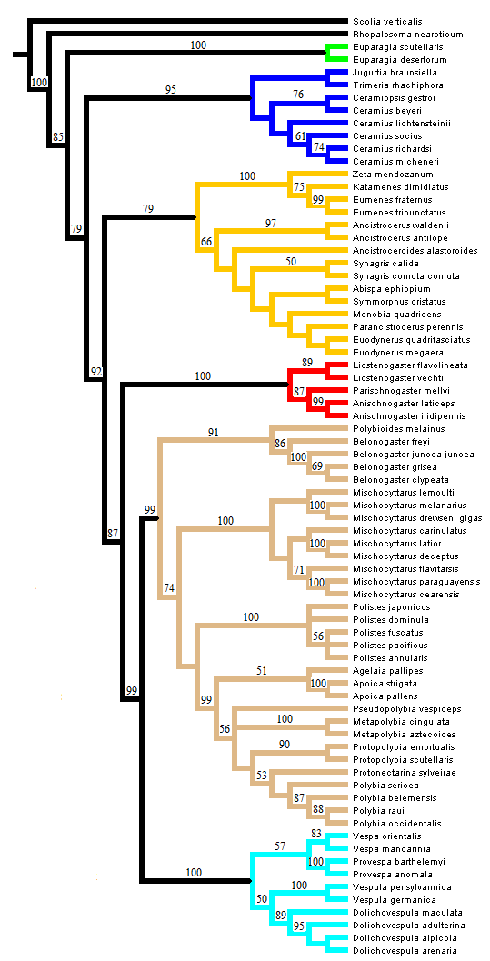
Fig. 1. Strict consensus of 6 equally parsimonious trees (L = 9415) obtained from simultaneous analysis of all molecular data, morphology and behavioral characters. Bootstrap values from 500 replicates indicated upon branches if ≥ 50. Subfamily taxa are represented by the following coloring scheme: Green = Euparagiinae; Blue = Masarinae; Red = Stenogastrinae; Orange = Eumeninae; Brown = Polistinae; Cyan = Vespinae.
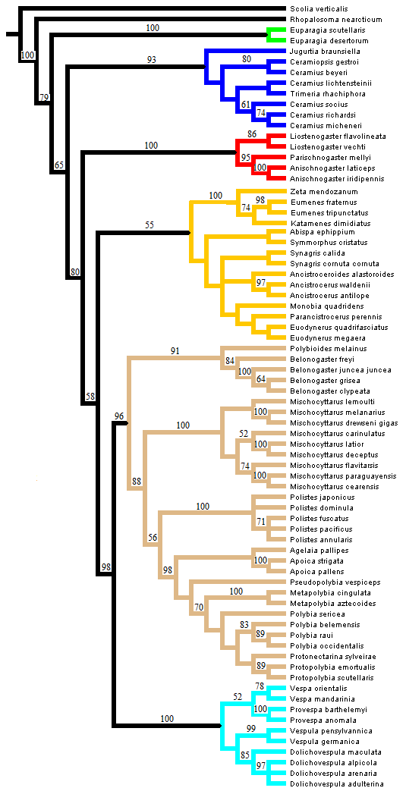
Fig. 2. Strict consensus of 6 equally parsimonious trees (L = 9271) obtained from simultaneous analysis of all molecular data, morphology but excluding behavioral characters. Bootstrap values from 100 replicates indicated upon branches if ≥ 50. Subfamily taxa are represented by the following coloring scheme: Green = Euparagiinae; Blue = Masarinae; Red = Stenogastrinae; Orange = Eumeninae; Brown = Polistinae; Cyan = Vespinae.
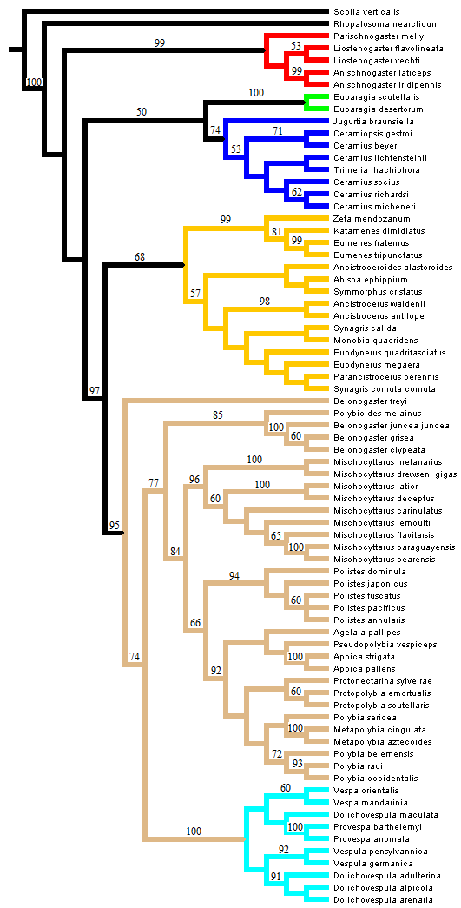
Fig. 3. Strict consensus of 2 equally parsimonious trees (L = 8610) obtained from analysis of molecular data only. Bootstrap values from 250 replicates indicated upon branches if ≥ 50. Subfamily taxa are represented by the following coloring scheme: Green = Euparagiinae; Blue = Masarinae; Red = Stenogastrinae; Orange = Eumeninae; Brown = Polistinae; Cyan = Vespinae.
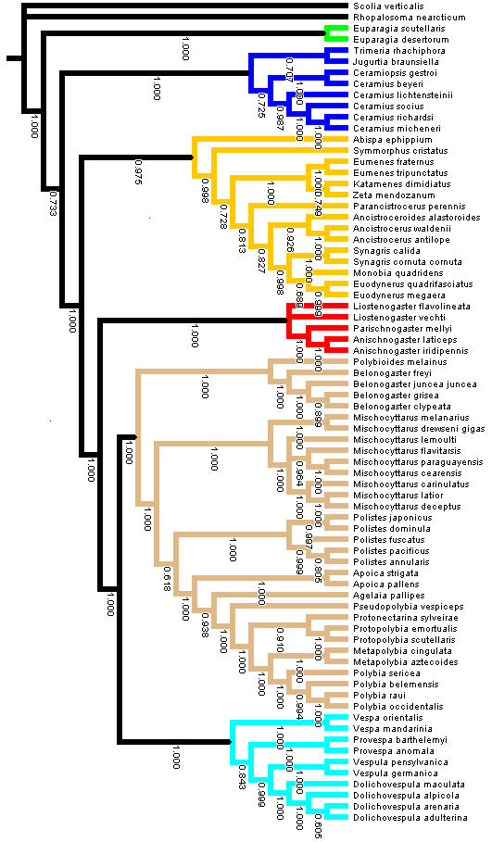
Fig. 4. Bayesian phylogeny derived from simultaneous analysis of molecules, morphology and behavior. Posterior probability (PP) indicated on branches; branches with PP below 0.5 collapsed. Subfamily taxa are represented by the following coloring scheme: Green = Euparagiinae; Blue = Masarinae; Red = Stenogastrinae; Orange = Eumeninae; Brown = Polistinae; Cyan = Vespinae.
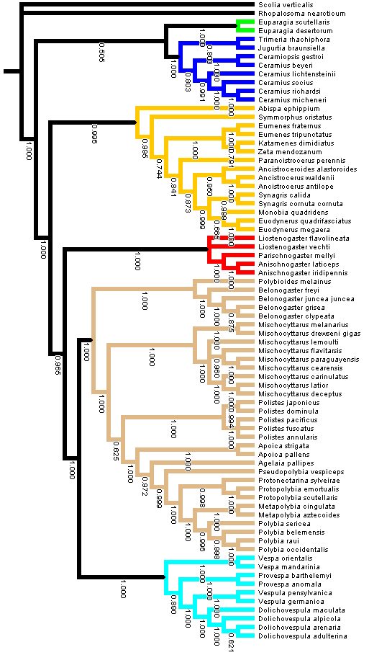
Fig. 5. Bayesian phylogeny derived from simultaneous analysis of molecules and morphology but excluding behavior. Posterior probability (PP) indicated on branches; branches with PP below 0.5 collapsed. Subfamily taxa are represented by the following coloring scheme: Green = Euparagiinae; Blue = Masarinae; Red = Stenogastrinae; Orange = Eumeninae; Brown = Polistinae; Cyan = Vespinae.
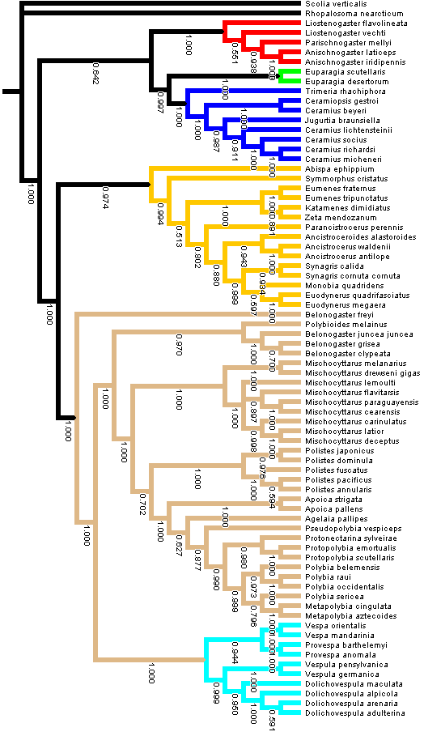
Fig. 6. Bayesian phylogeny derived from analysis of molecules alone. Posterior probability (PP) indicated on branches; branches with PP below 0.5 collapsed. Subfamily taxa are represented by the following coloring scheme: Green = Euparagiinae; Blue = Masarinae; Red = Stenogastrinae; Orange = Eumeninae; Brown = Polistinae; Cyan = Vespinae.
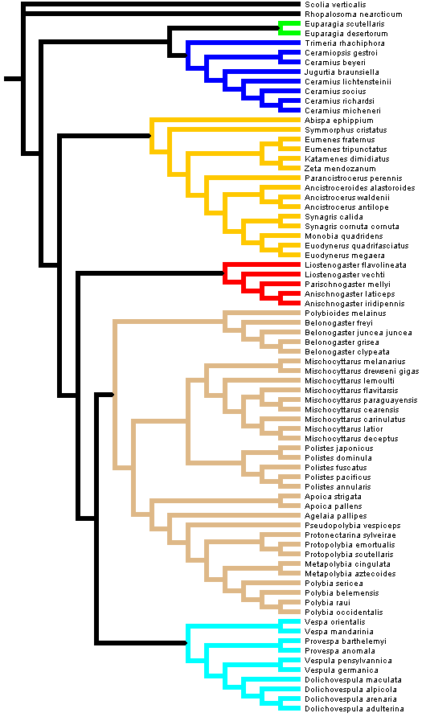
Fig. 7. Maximum likelihood tree (-ln = 42623.0886) derived from simultaneous analysis of molecules, morphology and behavior (unordered). Subfamily taxa are represented by the following coloring scheme: Green = Euparagiinae; Blue = Masarinae; Red = Stenogastrinae; Orange = Eumeninae; Brown = Polistinae; Cyan = Vespinae.
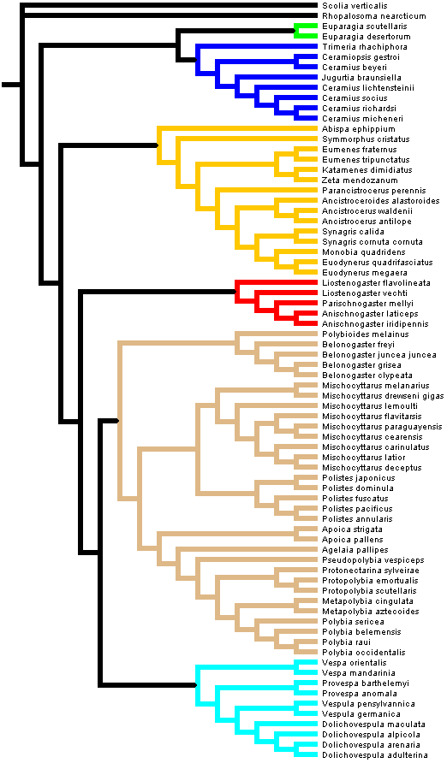
Fig. 8. Maximum likelihood tree (-ln = 41938.6760) derived from simultaneous analysis of molecules and morphology but excluding behavior (unordered). Subfamily taxa are represented by the following coloring scheme: Green = Euparagiinae; Blue = Masarinae; Red = Stenogastrinae; Orange = Eumeninae; Brown = Polistinae; Cyan = Vespinae.
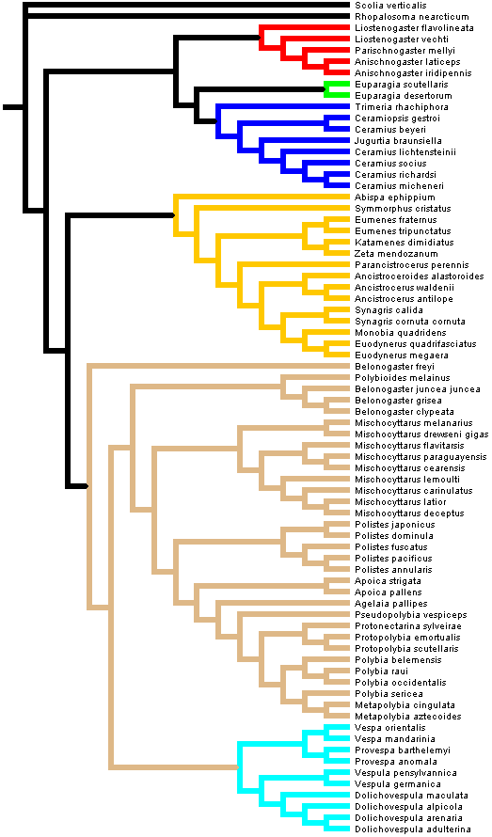
Fig. 9. Maximum likelihood tree (-ln = 38671.1889) derived from analysis of molecules only. Subfamily taxa are represented by the following coloring scheme: Green = Euparagiinae; Blue = Masarinae; Red = Stenogastrinae; Orange = Eumeninae; Brown = Polistinae; Cyan = Vespinae.

Table. 4. Summary of selected relationships. Y = yes, the relationship is supported; N = no, the relationship is not supported. P.C. 2010 represents results of Pickett and Carpenter (2010). ML = Maximum Likelihood; MP = Maximum Parsimony. Bayesian posterior probabilities converted into percentages. Support values listed in the order of ML, Bayesian and MP.
Relationships | Molecules only (ML,Bayes,MP) | Simultaneous Analysis  (ML,Bayes,MP) | All – behavior (ML,Bayes,MP) | P.C. 2010
Monophyly of…
Euparagiinae | Y,Y,Y (-,100,100) | Y,Y,Y(-,100,100) | Y,Y,Y (-,100,100) | Y (100)
Masarinae | Y,Y,Y (-,100,74) | Y,Y,Y (-,100,95) | Y,Y,Y (-,100,93) | Y (100)
Eumeninae | Y,Y,Y (-,97.4,68) | Y,Y,Y (-,97.5,79) | Y,Y,Y (-,99.6,55) | Y (100)
Stenogastrinae | Y,Y,Y (-,100,99) | Y,Y,Y(-,100,100) | Y,Y,Y (-,100,100) | Y (100)
Polistinae | N,N,N | Y,Y,Y (-,100,99) | Y,Y,Y (-,100,96) | Y (100)
Vespinae | Y,Y,Y (-,100,100) | Y,Y,Y(-,100,100) | Y,Y,Y (-,100,100) | Y (100)
Ropalidiini | N,N,N | Y,Y,Y (-,100,91) | Y,Y,Y (-,100,91) | Y (100)
Mischocyttarini | Y,Y,Y (-,100,96) | Y,Y,Y(-,100,100) | Y,Y,Y (-,100,100) | Y (100)
Epiponini | Y,Y,Y (-,100,92) | Y,Y,Y (-,100,99) | Y,Y,Y (-,100,98) | Y (100)
Polistini | Y,Y,Y (-,100,94) | Y,Y,Y(-,100,100) | Y,Y,Y (-,100,100) | Y (100)
(Epiponini + Polistini) | Y,Y,Y (-,70.2,66) | N,Y,Y  (-,61.8, ≥50) | N,Y,Y (-,62.5,56) | Y (95)
(Euparagiinae + Masarinae) | Y,Y,Y (-,99.7,50) | Y,N,N (-,-,-) | Y,Y,N (-.50.5,-) | N
(Provespa + Vespa) | Y,Y,Y(-,94.4,≥50) | N,N,Y (-,-,59) | N,N,Y (-,-,52) | Y (98)
Ceramius | N,N,N | N,N,N | N,N,N | N
Liostenogaster | N,N,Y (-,-,53) | N,N,Y (-,-,89) | N,N,Y (-,-,86) | Y (99)
Polybia | N,N,N | Y,Y,Y(-,100,≥50) | Y,Y,N (-,99.6,-) | N
Eumenes s.l. | Y,Y,Y (-,100,99) | Y,Y,Y(-,100,100) | Y,Y,Y (-,100,100) | Y (100)
Social groups | N,N,N | Y,Y,Y (-,100,87) | Y,Y,N (-,96.6,-) | Y (100)

ML analysis on just mitochondrial DNA (mtDNA) data places B. freyi within the Eumeninae. Using only 28S data and performing an ML analysis: Belonogaster came out monophyletic; Polistinae and Vespinae were sisters. Upon BLAST searching the B. freyi 16S data I found that sequence similarity was highest with eumenine species. Also the CO1 sequence is drastically different from the other Belonogaster sequences. Thus, the odd placement of B. freyi is due to false sequence data. The result of Polistinae paraphyly should be ignored.

Taxa  Table. 5. List of taxa and loci sampled in this study. A * indicates samples which were collected personally. Unpbl.C indicates unpublished sequence data obtained from J.M. Carpenter. A ^ denotes material that is available but not used in this analysis due to failed incorporation into the alignment. | GenBank Accession Numbers  COI 28S 16S 12S
Outgroup
Rhopalosoma nearcticum | EU567206 | GQ374724 | N/A |  | N/A
Scolia verticalis | GU596820 | EF013060 | N/A^ |  | GU596556
Euparagiinae
Euparagia desertorum | GU596821 | GU596726 | GU596598 |  | GU596509
Euparagia scutellaris | GU596949 | GU596727 | GU596692 |  | GU596810
Masarinae
Ceramiopsis gestroi | GU596822 | GU596714 | GU596604 |  | GU596588
Ceramius beyeri | GU596825 | GU596715 | GU596603 |  | N/A
Ceramius lichtensteinii | GU596823 | GU596716 | N/A |  | N/A
Ceramius micheneri | GU596824 | GU596717 | GU596602 |  | GU596504
Ceramius richardsi | GU596826 | GU596718 | GU596601 |  | GU596505
Ceramius socius | GU596827 | GU596719 | N/A |  | GU596506
Jugurtia braunsiella | GU596828 | GU596728 | GU596600 |  | GU596511
Trimeria rhachiphora | GU596829 | GU596812 | GU596599 |  | GU596557
Eumeninae
Abispa ephippium | NC011520 | JF510017 | EU302588 |  | N/A^
Ancistroceroides alastoroides | GU596832 | GU596703 | GU596687 |  | N/A
Ancistrocerus antilope | JN934263 | EF190743 | N/A |  | N/A
Ancistrocerus waldenii | GU596831 | GU596703 | GU596606 |  | N/A
Discoelius zonalis | JN934345.1 | N/A | N/A |  | N/A
Eumenes fraternus | EU649440 | EF190749 | N/A |  | N/A
Eumenes tripunctatus | GU596834 | GU596725 | GU596607 |  | GU596567
Euodynerus megaera | EU649462 | EF190753 | N/A |  | N/A
Euodynerus quadrifasciatus | JN934337 | N/A | N/A |  | N/A
Katamenes dimidiatus | GU596835 | GU596729 | N/A |  | GU596512
Monobia quadridens | GU596833 | GU596750 | GU596696 |  | GU596621
Parancistrocerus perennis | GU596830 | GU596751 | GU596605 |  | GU596522
Symmorphus cristatus | EU649667 | EF190750 | N/A |  | N/A
Synagris calida | Unpbl.C + * | Unpbl.C | Unpbl.C |  | Unpbl.C
Synagris cornuta cornuta | Unpbl.C | Unpbl.C | Unpbl.C |  | Unpbl.C
Zeta mendozanum | GU596836 | GU596818 | GU596608 |  | GU596561
Stenogastrinae
Anischnogaster iridipennis | GU596837 | GU596705 | N/A |  | N/A
Anischnogaster laticeps | GU596838 | GU596706 | N/A |  | N/A
Liostenogaster flavolineata | GU596839 | GU596730 | N/A^ |  | GU596568
Liostenogaster vechti | GU596840 | GU596731 | N/A^ |  | N/A
Parischnogaster mellyi | GU596841 | GU596752 | GU596697 |  | GU596523
Taxa  Table 5 (continued) | GenBank Accession Numbers  COI 28S 16S 12S
Polistinae
Agelaia pallipes | GU596948 | GU596702 | GU596686 | GU596571
Apoica pallens | GU596895 | GU596707 | GU596614 | N/A
Apoica strigata | GU596897 | GU596709 | GU596616 | GU596572
Belonogaster clypeata clypeata | Unpbl.C | Unpbl.C | Unpbl.C | Unpbl.C
Belonogaster freyi | Unpbl.C | Unpbl.C | Unpbl.C | Unpbl.C
Belonogaster grisea | Unpbl.C | Unpbl.C | Unpbl.C | Unpbl.C
Belonogaster juncea juncea | Unpbl.C | Unpbl.C | Unpbl.C | Unpbl.C
Metapolybia aztecoides | GU596903 | GU596732 | GU596622 | GU596589
Metapolybia cingulata | GU596904 | GU596733 | GU596623 | GU596575
Mischocyttarus carinulatus | GU596852 | GU596735 | GU596626 | GU596514
Mischocyttarus cearensis | GU596853 | GU596736 | GU596627 | GU596515
Mischocyttarus deceptus | GU596851 | GU596737 | GU596624 | GU596513
Mischocyttarus drewseni gigas | GU596907 | GU596738 | GU596628 | GU596516
Mischocyttarus flavitarsis | GU596908 | GQ374721 | GU596629 | GU596563
Mischocyttarus latior | GU596909 | GU596740 | GU596630 | N/A^
Mischocyttarus lemoulti | GU596911 | GU596742 | GU596632 | GU596519
Mischocyttarus melanarius | GU596913 | GU596743 | GU596634 | GU596590
Mischocyttarus paraguayensis | GU596916 | GU596746 | GU596636 | N/A
Polistes annularis | GU596854 | GU596754 | GU596639 | GU596524
Polistes dominula | GU596870 | GU596769 | GU596651 | GU596549
Polistes fuscatus | GU596874* | GU596772 | GU596653 | GU596534
Polistes japonicus | GU596877 | GU596776 | GU596657 | GU596566
Polistes pacificus | GU596885 | GU596785 | GU596665 | GU596543
Polybia belemensis | GU596924 | GU596794 | GU596673 | N/A
Polybia occidentalis occidentalis | GU596931 | GU596799 | GU596678 | N/A
Polybia raui | GU596932 | GU596800 | GU596698 | N/A
Polybia sericea | GU596935 | GU596801 | GU596679 | N/A
Polybioides melainus | GU596937 | N/A | GU596681 | GU596583
Protonectarina sylveirae | GU596938 | GU596803 | GU596682 | GU596584
Protopolybia emortualis | GU596939 | GU596804 | GU596683 | N/A
Protopolybia scutellaris | GU596941 | GU596805 | GU596685 | GU596593
Pseudopolybia vespiceps | GU596944 | GU596809 | GU596699 | GU596554
Vespinae
Dolichovespula adulterina | Unpbl.* | N/A | N/A | N/A
Dolichovespula alpicola | Unpbl.* | N/A | N/A | N/A
Dolichovespula arenaria | GU596847* | GU596723 | GU596691 | GU596508
Dolichovespula maculata | GU596843 | GU596724 | GU596694 | N/A
Provespa anomola | GU596849 | GU596806 | GU596609 | GU596550
Provespa barthelemyi | GU596850 | GU596807 | GU596610 | GU596551
Vespa mandarinia | GU596946 | GU596813 | GU596700 | GU596570
Vespa orientalis | GU596844 | GU596814 | GU596611 | GU596558
Vespula germanica | GU596845 | GU596815 | GU596612 | GU596595
Vespula pensylvanica | Unpbl.* | N/A | FJ821513 | N/A
References

Darriba, D., Taboada, GL., Doallo, R. and Posada, D. 2012. jModelTest 2: more models, new
heuristics and parallel computing. Nat. Methods. 9: 772.

Goloboff, P.A., Farris, J.S. and Nixon, K.C. 2008. TNT, a free program for phylogenetic
analysis. Cladistics. 24: 774-786.

Huelsenbeck, J.P., Ronquist, F., 2001. MRBAYES: Bayesian inference of phylogenetic
trees. Bioinformatics. 17: 754-755.

Lewis, P.O. 2001. A likelihood approach to estimating phylogeny from discrete morphological
character data. Syst. Biol. 50: 913-925.

Pickett, K.M. and Carpenter, J.M. 2010. Simultaneous Analysis and the Origin of Eusociality in
the Vespidae (Insecta: Hymenoptera). Arthropod Syst. Phylogeny. 68: 3-33.

Ronquist, F., Huelsenbeck, J.P., 2003. MRBAYES 3: Bayesian phylogenetic inference
under mixed models. Bioinformatics. 19: 1572-1574.

Ronquist, F., Teslenko, M., van der Mark, P., Ayres, D.L., Darling, A., Hohna, S., Larget, B.,
Liu, L., Suchard, M.A. and Huelsenbeck, J.P. 2012. MrBayes 3.2: Efficient Bayesian phylogenetic inference and model choice across a large model space. Syst. Biol. 61:539-542.

Zwickl, D. J. 2006. Genetic algorithm approaches for the phylogenetic analysis of large biological sequence datasets under the maximum likelihood criterion. Ph.D. dissertation, The University of Texas at Austin.

