

October 17, 2012

Canadian Medical Education Journal

Room G16, Health Sciences Centre

University of Calgary

3330 Hospital Drive NW

Calgary AB T2N 4N1

Canada

**Attention: Tina Vonhof**

Dear Ms. Vonhof:

We are pleased to submit our article entitled *FAMILY MEDICINE RESIDENTS – RISK OF ADVERSE MOTOR VEHICLE EVENTS – COMPARISON BETWEEN RURAL AND URBAN PLACEMENTS* for consideration for publication in the Canadian Medical Education Journal. The manuscript is, we believe, highly relevant to your readership. Motor vehicle crashes area a leading cause of injury related deaths in Canada. There also is awareness that medical residents may be susceptible to adverse motor vehicle events (crashes/close calls) due to sleep deprivation. However, there have been few empirical studies in this area. Our research was designed to address this limitation.

Results from our national survey of residents indicate that the risk of adverse motor vehicle events was high for both urban and rural residents, with rural residents having a higher percentage of crashes and urban residents reporting more close calls when adjusted for exposure. It also is notable that our survey of residency programs in Canada indicate that few medical residency programs have travel policies in place. The research results have the potential to inform on policies related to safety issues for Family Medicine residency programs in both rural and urban locations across Canada. The results also may help to increase awareness of factors (e.g., fatigue, distraction, etc.) leading to adverse motor vehicle events in this population, which in turn could lead to future enhancement of driving safety.

As requested, we attest that (a) the material has not been published in whole or in part elsewhere; (b) the paper is not currently being considered for publication elsewhere; (c) all authors have been personally and actively involved in substantive work leading to the report and will hold themselves jointly and individually responsible for its content; and (d) all relevant ethical safeguards have been met in relation to patient or subject protection.

In closing, thank you in advance for your consideration and we look forward to hearing from you.

Kindest regards,

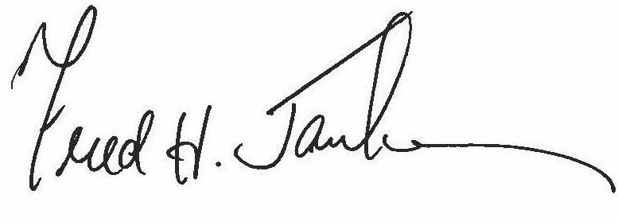

Dr. Fred Janke

205 College Plaza, University of Alberta, Edmonton, Alberta T6G 2C8

[fred.janke@ualberta.ca](mailto:fred.janke@ualberta.ca)