

Department of Civil Engineering, Ryerson University, Toronto, Ontario M5B 2K3
Tel: 416-979-5000 ex 7868
Fax: 416-979-5122

October 13, 2008

Re: New Paper Submission

Dear Professor Spedding,

Enclosed please find a new manuscript entitled, "Technology-Independent Algorithm for Collision Warning System at Semi-Controlled Intersections,” by Essam Dabbour and Said Easa that is submitted for possible publication in the Canadian Journal of Transportation

Thank you for your kind consideration.

Sincerely,

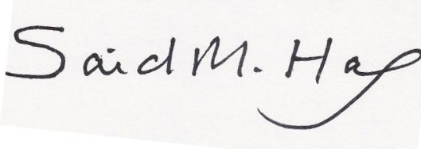
Said Easa, Ph.D.
Professor, Department of Civil Engineering
Email: seasa@ryerson.ca

