Canadian Journal for New Scholars in Education
Attn: Brenna Quigley, Editor
University of Ottawa
Emailbquig021@uottawa.ca

June 5, 2012

Brenna Quigley:

I am writing to submit the following manuscript, Informing Education Research and the Praxis of Leadership through the use of Autoethnography and Phenomenology, for publication in the Canadian Journal for New Scholars in Education.

As requested, I wish to acknowledge the following:

- I am available and willing to work closely with both a Review Editor and Copy Editor to bring the manuscript to completion under specified deadlines;
- I do not intend to translate the manuscript
- I verify the originality and unpublished nature of the manuscript
- I grant CJNSE/RCJCÉ first publication rights;
- I agree not to publish the same manuscript elsewhere, in whole or part, for one year after publication;
Thank you for your consideration. I look forward to your reply.

Sincerely,

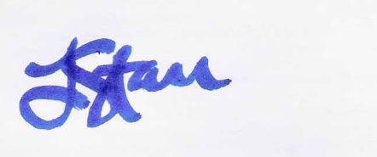
Lisa Starr

