Correspondence Analysis, “A Brief Conversion”: outliers, final cloud, scenes.
Figure 1: Results of the first Correspondence Analysis: two outliers.
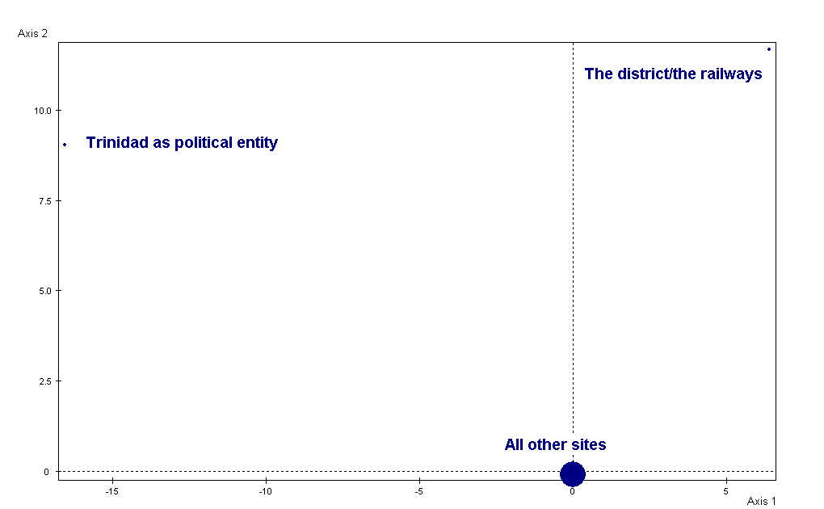

Figure 2: Results of the second Correspondence Analysis: a set of outliers belonging to one scene.
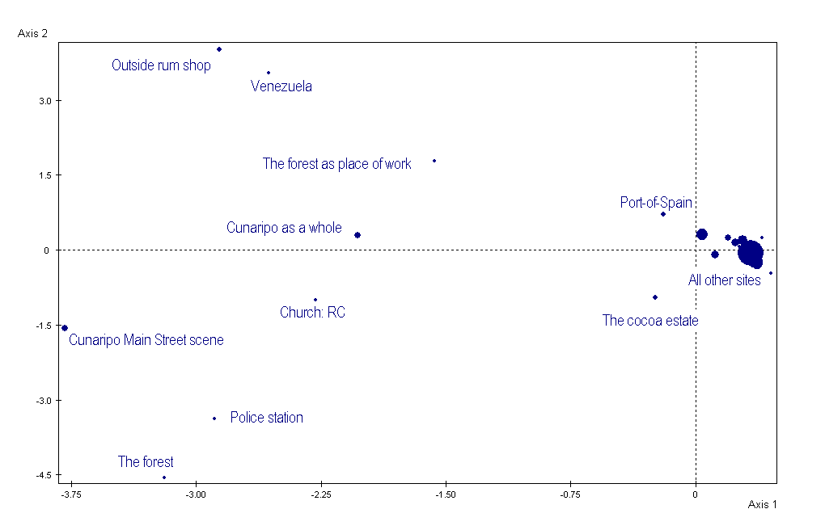
Figure 3: Results of the third Correspondence Analysis: one outlier.
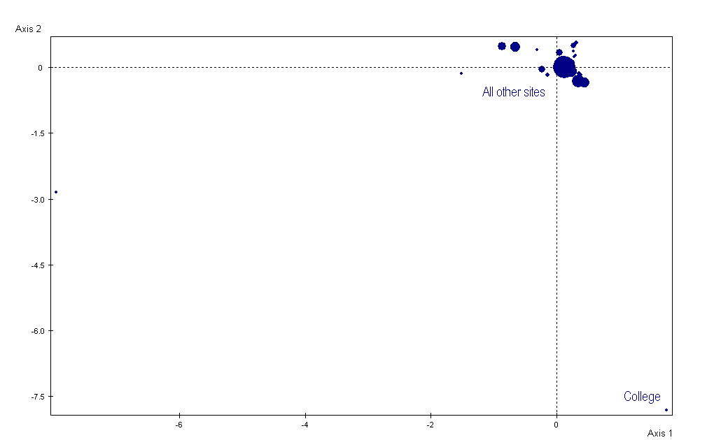
Figure 4: the results of the fourth correspondence analysis: the final clouds of properties and individuals.
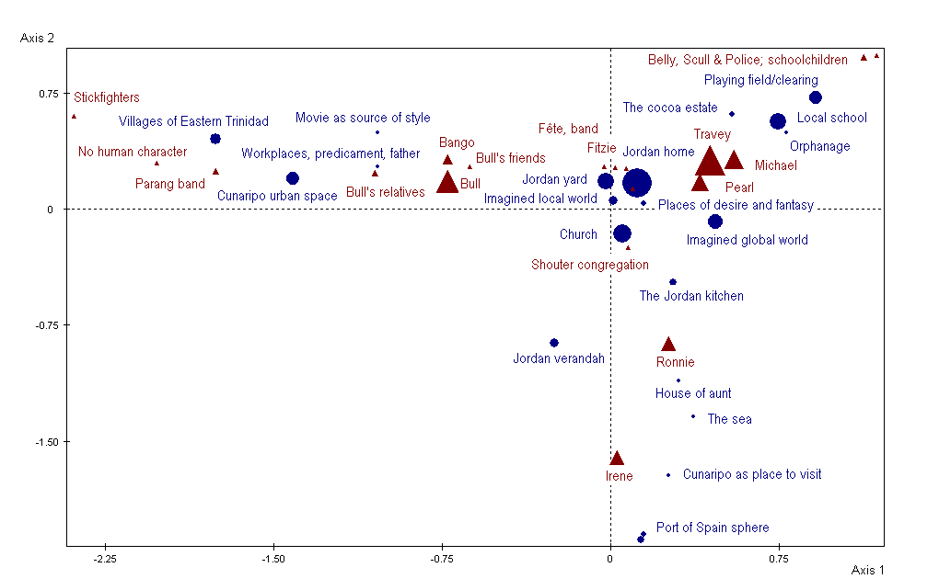

Figure 5. Supplementary variables: projecting the scenes into the plane of axes 1 and 2.
