Tim Heath, PhD 8 November 2015
Associate Dean, School of Arts and Sciences
Red Deer College
100 College Boulevard, Box 5005
Red Deer, AB
T4N 5H5
tim.heath@rdc.ab.ca

Denae Dyck
PhD student, department of English
University of Victoria
PO Box 1700 STN CSC
Victoria BC
V8W 2Y2
denaed@uvic.ca

Editor
ARIEL: A Review of International English Literature
Department of English
University of Calgary
Calgary, AB
T2N 1N4

To Whom it May Concern:

Please consider our article “many cross-currents of opposing thought”: Narrative Pluralism in
Bessie Head’s A Question of Power for publication in ARIEL. We have prepared the manuscript according to ARIEL guidelines, including an abstract which outlines the article’s argument and a list of keywords.

Our institutional affiliations are captioned in address lines above. Please note that Denae is under obligation by SSHRC to disclose that she is receiving funding for her PhD studies and thus must credit SSHRC in any publications.

Thank you for your consideration.

Sincerely,

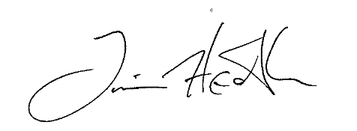

Tim Heath Denae Dyck

