Perspectives on Palestine: Architecture and Narrative in Joe Sacco’s Footnotes in Gaza

In their introduction to Comics and the City: Urban Space in Print, Picture, and Sequence (2010), Arno Meteling and Jörn Ahrens argue that the development of comics during the twentieth century was closely linked to the growth of modern cities and that comics became an effective form through which writers and artists could represent cityscapes and explore distinctly urban forms of cultural memory. As the comic book evolved from newspaper comic strips, it remained closely linked with ideas of the city: “The city functioned as an important plot element, even an atmospheric and symbolic protagonist, and suddenly became the focus of attention in many genres” (5). And, interestingly, as comics sought to represent and explore urban experience, cityscapes also began to resemble comics: “The competence of comics in capturing urban space and city life can be found within the cityscape itself, for example, as combinations of words and images in the form of signage and graffiti, which are deeply influenced by the aesthetics of comics (6). It is telling, therefore, that many of the words we use to describe comics (for example: panes, frames, and gutters) are architectural in origin.
This essay explores how Joe Sacco’s work of graphic non-fiction Footnotes in Gaza (2009) calls attention to the complex relationship between built spaces, urban landscapes, and visual/verbal narrative form. By drawing on recent criticism that has explored how visual and spatial modalities relate to knowledge and power in Palestine, I will discuss how Sacco’s work provokes a particular way of reading that is attune to the way that stories respond to, and are affected by, differing spatial and structural organizations. In literary theory, one finds relevant theoretical explorations of spatiality and narrative, perhaps the most well known of which is in the work by Mikhail Bakhtin, whose notion of the ‘chronotope’ is defined as a fusion of time and space and a sense in which narrative elements can be implied through spatial and non-chronological features. For example, in Bakhtin’s discussion static ideas such as ‘the road’ or ‘the threshold’ can convey a strong sense of historical change or political process. Yet few critics have recognized the potential ways that comics art can similarly raise questions about the various ways that inanimate structures such as walls, borders, maps, and towers are able contain, provoke, or inhibit the processes of memory and storytelling.
Past critical discussions of Sacco’s work have focused mostly on how his graphic narratives re-mediate journalistic discourse and reframe contemporary events. One of the first scholars to comment on Sacco’s critical journalism was Edward Said who in his Preface to Sacco’s Palestine (2001) describes comics as an appropriate means by which to render the Palestinian conflict in an age of mass media. “With the exception of one or two novelists and poets,” Said writes, “no one has ever rendered this terrible state of affairs better than Joe Sacco. Certainly his images are more graphic than anything you can either read or see on television” (iii). Other discussions have similarly commented on Sacco’s challenges to mainstream journalism and have described the ways that his graphic narratives foreground the limitations of the reporter in the field. For example, Andrea A. Lunsford and Adam Rosenblatt have described Sacco’s work as offering a self-critique of journalistic objectivity, “highlighting the agency of his subjects, with all of their strengths and weaknesses” and ultimately “escaping from the dominant paradigm of war reporting, a paradigm in which people’s stories of suffering often become commodities, pre-packaged and even given new narrative trajectories by the journalists who collect them” (130). In another study, Terri Tomsky similarly addresses the issue of trauma in Sacco’s The Fixer (2003), drawing attention to how Sacco’s graphic narratives explore the ways that memories themselves are shaped by historical circumstances and circulate in a “commodity market of traumatic memories.” Sacco’s work, according to Tomsky, does not simply depict moral gray areas but ultimately reveals how the framework of representations itself is able to “mediate, authorize, commemorate and circulate trauma in different ways” (55).
Footnotes in Gaza can also be interpreted along these lines, particularly insofar as Sacco depicts himself as a character involved in the events and stories as they unfold. Unlike the so-called embedded journalist who reports from a privileged position on the inside, Sacco is shown to be embodied, independent, and vulnerable. He relies on his translators and guides; he complains, curses, and drinks with other journalists; he describes his fears, setbacks and annoyances as he conducts interviews and tries to go about his normal daily affairs. Yet unlike Sacco’s previous work, which has focused mostly on contemporary political events and circumstances, Footnotes in Gaza weaves together the past with the present and foregrounds problems of retrieving and narrating a more distant history.
The narrative focuses on the events of 1956 when Israeli forces are reported to have violently suppressed a Palestinian insurrection in the towns of Khan Younis and Rafah. In an interview, Sacco describes how he first became interested in the story while reporting in Gaza for Harper’s Magazine. After his initial excitement, he was told that the story lacked the urgency or drama necessary for a mainstream media publication (“Joe Sacco Wide Eyed”). What resulted is an alarming collection of impressions and reconstructed memories. In Footnotes in Gaza the reader confronts multiple narratives – sometimes overlapping and conflicting – told by older residents of Gaza who remember, or fail to remember, events that took place nearly fifty years ago. Readers are told about the Palestinian guerilla group the Fedayeen from the perspective of an old timer, a man “marinated in ruminations of political betrayals and stewed for decades in remembrances of military ineptitudes” (50). Throughout the book Sacco interviews several other eyewitnesses, and through these mediated accounts we gain a view of history that is fragmented, incomplete, and framed by social circumstances.
There are several examples that exemplify the way that the architectural realities of Palestine inform, structure, and disrupt the narrative. In one sequence Sacco depicts an elderly Palestinian woman struggling to recall details of the past. He writes, “Her tower of memory has collapsed. She gropes around to offer us a piece of her rubble” (200). This image of collapsing architecture speaks to a very real context of destruction and violence but it also reveals a larger concern about the vulnerable relationship between space and memory inside Gaza. In other cases, Sacco’s sensitivity to complex and contested architectural terrain results in a fragmented and multi-perspectival narrative vision. The panel below (fig 1) depicts an Israeli AFV (Armored Fighting Vehicle) racing across a stretch of uninhabited space on the border of Rafah and Egypt. In a region where tunneling has been prevalent, the AFV is involved in the destruction of Palestinian homes that have been identified as housing militants or as having some connection with tunneling operations. Footnotes in Gaza explores the issue of destroying houses in some depth, and the character Abed, who is Sacco’s guide and translator, owns a house that is eventually knocked down by an AFV. Here Sacco captures the emotional turmoil that results from the presence of the AFV: we see the young Palestinian onlookers running for cover, the AFV closing in, and a journalist trying to get a shot. The images, which resemble photographs, are scattered on the page, capturing the emotional intensity of the events. But in a way that a photograph cannot possibly depict, the page presents an exploding narrative of danger and includes overlapping images and textboxes; the text runs simultaneously in different directions down the page, provoking a non-linear reading and a flurry of ocular activity.

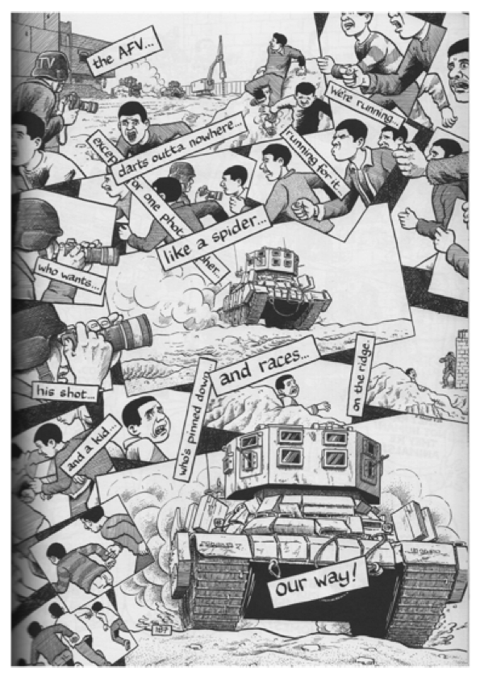
FIGURE 1 Joe Sacco, Footnotes in Gaza, p. 187

Further emphasizing the relationship between visual modalities and structures of power and control, Sacco places maps in opposition to narrative panes which themselves contain fragmented urban structures. The image below (fig. 2) depicts a map of the Gaza Strip with its complex political landscape. In this image, the Palestinian towns, refugee camps, Israeli settlement areas, and security zones are designated with different shades and shapes while on the right hand side the reader is invited to view the outcome of these abstractions with information about the social problems and strife that such geopolitical fragmentation and economic isolation have created. Viewed from a safe distance, the map is a precise mode of visual representation that contrasts with the depictions of social life within. As outside and inside perspectives of Gaza are juxtaposed, the reader is forced to consider not only the disastrous social effects of mapping practices, but also their constructed, situated, and perspectival nature.
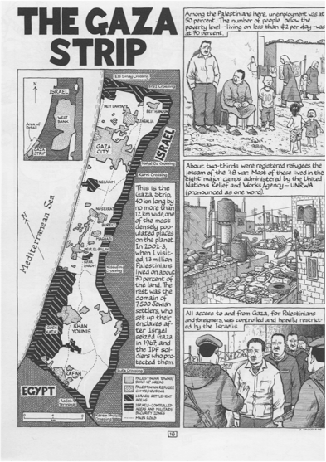
FIGURE 2 Joe Sacco, Footnotes in Gaza, p. 4
Yet as they inscribe lines of domination and control, maps also evolve and change, and within them one can find spaces for creativity and resistance. Architect and critic Eyal Weizman has written extensively on the extent to which urban spaces, structures, and infrastructure can be understood not only as forms that dictate physical divisions in Israel and Palestine, but also to serve as a “conceptual way of understanding political issues as constructed realities” (6). Weizman’s work focuses on separation walls, barriers, closures, road blocks, and special security zones, but rather than interpret such lines of demarcation and control in purely material terms, he contends that the borderlines that truly mark difference and differentiation are flexible and elastic. He writes that the various inhabitants frontier regions “do not operate within the fixed envelopes of space – space is not the background for their actions, an abstract grid on which events take place – but rather the medium that each of their actions seeks to challenge, transform or appropriate” (7).
From this point of view, architectural features have implications far beyond their practical and political significance. For example, Weizman describes how Israeli control is both facilitated and resisted through a three-dimensional “politics of verticality” (12). Hilltops and regions of higher elevation have strategic value and tactical priority, as does the control over airspace and sub-terrain (Palestinians do not have official access to aerial spaces or underground regions and resources). Within this context, Weizman describes the extent to which built structures and political contestations over space relate to ways of seeing and being seen (for example, he describes how settler homes are designed in such a way that allows the inhabitants to look out and over empty frontier regions). In a particularly telling study of the symbolic power of the gaze, he describes the use of one-way mirrors at the Allenby Bridge checkpoint, a feature that was designed during the Oslo I agreement and was intended to create the illusion that Palestinian officials were in control of the border procedures, when in fact an Israeli official was always behind the glass and at any given time and would have ultimate authority. He refers to this panoptical arrangement as symptomatic of a larger conceptual unwillingness of Israel to accept responsibility for the social fragmentation and economic stagnation within Palestinian society, a condition he defines as “prosthetic sovereignty” and which encapsulates the desire to view Palestine as a walled off, aerially policed, and infrastructurally dependent (120).
Weizman’s perspectives on the ideological and political aspects of space and architecture suggest ways of reading and interpreting Sacco’s work. As Footnotes in Gaza offers powerful renderings of the geographical complexity of the region, it invites readers to examine the urban contexts of division and obstruction and to consider how spatial organization relates to Weizman’s notion of a ‘politics of verticality’. Some of Sacco’s images are meticulous in detail and highly effective in terms of illustrating the extent to which space is controlled and managed from different points of view and sightlines. For example by rendering the panoptical Tal Zorob Tower that looms over Rafah, Sacco draws attention to the ubiquitous presence of surveillance and control, or in another image (fig. 3) he provides a full-page map of the highly sensitive region of Rafah, a contested area known for tunneling operations.
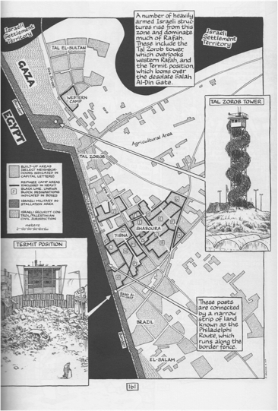
FIGURE 3 Joe Sacco, Footnotes in Gaza, p. 161
While Sacco’s depictions of these contested areas reveal the fragmented nature of the landscape, they also show how time itself can be carved up and divided. It is important to mention here that ideas of temporality and chronology in Sacco’s work have been explored extensively in recent critical discussions. For example, in her study of Footnotes in Gaza, Maureen Shay has discussed the sense in which temporality is disrupted in Sacco’s work, a stylistic technique that she refers to as “circular visuality” (207). Shay interprets Sacco’s narrative more as an example of critical ethnography than as a work of comics journalism, arguing that Sacco’s interest in integrating and juxtaposing the past with the present can be interpreted as a strategy that resists assumptions about passivity and temporal distance in ethnographic discourse. Another study by Rose Brister and Belinda Walzer has similarly explored issues of temporality in Footnotes in Gaza, suggesting that Sacco’s work exemplifies a sense of kairos, or a way of reading multiple temporalities and histories through layered spaces. In yet another study, Hillary Chute comments on the sense of narrative disruption in Sacco’s graphic narratives: “Sacco’s works push on the disjunctive back-and-forth between looking and reading: this rhythm— often awkward and time-consuming—is … especially valuable in treating a subject as politicized and ethically complicated as the Israel-Palestine conflict” (460). Chute’s attention to the reader’s experience is particularly significant here, since through the reader’s negotiation of the text Sacco’s work is able to communicate these themes of temporal disruption. However, just as we interpret Sacco’s work as challenging our sense of chronology and temporality in these various ways, it is also important to recognize the ways in which his graphic narrative is rooted within specific material and spatial realities. Weizman describes the relationship between time and space in terms of the highly regulated and vast network of checkpoints in Palestine (there are approximately 200 ‘territorial cells’ in the West Bank alone, all separated and controlled through a series of checkpoints) (146). Through the cluttering of words and images, and an engagement with themes of obstruction and deferral, Sacco’s work responds to and enacts this repressive fragmentation of time and space in Palestine. Indeed, throughout the graphic narrative, delay and confinement are overarching motifs. There are several characters who are unable to move: Khaled, a known insurgent, is in a continual state of hiding and unable to leave Gaza; Sacco himself is hampered in on many occasions, such as when he waits for a press pass to enter Gaza, or finds himself stuck in a traffic jam at a checkpoint; and then, in perhaps the most extreme example, there are the hundreds of men in 1956 who were incarcerated in the schoolyard as they await instructions from the IDF officers.
In a way that is very different from a conventional written narrative, the comics form allows Sacco an opportunity to emphasize the experience of being locked into a world that is framed, structured, and purposefully delineated. A conventional literary critical approach would be to interpret Sacco’s narrative in relation to Gérard Genette’s well-known discussion of narrative levels in fiction. The first level, according to Genette, is the diegesis, which refers to the level of the characters and their interactions: this would be present-day Gaza and includes the narrator and his interactions with people. The second level is the extra-diegetic level – this is the narrator’s level of the story that includes the asides and confessions to the reader, those remarks that are ‘after the fact’ and reflect back on the experience with a greater and wider knowledge. This level includes text boxes and commentary that guide and explain the illustrations. The third is the meta-diegetic level, which includes the embedded stories, or the stories within the story. This level includes the events of 1956 as they are re-created and dramatized. Yet in graphic narrative form – and as it provokes a disjunctive and non-linear reading experience –Footnotes in Gaza does not provide a clear demarcation between these narrative levels, and instead shows how images of the past are overlaid with thoughts of the present, as memories, commentary, and experiences impinge upon and inform each other.
If the development of comics has an inherent relationship with the growth of the modern city, then Sacco’s work shows that it is also a mode through which the disconnection and fragmentation of urban spaces can also be explored. By revealing the ways in which Palestine has been built and re-built, imagined and re-imagined, Footnotes in Gaza shows that stories are always contingent on political, personal, and historical conceptualizations of space and time. Sacco’s graphic narrative seeks to reframe the subject of the Israeli-Palestinian conflict in several ways: in terms of retrieving marginalized oral histories and recasting memories in a visual form; in depicting the many lines that fragment the physical and human geography of the region; and in terms of delineating and exposing the narrative subject as an active, fallible, and embodied presence a the larger historical context. But at last, it is a polysemic text that asks us to consider how our own perceptions and interpretive experiences are negotiated through frames and across empty spaces.
WORKS CITED
Ahrens, Jörn, and Arno Meteling. Comics and the City: Urban Space in Print, Picture, and Sequence. New York: Continuum, 2010. Print.
Bakhtin, M. M., and Michael Holquist. The Dialogic Imagination: Four Essays. Austin: U of Texas, 1981. Print.
Bartley, Anne. “The Hateful Self: Substitution and the Ethics of Representing War.” Modern Fiction Studies 54.1 (2008): 50-71. Print.
Brister, Rose and Belinda Walzer. “Kairos and Comics: Reading Human Rights
Intercontextually in Joe Sacco’s Graphic Narratives.” College Literature 40.3 (2013): 138-155. Print.
Chute, Hillary. “Comics as Literature? Reading Graphic Narrative.” PMLA 123.2 (2008): 452-465. Print.
Collins, John. “Confinement Under and Open Sky: Following the Speed Trap from Guernica to Gaza and Beyond.” Globalizations 5.4 (2008): 555-569. Print.
“Joe Sacco: Wide-Eyed In Gaza.” Narr. Robert Pollie. The Seventh Avenue Project. KUSP: Central Coast Public Radio. Web 9 August 2013.
Kozol, Wendy. “Complicities of Witnessing in Joe Sacco’s Palestine.” Theoretical Perspectives on Human Rights and Literature. Eds. Elizabeth Goldburg and Alexandra Schultheis Moore. New York: Routledge, 2012. 165-179. Print.
Lunsford, Andrea and Adam Rosenblatt. “‘Down a Road and into an Awful Silence’: Graphic Listening in Joe Sacco’s Comics Journalism.” Silence and Listening in Rhetorical Arts. Eds. Cheryl Glenn and Krista Ratcliffe. Carbondale: University of Southern Illinois Press, 2011.130-146. Print.
Sacco, Joe. Footnotes in Gaza. London: Jonathan Cape, 2009. Print.
Said, Edward. “Homage to Joe Sacco.” Preface. Palestine. Seattle: Fantagraphics Books, 2001. i-v. Print.
Shay, Maureen. “Framing Refugee Time: Perpetuated Regression in Joe Sacco’s Footnotes in Gaza” Journal of Postcolonial Writing 50:2 (2014): 202-215. Print.
Tomsky, Terri. “From Sarajevo to 9/11: Travelling Memory and Trauma Economy.” Parallax 17.4 (2011): 49-60. Print.
Weizman, Eyal. Hollow Land: Israel’s Architecture of Occupation. London: Verso, 2007. Print.

Note

Other critics such as John Collins have pointed to the ways that speed and time relate to space in Palestine. Collins describes the political situation as a ‘dromocracy’ (the rule over a population through the management of speed). Drawing on the work of Virilio he argues that “the confinement of Palestinians, particularly in Gaza, derives not only from geopolitics, but from chronopolitics” (562).

