Comics Online: Detention and White-Space in ‘A Guard’s Story’
“Comics are…like sheet music, they allow you to turn space into time”
Art Spiegelman
Introduction
As Hillary Chute suggests, “in the historically relative sense of the term, the medium of comics has always been experimental” (407). Experimental writing, with its self-conscious investment in exploratory forms of representation also plays a critical role in relation to creating new forms of testimony, something which has been an important dimension in the emergence of graphic narratives as a medium of social critique. “At Work Inside Our Detention Centres: A Guard’s Story” was published online in February 2014 by the non-profit (and now defunct) news site, The Global Mail. The story depicts an anonymous narrator’s experience working as a guard inside one of Australia’s detention centres. Motivated by a desire to see what life was like “on the inside”, she or he decided to work as a ‘client support worker’—a guard—for Serco, a multinational company that operates detention centres on the Australian mainland. The story follows the narrator’s training as a guard before focusing on several episodes that punctuate his or her employment. Over time, the brutalizing treatment of the detainees has a dramatic impact on the narrator’s well-being and the story ends with the narrator’s resignation. By sharing this experience the narrator breached a confidentiality agreement with Serco to keep details about his or her employment private. The secrecy surrounding the subsequent act of narration and the use of a hand-drawn form to communicate this non-fictional story are thus critical aspects to the production of this piece.
The production of the comic comes at a time when Australia has largely abrogated its humanitarian responsibilities under international law, and particularly the 1951 Refugee Convention. In May 2013, the Australian Federal Government passed amendments under the Commonwealth Migration Act 1958 (Migration Act) that excised mainland Australia from the ‘migration zone’. Previously, asylum seekers who reached the Australian mainland could not be sent offshore for processing. Now, asylum seekers to Australia are transferred to the tiny Pacific nation of Nauru and Manus Island in Papua New Guinea where they are held in mandatory detention. The detrimental impact of detention was expressed most clearly by Gillian Triggs, President of the Australian Human Rights Commission (AHRC), who stated that, “34 per cent of children detained in Australia and Christmas Island have a mental health disorder of such severity that they require psychiatric support” (AHRC). This followed the release of the AHRC report, ‘The Forgotten Children: National Inquiry into Children in Immigration Detention 2014’, which recommended the release of all children in detention, and for the Migration Act to be amended so that children and parents can only be detained for limited length of time. The report was received with hostility by the Australian Federal Government, which sought Triggs’ resignation and alleged that the ‘Forgotten Children’ report was tainted by bias. At the time of writing Triggs remains President of the AHRC, but tension around the treatment of asylum seekers remains high.
Against this political landscape, the ‘comics journalism’ of ‘A Guard’s Story’ offers a striking depiction of the plight of individuals in detention centres. ‘Comics journalism’ is a term most frequently associated with the work of Joe Sacco, perhaps best known for his work Palestine (1996), in which he uses the comics format to present his ventures in Palestinian refugee camps and surrounds. As Sacco has written: ‘[t]here will always exist, when presenting journalism in the comics form, a tension between those things that can be verified, like a quote caught on tape, and those things that defy verification, such as a drawing purporting to represent a specific episode.’ Sacco goes on to note that ‘there is nothing literal about a drawing’, and that cartoonists arrange the elements of a story ‘deliberately’ and ‘with intent’ on the page (‘Preface’). This is what I call the ‘opaque legibility’ of comics—that their words and images are highly mediated, and self-consciously so. This is not to suggest that drawings, or words, cannot or should not be accurate, but that the comics form supports different approaches to representation because of its non-mimetic capacity. In other words, the organisation of the panels and their contents offer windows into the words they represent. How these windows are positioned, and the contents they capture are unique to each creator’s pen. In contrast to Sacco’s comics journalism, ‘A Guard’s Story’ was created through a collaborative effort between journalists and artists, and the anonymous ‘guard’ of the story. This attribute of the text sets it apart from sole-authored and now ‘canonical’ comics such as Fun Home by Alison Bechdel, Art Spiegelman’s Maus, and Persepolis by Marjane Satrapi. The collaborator-authors of ‘A Guard’s Story’—Sam Wallman, Nick Olle, and Pat Grant—explain that they maintained close communication with the narrator to ensure that his or her experiences were recorded accurately. Indeed, Wallman has explained that excluding a brief statement about Serco, the comic narrative captures the narrator’s own words exactly.
‘A Guard’s Story’, however, is not the first visual exposé on dysfunction within Australian detention centres. In 2008, the Australian Broadcasting Corporation’s Four Corners program produced a report entitled ‘The Guard’s Story’, which traced the experiences of several guards working inside one of Australia’s most notorious detention centres at Woomera, before this centre was eventually closed in 2002 (McDermott). Much like the narrator’s experiences in ‘A Guard’s Story’, the guards interviewed on Four Corners spoke of the poor training offered to trainee guards, and the prevalence of self-harm and the deterioration of mental health among detainees and guards alike, including the emergence of post-traumatic stress disorder in both groups. The program also revealed footage of episodic violence within Woomera as recorded by several guards working there. ‘A Guard’s Story’, then, might be regarded as a continuation of the Four Corners report in a different medium.
As illustrator Sam Wallman explains, the piece offers a useful ‘entry point’ into discussions about the treatment of refugees and asylum seekers in Australia. The production of the narrative created substantial comment in an already uneasy political landscape about the place and plight of asylum seekers to Australia. With 64,000 ‘likes’ on Facebook, and almost 4,000 ‘tweets’ on Twitter, ‘A Guard’s Story’ was also shared more than 50,000 times within a fortnight of its publication (Fisher). Indeed, the mobility of the text is critical to the transmission of its testimony as media bans on detention centres have meant that the detainees drawn by Wallman are rarely heard or seen in mainstream Australia media. Their images are most commonly found in brief clips on news media—frequently depicted behind fences, or in transit, as though that is their ontological status ab initio. As a contrapuntal cultural narrative, ‘A Guard’s Story’ complicates this dominant narrative about the (non)place of asylum seekers in Australia by depicting individual stories—about the asylum seekers as well as the guards, whose stories are wound together, and sometimes more intimately than might otherwise be imagined.
Ironically, in the same month as ‘A Guard’s Story’ was published, the Australian Department of Customs and Border Control also released a comic aimed at deterring would-be asylum seekers to Australia (‘Afghanistan Storyboard’). The storyboard, written in Afghani and intended obviously for an Afghan audience, depicts a young man who tearfully leaves his family in war-torn Afghanistan, before arriving in Australia by boat. As part of the Government’s ‘No Way’ campaign—‘there’s “no way” you’ll stay in Australia if you arrive without a visa’, this work was criticised by human rights groups such as Amnesty International for its underlying message, which perversely appeared to suggest that detention in Australia was ‘worse’ than conditions in the homeland. At the time of writing, this comic has been removed online, but its production in this context is significant because it signals the complex participation of online media within global mediascapes.
Changing the Frame
Johanna Drucker has suggested that ‘graphic novels are uniquely contemporary phenomena for reasons that combine technological opportunity and cultural disposition’ (39). In the case of ‘A Guard’s Story’, this technological vector is highlighted by the story’s publication via an online platform. The radical mobility of online material helped make the story a ‘global’ phenomenon, such that for example, a blog dedicated to ‘World Comics Finland’ actively promoted the story, alongside a frenzied discussion of how to share the story on reddit’s Australian platform. In an online context, the graphic narrative form readily incorporates the digital dimension to its system of signification precisely because it already operates at the nexus between visual and verbal forms of communication—a feature that characterizes most online materials. Online comics range from simple drawings to strips that incorporate gif animations in novel and delightful ways. One of the most remarkable is Luke Pearson’s ongoing strip, ‘Some People’, which uses loops in its narratives to create stories that are at once rhizomatic yet simple to navigate. Like many comics, Pearson’s strip invites the reader to slow down by utilizing loops in the narrative to first confuse and then reward the patient reader.
In an era of impulse driven consumption, comics usefully intervene in everyday reading practices because they encourage readers to take time to create meaning, thereby stimulating the kind of counter-cultural thinking associated with experimental or exploratory literature. In contrast to the sound bites and visual ‘flashes’ that constitute much of our engagement with news and online media, many digital graphic narratives exploit the online format to subvert, rather than support, common reading practices. Much like their paper counterparts, online comics frequently require the reader to lengthen their reading time and concentration to comprehend the biocular messages before them. Typically, the use of panels helps shape the process of meaning-making as the iconographic value of both words and images are combined to create meaning. So, for example, an elongated panel can function in a similar way to an establishing shot in film, inviting the reader to absorb the setting and details of a scene, whereas a narrow panel may act as a brief incision of information, perhaps conveying shock, excitement or any number of experiences we might associate with rapidity.
Across this exploratory spectrum, one can discern how the biocularity of visual-verbal texts allows artists to complicate the representation of time and space across the surface of the page, utilising rhythm, balance, and shifts in perspective to experience the text as an embodied process. Even where the panels are presented in a traditional ‘comic strip’ format, the sequential nature of the narrative encourages the reader to move ‘back-and-forth’ between frames to confirm, query, or unsettle their interpretation of the text. This embodied oscillation mimics the way in which we learn to interpret the world by testing established forms knowledge and discovering the unknown as we move through time. Reading in this way is particularly useful where a new or unfamiliar perspective is being presented because it asks the reader to engage with frequently defamiliarized ways of seeing the world. These techniques are all in evidence in “A Guard’s Story”.
‘A Guard’s Story’
The opening sentence of ‘A Guard’s Story’ states “I always knew indefinite detention did bad things to people”. This statement is accompanied by the hand-drawn image of a man’s face placed behind bars (Figure 1).

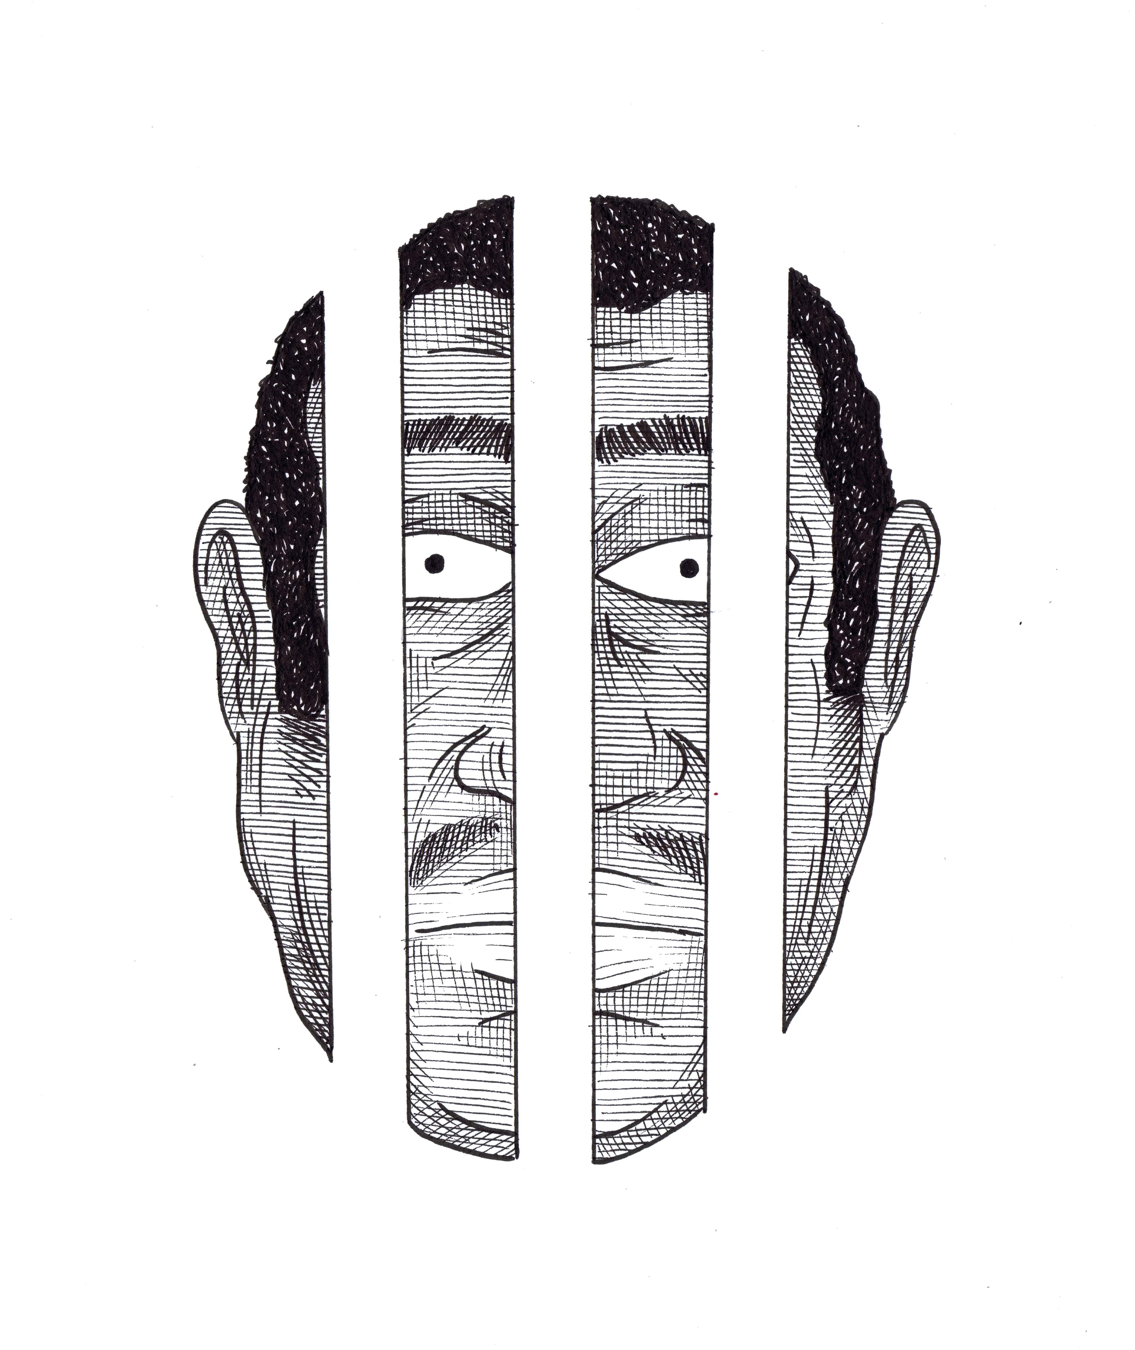
Figure 1: White Bars

The bars are striking for the way they are formed through the use of negative space, that is, the white-space that dominates the narrative. Staring out blankly, the man’s face is trapped by bars that emerge, and are swallowed by the screen. Scrolling ‘down’ the story, the next image depicts the man’s head, now carved open along the lines where the bars were initially held. Unaccompanied by words, the violence of his presumed indefinite detention is made known through the physical deformation of his head (Figure 2).

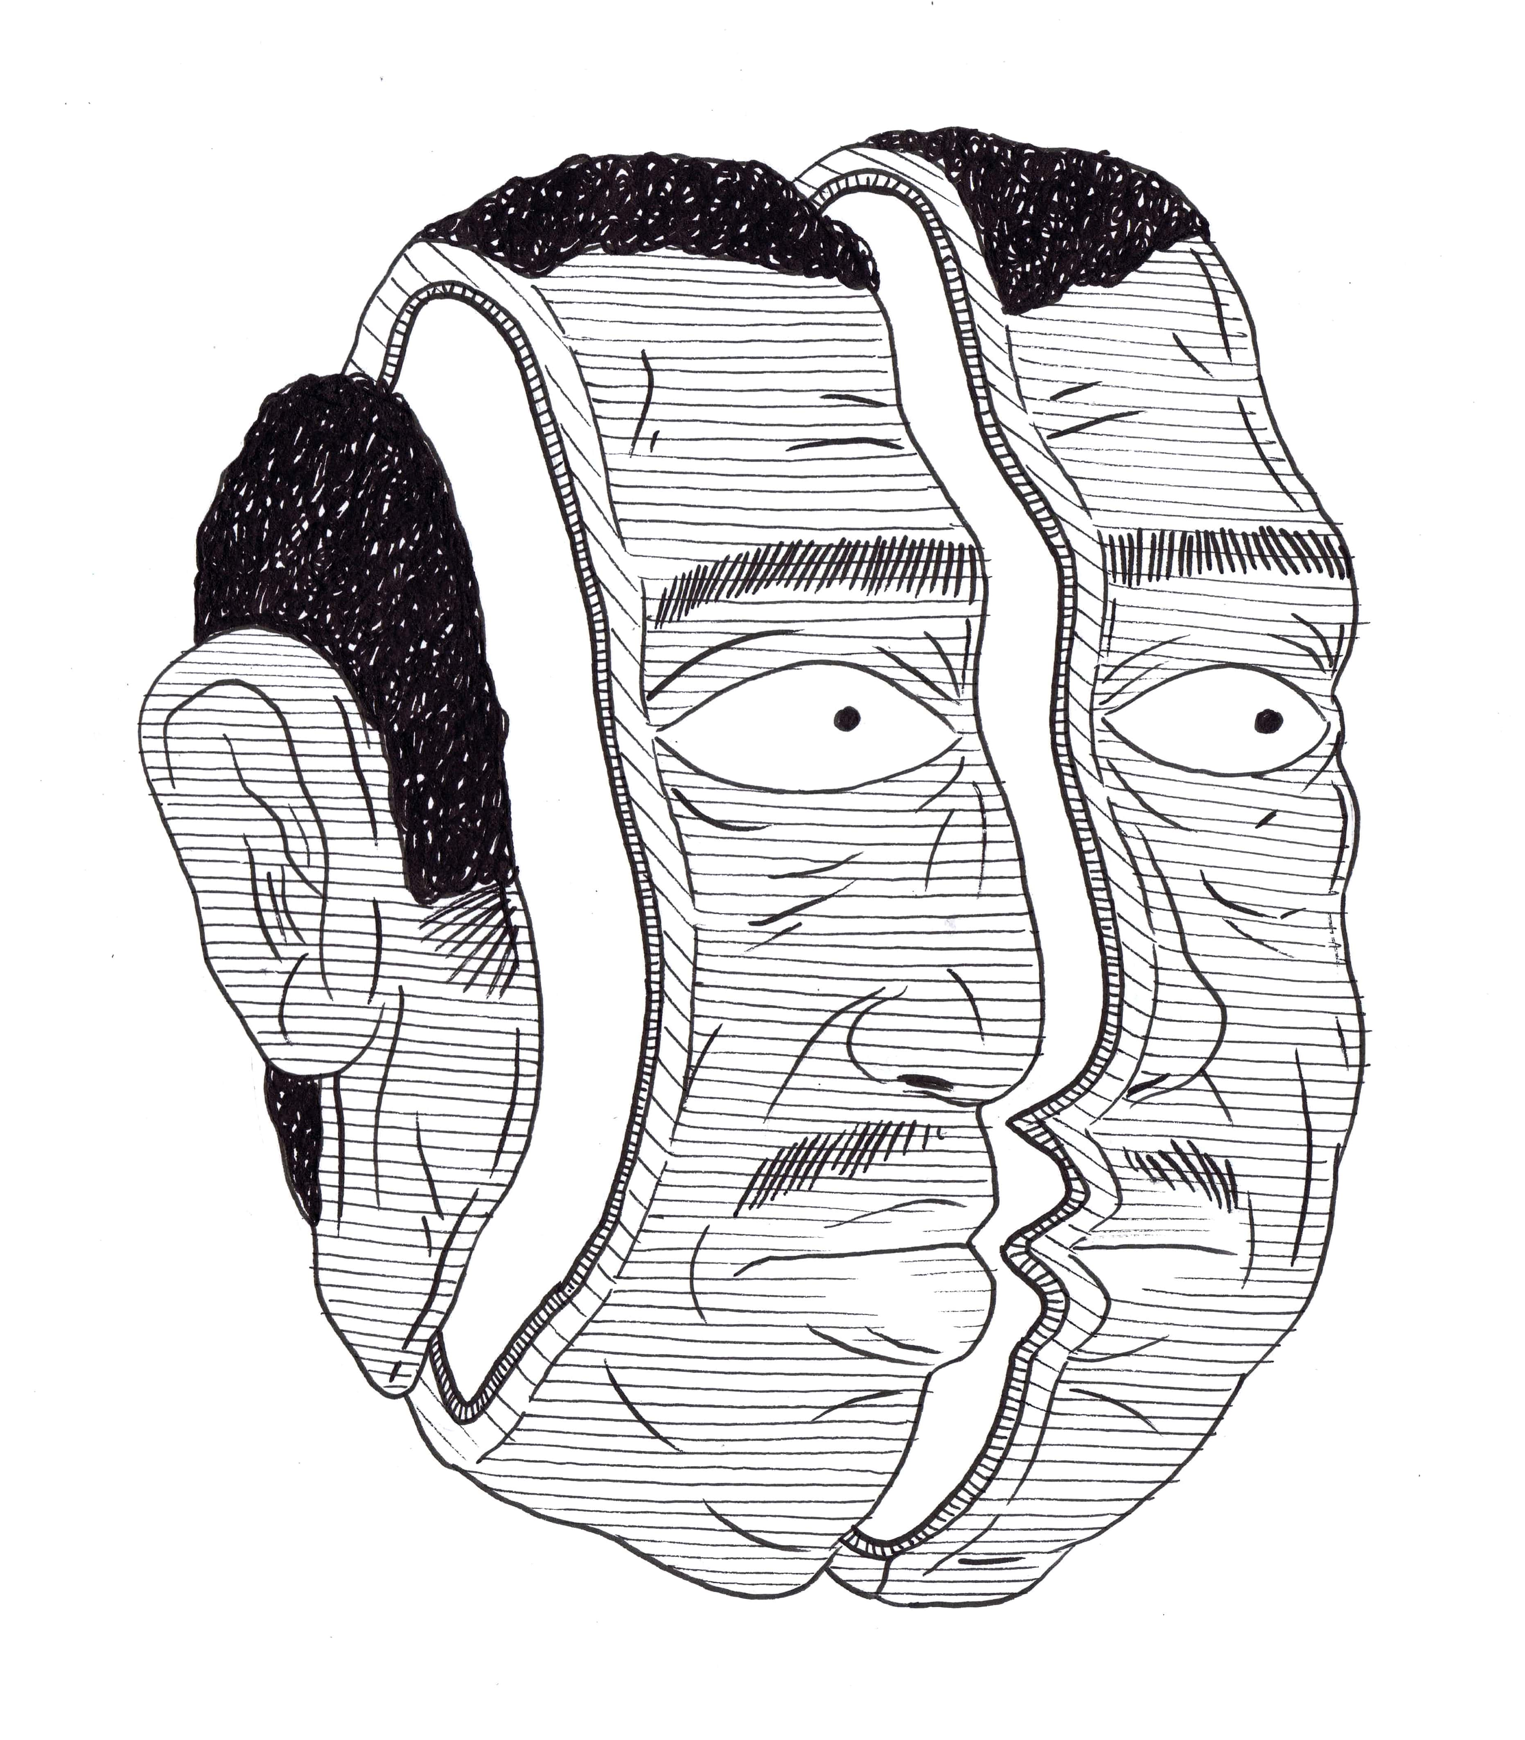
Figure 2: Wounded Head

Read sequentially, the opening images of ‘A Guard’s Story’ are important because of the way that the shift in perspective—and adjustment in the use of white-space—reveal vastly different messages. The first image is presented to the reader en face, the man’s visage interrupted by the bars. Much like this outlook, the visual message seems fairly straightforward. The second image, however, challenges this assumption. The new viewpoint allows the viewer to discern the violence that lies behind the initial image. It seems that ‘indefinite detention’ has taken its toll on the subject before us, for reasons that as yet remain unknown. The statement, ‘I always knew indefinite detention did bad things to people’, also confirms that this is a story told in retrospect, and that the images are informed by this proleptic understanding.
In Precarious Life: The Powers of Mourning and Violence (2004), Judith Butler defines ‘indefinite detention’ as an “illegitimate exercise of power”, but one that is “part of a broader tactic to neutralize the rule of law in the name of security” (67). Butler continues that “‘[i]ndefinite detention’ does not signify an exceptional circumstance, but, rather, the means by which the exceptional becomes established as a naturalized norm” (67). Butler’s definition of the term falls within her analysis on the indeterminate status of detainees at Guantanamo Bay, which in turn informs her broader discussion about what constitutes a ‘grievable life’. Although ‘A Guard’s Story’ arises in response to the treatment of asylum seekers, rather than political prisoners, ‘detainees’ in Guantanamo and Australia are both subject to what might be described as extra-judicial laws, designed to keep these groups beyond the reach of the rule of law. It is the horror of this occlusion—what Agamben terms the ‘state of exception’—which ‘A Guard’s Story’ speaks out against. Like Butler, Agamben isolates a specific reduction at work in states of exception, most particularly how the subject of the exception is reduced to “bare life”, occupying “a zone of indistinction and continuous transition between man and beast” (1998: 109). This zone of indistinction is instantiated through the state of exception—an inherent aspect of the law which permits the law, or laws, to be set aside as required, but usually only in circumstances of “emergency”, in which either the state or some essential element of it are gravely imperiled. In an Australian context, we can see the operation of this maneuver clearly through the amendments to the Migration Act. That is, without the sovereign operation of the statute in the first instance, it would not be possible to amend the law so as to exclude its operation under its new form.
By adopting a simple schematic comparison, “A Guard’s Story” draws attention to the negative materialities of a biopolitical order, and specifically the way in which the ‘state of exception’ operates as the “preliminary condition for any definition of the relation that binds and at the same time, abandons the living to the law” (2005: 1). In this way, the story extends the connectedness between graphic narratives, and the haptic representation of bodies—found in print narratives such as Persepolis, Fun Home, and Maus, among others, into a digital context. In in the examples below, the reader can observe the ways in which indefinite detention conscripts the bodies it circumnavigates to a zone of indistinction.
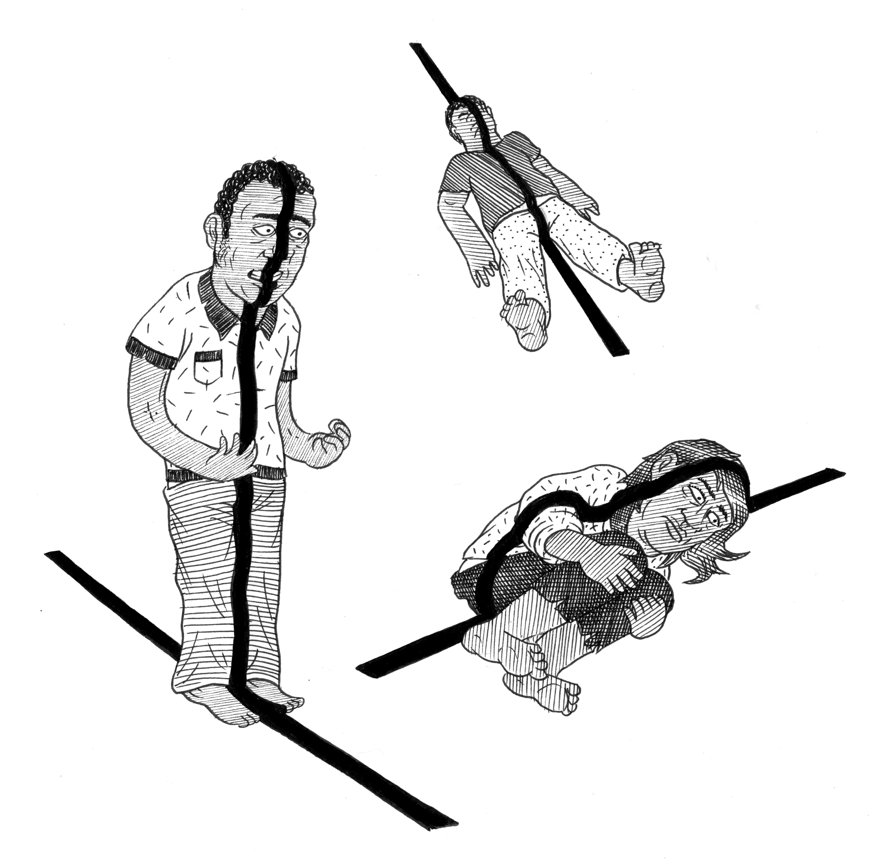
Figure 3: Marking Boundaries
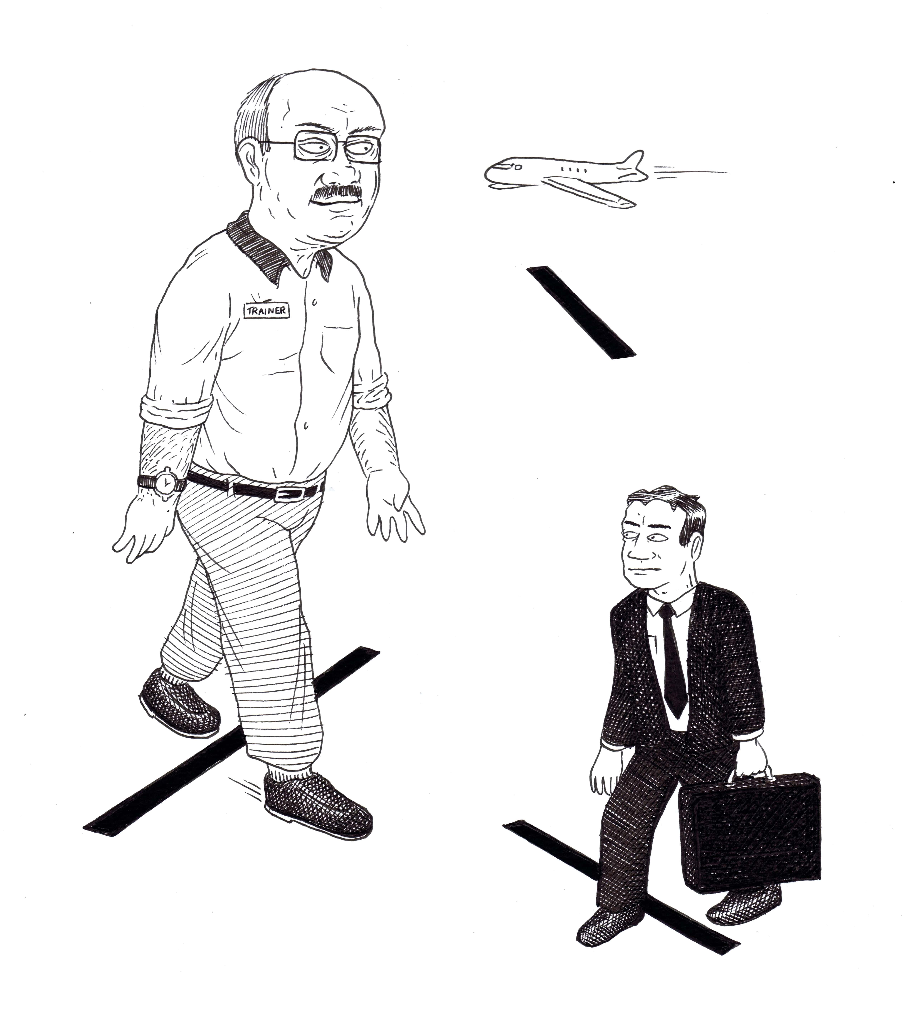

Figure 4: Boundary Privileges

The boundaries in the first scene acquire the force of material reality against the individuals whose bodies they bisect, depicted as solid black lines that cross and contain those bodies. Here the detainees are depicted in painfully contorted positions, vulnerable to the outsized graphic boundaries that cleave them. By way of contrast, the second scene depicts the ease with which other individuals—those without the ‘state of exception’—can circulate within and traverse lines of exclusion. Accordingly those boundaries now acquire ‘regular’ proportions, ready to be stepped or flown over, and mostly disregarded. In corporeal terms, we see that the indeterminate status of asylum seekers can acquire what Judith Butler calls the “violence of derealisation” (32) in terms of their representation as racial and cultural Others, whose presence is “neither alive nor dead but interminably spectral” (32-33). The spectrality of which Butler speaks echoes Agamben’s work on bare life and the reader can observe how the biopolitical contours of detention are realised through the material incursions of the non-being afforded to the inmates of the detention centre. Perhaps more accurately, we could think that the inmates’ bodies are recognised as material when they are tattooed by the boundaries around them, bodies that are restricted by not only how they travel, but how they are recognised. In this instance, the bodies of the detainees are at least partially defined through the boundaries that mark the confines of their recognition.
White-space and Reading Online
In contrast to the boundaries that mark the bodies of the asylum seekers, the narrative structure of ‘A Guard’s Story’ is devoid of frames or panels altogether. Informally, the screen acts as an extra-diegetic panel that frames some of the segments, however, the preponderance of white-space is one of the most notable aspects of this piece. As Tony Hughes-d’Aeth suggests, the impact of a field without borders is that it ‘implicates the seer into the world of the seen’ (213). This is relevant to ‘A Guard’s Story’, where ‘not-seeing’, represented by the white field of the interface, is transformed into a negative space that shapes and holds its narrative contents. The use of white-space to ‘de-frame’ the story, instead of panels to maintain a comfortable distance between the narrative and the reader, is significant because of the way it positions the reader to engage with the story’s destabilising impulse.
Rebecca Scherr makes the same point in her analysis of Footnotes in Gaza (2009) by Joe Sacco, where she states, “[w]e are addressed not as passive viewers, but as active participants in the gathering and hearing of testimony; our engagement with the material is corporeal, physical, intimate” (5). Similarly, the absence of formal frames in ‘A Guard’s Story’ enhances the dispossession of its ‘contents’, mimicking the precarious and uncertain status of the detainees—as psychic, embodied and legal subjects—over substantial, if not indefinite periods of time. Here, the preponderance of white-space seems thick with unresolved meaning, as it surrounds the people and objects within it, if not threatening to engulf them altogether. The use of white-space can be linked to a longer tradition in the production of graphic arts such as wood engraving, linocut, etchings and wood block where the carving of a surface would produce the opposite image in print.
Another distinctive feature of the text is that the reader must scroll vertically to navigate the text, through which the story gradually emerges. The physical act of scrolling can be regarded as the digital counterpart to turning the page in a print novel, and the scroll ‘up’ or ‘down’ resembles flipping back and forth between the pages of a book. Here, ‘scrolling’ takes on both material and digital dimensions, that is, by navigating the text the reader also unfurls the digital scroll of the text. The intimate relationship between the two senses of the term draws attention to the way in which textual meaning is shaped not only through the text’s content, but also its form in space and time, present here in an online context.
This form of navigation also seems apt for the way that asylum seekers are moved away from and increasingly off Australian shores. As the editors of the Routledge Companion to Experimental Literature state, by ‘unrepressing’ questions about what literature is, its limits and possibilities, “[e]xperimentation makes alternatives visible and conceivable” (1). In the case of ‘A Guard’s Story’, the embodied reading practice imitates a descent into the psyche as it unravels repressed elements about the treatment of asylum seekers to Australia. Like an extension to a physical descent, the reader can use the mouse to pause at or skim over different parts of the text, as well as reencountering them by scrolling ‘up’. In this way, the narrative takes full advantage of the online graphic narrative form to map its representation of traumatized subjects through the very structure of the story. This is, I suggest, also connected to the predominance of white-space in the text, as we encounter scenes that partially emerge from its opacity. Through the illustrations and the narrator’s text, the reader is brought to bear witness on scenes that it seems, would otherwise remain submerged. The emergence of these scenes is thanks to the hand-drawn images that escape the restriction on visually recording the spaces of the detention centres.
The hand-drawn aspect of comics is important, particularly in circumnavigating visual censorship. Further, the indexical mark of the artist’s hand offers a point of connection between reader and the text beyond the transmission of the content itself. In this respect, I agree with Johanna Drucker’s suggestion that the ‘energy’ of drawings by hand imparts a “lively immediacy, vigor, and an urgency to communicate that becomes part of the urgency of the story” (44). This kind of communication gains particular traction when considered in relation to Rebecca Scherr’s discussion of ‘haptic visuality’. Scherr posits that haptic visuality can be understood as ‘a connective readerly address incorporating sensation and emotion in its communicative reach’ (21). As Scherr suggests, the ‘tactile’ quality of the line drawing ‘continually communicates the subjective and affective dimensions of the content presented’ (24). The impact of the story is also apparent in Wallman’s comments about the difficult process involved in its production:
It was emotional to make. I have some friends who have recently got out of detention and are waiting for their visa applications to be processed, and one of them has been denied already. They’re having a really hard time and I was thinking of them a lot while I was drawing. It was pretty sad to spend 100 hours sitting on my own, thinking about how brutal things are. (Fisher)

The brutality of which Wallman speaks, finds its way into the text, both in its content, and form. In a digital context, the physical connectedness between reader and text is enhanced by the scrolling that is inherent to the interface. As one scrolls downward, people and objects appear to float on-screen circumscribed by a spatial and temporal vacuum. In representational terms, it appears that the narrator’s experiences have ‘undone’ the ability to neatly hold the narrative within an organising frame. The absence of panels means that the reader cannot hold onto any rhythmic associations to guide their reading, but must confront with the lack of momentum to propel this act. This lack replicates the space of indefinite detention and the reader is asked to work harder to allocate perspective to the images that emerge from the white-space. In Butler’s words, what we encounter is something that “exceeds the frame that troubles our sense of reality; in other words, something occurs that does not conform to our established understanding of things” (2009: 9). We see this in practice in ‘A Guard’s Story’, where the untethered contents of the narrative float on-screen, and the entire work is indeed characterized by a limbo that surrounds the status of the detainees, represented visually not only through the use of white-space, but also signified through the uprooted buildings that punctuate the story, and which act as markers of transitions in the narrative’s arcs (Figure 5).
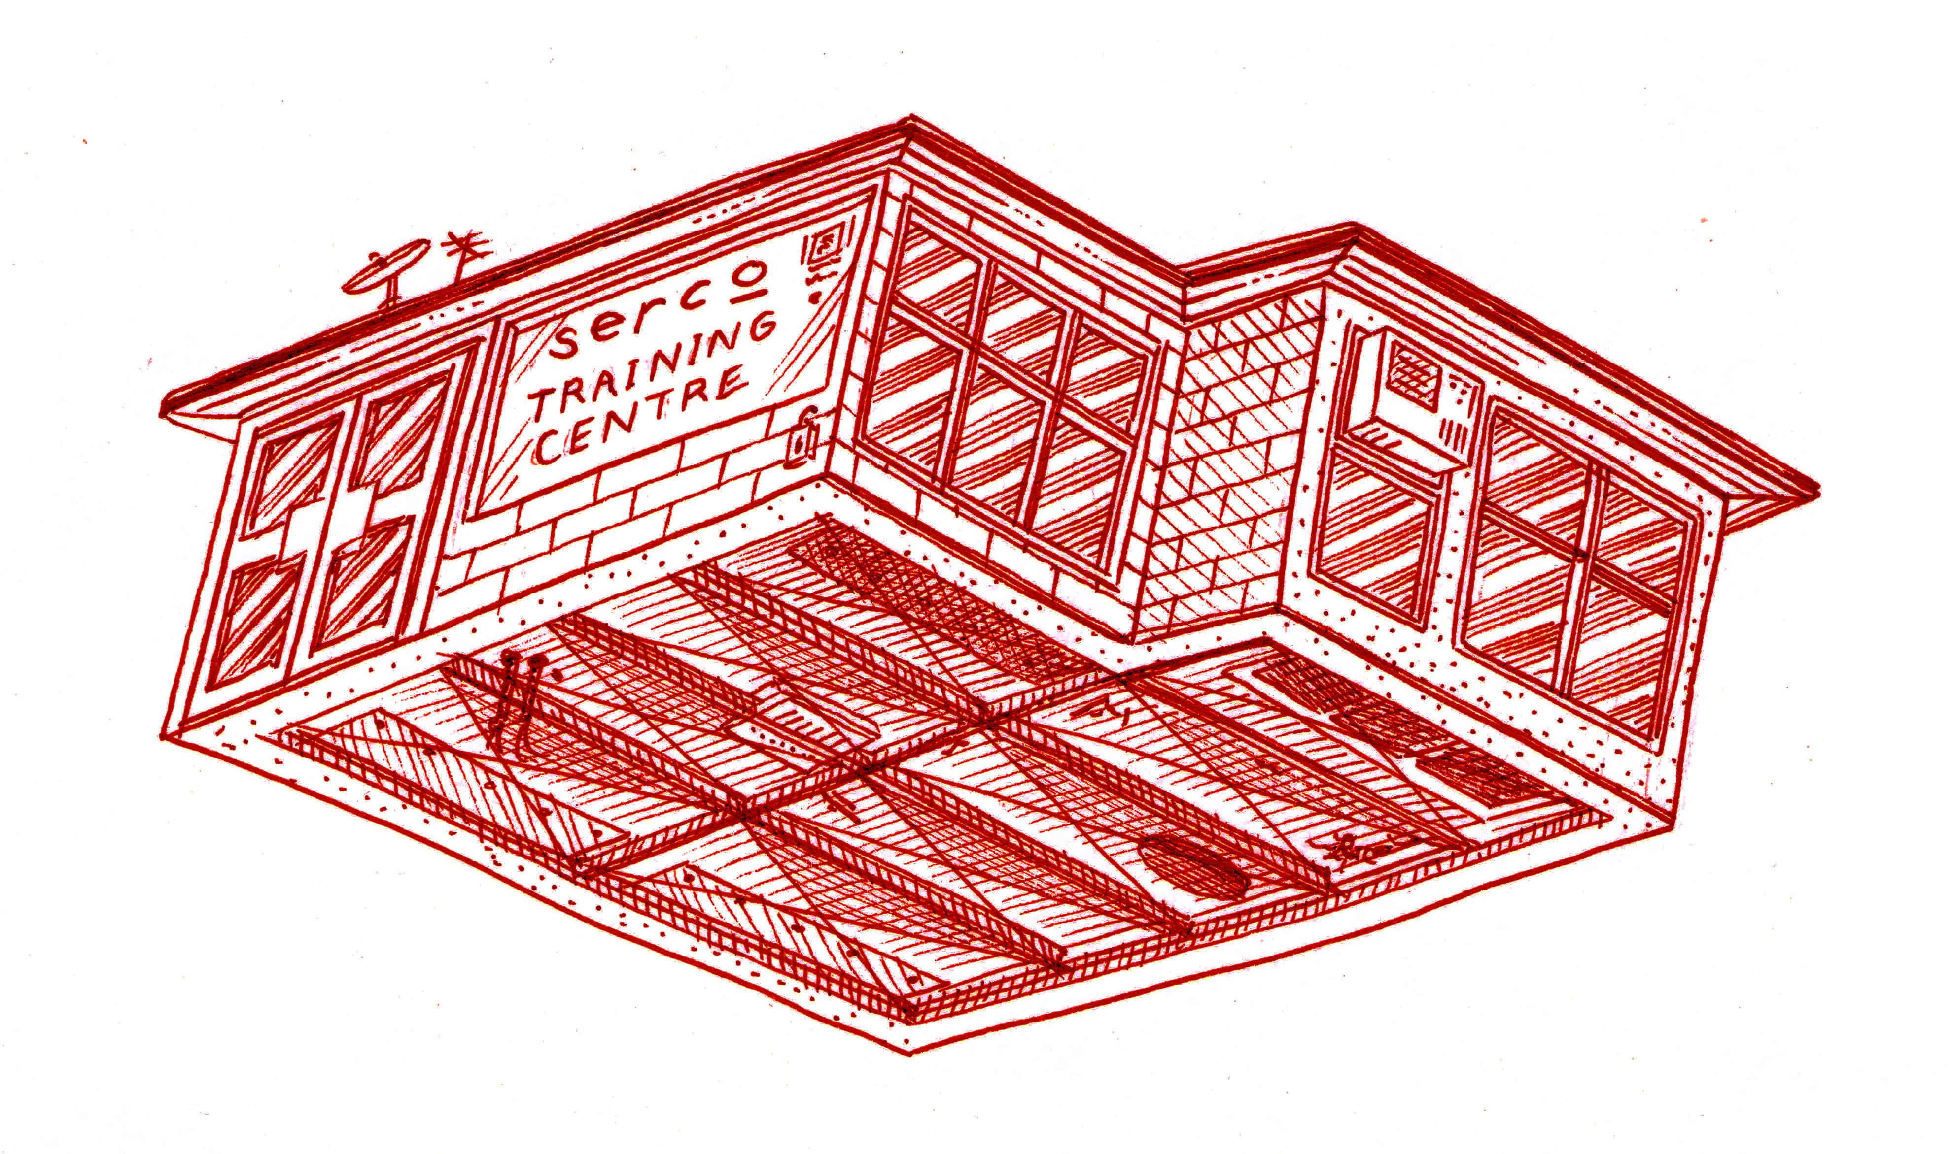

Figure 5: Serco Training Centre
Dislodged from any recognizable setting, the floating structure suggests a state of transition along with uncertainty about its significance—reminiscent of the farmhouse in which Dorothy travels from Kansas to Oz. It also offers a visual approximation of the ‘zone of indistinction’ of which Agamben speaks. In ‘A Guard’s Story’, however, it not only the buildings that are deracinated: in one sequence, the narrator recalls hearing about a child refugee who “cut his head open on the way home from school”. This incident is illustrated from the interior perspective of the bus, and with little to orient the scene. The reader is presented with a bus-seat bearing the child, with the deep angle of the seat lying perpendicular to the adjacent windows, and immediately the mismatched angels indicate the traumatic trajectory of the child’s journey. The view through the bus windows mimics the structure of the story as a whole, their downward tilt revealing a gradual descent from the view of sky-scrapers, through the Earth’s crust to what looks like the magma core—but figured as an explosion. This micro-sequence powerfully supports the devastation of the main action. The subsequent panel depicts the bus in quarter-profile, a stylised stream of blood gushing forth from the open door of the bus.
Recalling the frequency of self-harm by the detainees, the narrator remembers another incident where a man placed broken glass in his mouth, threatening to swallow the shards if he was not permitted to meet with his case worker. The horrific contrast between the desperation of this act and the relative simplicity of the demand is captured in the image of a man whose desperate eyes look out to the reader, while his mouth is bloodied and covered by slivers of glass. His careworn face and electrified hair contribute to the impact of this recollection, and it is precisely the hand-drawn images that make this representation all the more visceral as they connect the reader to the artist’s hand, and to the haptic visuality of the text.
At times only parts of an image are allowed to be exposed or remembered (Figures 6 and 7). For example, in the next panel, the violence of detention is now writ explicitly on the body, as the narrator explains that “…self-harm was really common in the detention centres…everywhere you looked there were people with fresh cuts and scars up their arms”. These statements bookend the drawing of a forearm in close focus, with a ‘Victorian’ state border tattooing the upper arm, before morphing into the form of scars and fresh cuts towards the wrist (Figure 6).
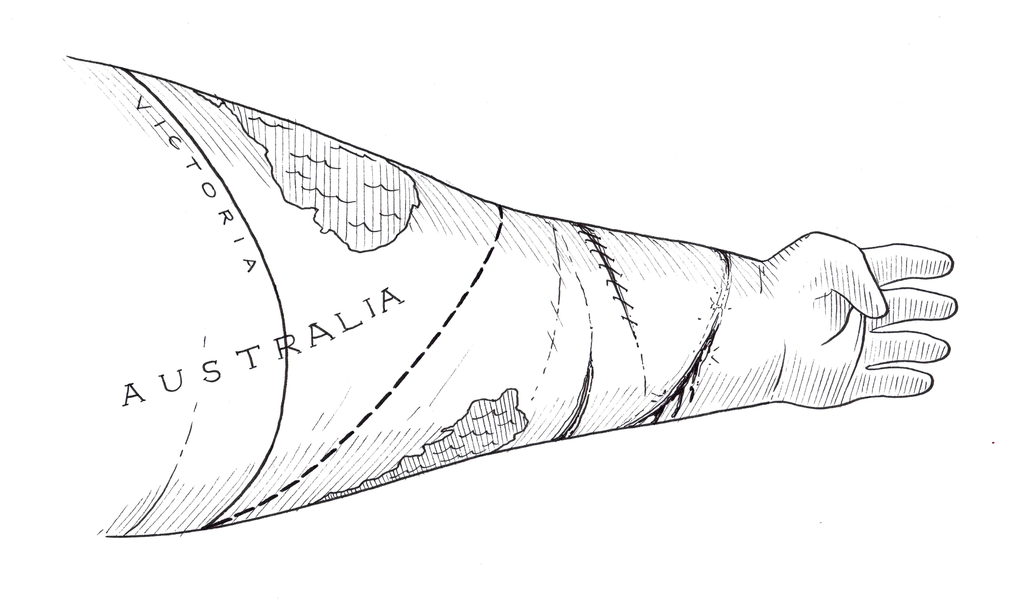
Figure 6: Marking Boundaries

As an analogue to self-harm, the social and intimate impact of detention is represented in this image, where the body becomes the material site over and through which boundaries are contested and shaped. The policing of bodies that the guards undertake is a material process in its own right, as well as a metaphor for the federally mandated policing of the Australian mainland and its territories. The story presents detention as a liminal space that is at once part of but also expelled from the nation through the exposure of its subjects to extra-juridical ‘laws’. In this space, the body as a biopolitical site is brought into sharp relief, evident in the actions of the asylum seekers such as self-harm. Wallman’s drawings are somewhat similar to the searing images of Joe Sacco, where human appendages appear somehow more flexible than their material equivalents. Far from detracting from their impact, the representation of suppleness in the subject’s bodies reminds the viewer of the vulnerability of the body, as well as its ability to bear—up to a point—inhumane conditions. Their elasticity also, I suggest, bears the mark of their trauma. These bodies are elastic because they have had to contend with suffering and deprivation—and their figuration speaks of these conditions. By foreclosing the representation of asylum seekers, these images thwart the concerns that are otherwise being presented.
For example, the narrator participates in a training exercise designed to immobilise its subject, and contemplates “[a]ll I could think was that this was happening to a refugee inside a detention centre or a Tamil guy who had lived through a war and was fleeing from torture”. The picture accompanying this statement depicts the narrator lying underneath two co-workers, who look at each other as they happily contemplate their success in executing the exercise. In contrast, the narrator looks out towards the reader, his face lying behind a row of three masks. These veneers depict the narrator’s imagining of the refugees as they are pacified—their physical restraint perhaps reinvoking the traumas they have previously withstood. The sequential placement of the masks also indicates the empathic relation between the narrator and the refugees he encounters. Not surprisingly perhaps, the narrator’s internal response to the training exercise is “I couldn’t handle it”, and this statement resides below the image of a large messy black knot. Over time, the strain of working as a guard becomes overwhelming, and the narrator decides to resign, suffering from deteriorations in his or her relationships and mental health. The narrator concludes, “Nobody on the outside believed how bad it was in there”, and this brings the main action to a close.
Conclusion
In the brief coda, the narrator encounters two Rohingyan asylum seekers from the detention centre in a suburban shopping centre. In detention, the two men stage a protest by standing on the roof of the centre, and the narrator notes, ‘I don’t know how long they were there for’. The narrator explains that ‘we [the guard’s] were told not to look at them or speak to them…to pretend they weren’t there’. Acting against this injunction, however, the narrator notes that ‘I used to look up and wave at them when no-one was looking’. Responding to the narrator’s recognition of their presence, the men ‘waved back but never smiled’, and it is this simple, yet powerful exchange that impresses itself upon the narrator’s mind (Figure 7).

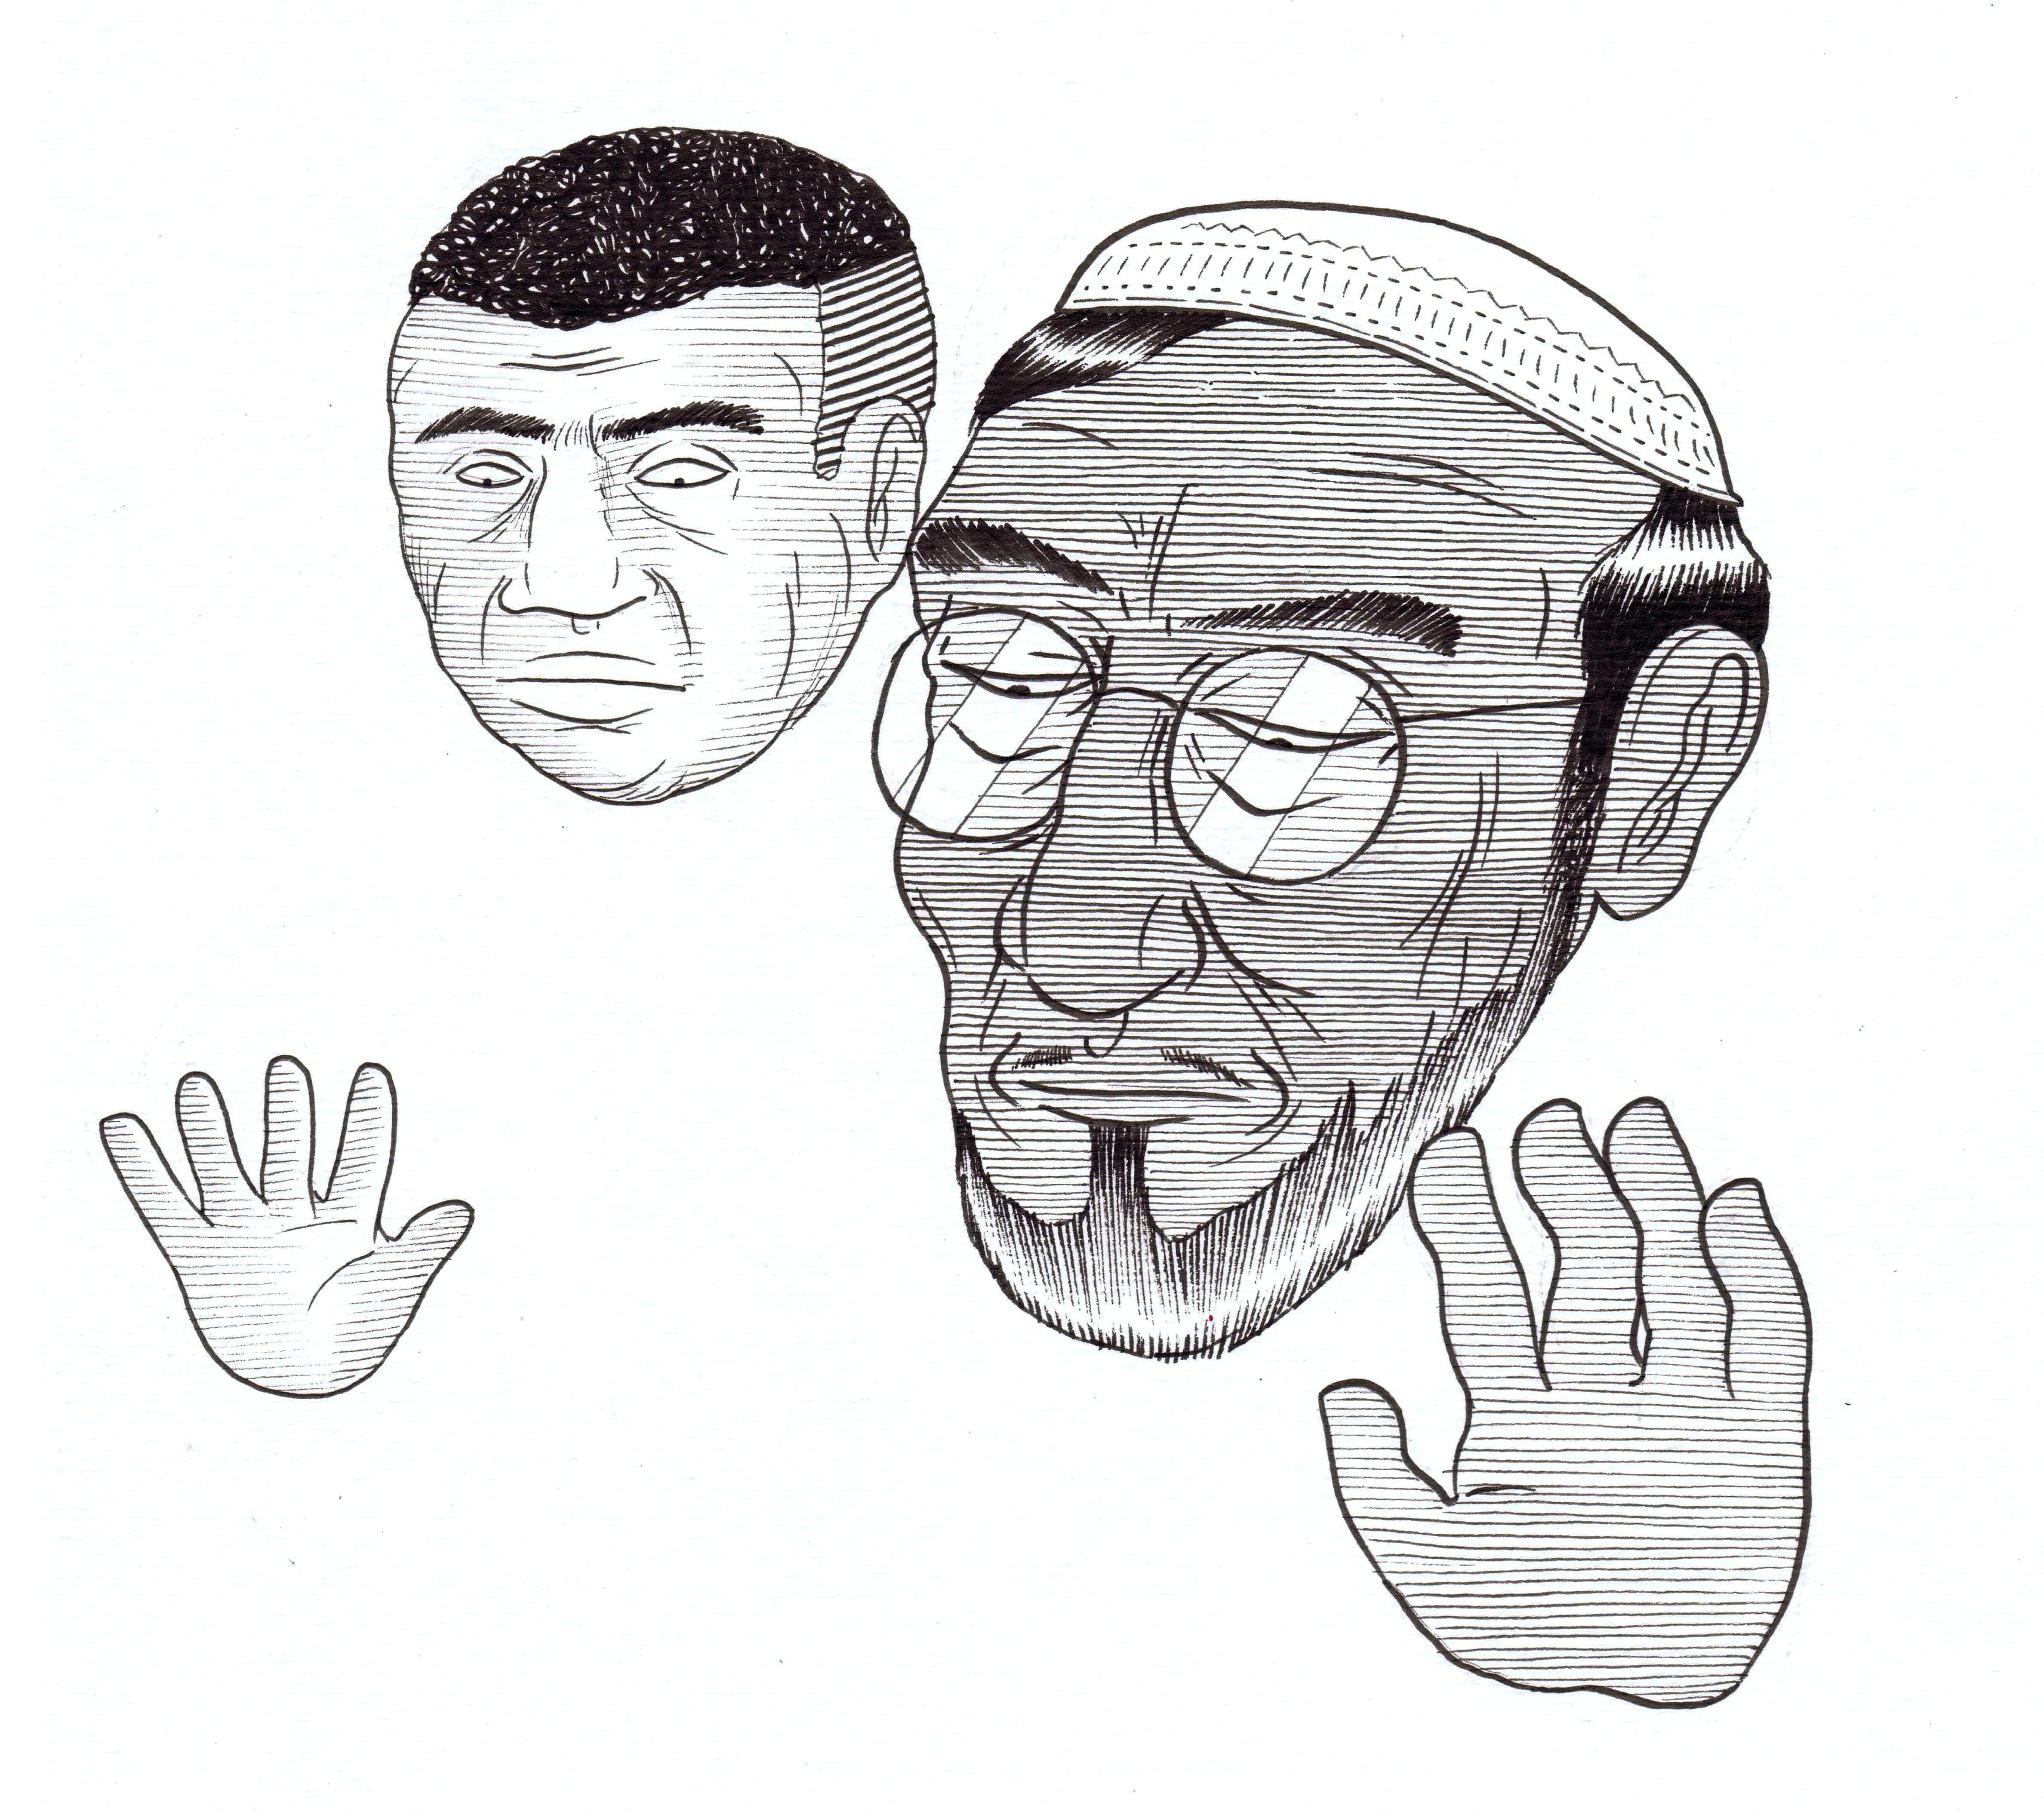
Figure 7: Recognition
This image is repeated at the end of the narrative and the recognition of the Rohingyan men to the narrator’s acknowledgement offers something of a reprieve—a literal and metaphorical afterlife—to the deprivation of recognition within the detention centre. Perhaps more than any other sequence in the story, this episode conveys how sight and vision—as non-verbal forms of communication—can recognize what would be otherwise be denied. In the case of the Rohingyan men, their presence is disavowed within the detention centre; the employees are instructed not to look at them precisely because of the knowledge that the men are on the roof. The men also look back at the guard, and it is their gaze that is represented in the story, and their faces and the hands are brought out of the white-space that otherwise consumes their bodies. Like their faces, their open, outward-facing palms denote the communication that is taking place. Yet their downcast gaze resists the reader’s desire to be acknowledged, producing an effect similar to the disavowal to which the men are subject.
Judith Butler suggests that “[t]o learn to see the frame that blinds us to what we see is no easy matter” (2009: 100). Here, readers are presented with a new perspective on the space of the camp as a biopolitical site in an Australian context. Remarkably, the narrative offers this insight through the eyes of a guard, a usually maligned figure within discussions of biopolitics. In this context, the devastating impact of detention is represented not only in relation to the detainees, but also on the subjects that would police them. The narrative draws attention, literally, to the physical connectedness of the detainees, in the ways they support each other and the privileged position of the guard allows comparisons to be created between life inside and outside the space of the camp. Through the haptic visuality of the text, and the use of scrolling, the narrative offers an important extension of the biopolitical impulse of comics into the digital realm. As an experimental work, ‘A Guard’s Story’ continues the explorative agenda of graphic narratives through its formal innovations. Discarding the use of traditional panels introduces an interruption of normalized reading, at least in the context of reading Western graphic narratives, and the work thus offers a self-reflexive consideration of how perspectives are formed and discarded. As with other graphic narratives, the hand-drawn images offer intimate and indexical marks of the artist as he rendered the narrator’s story into a visible and recognizable form. In so doing, the story begins to ‘unrepress’ a narrative by inviting readers to witness its difficult contours.

Works Cited
Agamben, Giorgio. Homo Sacer: Sovereign Power and Bare Life. Stanford: Stanford University Press, 1998. Print.

---. “No to Bio-Political Tattooing” January 2004. Web. 18 June 2015. <http://www.egs.edu/faculty/giorgio-agamben/articles/no-to-bio-political-tattooing/>.

---. State of Exception. Chicago: Chicago University Press, 2005. Print.

Australian Human Rights Commission. “‘Locking up Children Taints Us All’, says Commission President. 12 February 2015. Web. 20 June 2015. <https://www.humanrights.gov.au/news/stories/locking-children-taints-us-all-says-commission-president>.

Anon. “Interview with Chris Ware: The Art of Comics No. 2”. The Paris Review. 210 (Fall 2014): 188-221. Print.

Australian Customs and Border Protection Services. “Afghanistan Storyboard.” Web. 10 Mar. 2014]. <http://www.customs.gov.au/webdata/resources/files/Storyboard-Afghanistan.pdf>.

Bray, Joe, Alison Gibbons and Brian McHale Eds. Routledge Companion to Experimental Literature. Abingdon, Oxon.: Routledge, 2012. Print.

Butler, Judith. Frames of War: When is Life Grievable? London: Verso, 2009. Print.

---. Precarious Life: The Powers of Mourning and Violence. London: Verso, 2006. Print.

Chute, Hillary. “Graphic Narrative”. Routledge Companion to Experimental Literature. Eds Bray, Joe, Alison Gibbons and Brian McHale. Abingdon, Oxon.: Routledge, 2012. 407-419. Print.

Chute, Hillary L. and Marianne DeKoven. “Introduction: Graphic Narrative.” Modern Fiction Studies 52.4 (2006): 767-82. Print.
Dekoven, Marianne. A Different Language: Gertrude Stein's Experimental Writing. Madison: University of Wisconsin Press, 1983. Print.

Drucker, Johanna. “What is Graphic About Graphic Novels?” English Language Notes 46.2 (2008): 39-55. Print.

Fisher, Tim. “Telling a Guard’s Story”. Broadsheet. 20 Feb. 2014. Web. 28 Sep. 2014. <http://www.broadsheet.com.au/sydney/art-and-design/article/global-mail-guards-story>.

Flitton, Daniel, Marc Moncrief. “Refugees’ mental anguish in Australia’s ‘Guantanamo’”. 25 Aug. 2014. Sydney Morning Herald. Web. 14 Sep. 2014. <smh.com.au>

Hirsch, Marianne. “Editor’s Column: Collateral Damage.” PMLA 119.5 (2004): 1209-15. Print.
Hughes-d’Aeth. Tony. Paper Nation: The Story of the Picturesque Atlas of Australia. Carlton: Melbourne UP, 2001. Print.

McDermott, Quentin. “The Guard’s Story”. Australian Broadcasting Corporation. 15 Sep. 2008. Television.

Scherr, Rebecca. “Framing Human Rights: Comics Form and the Politics of Recognition in Joe Sacco’s Footnotes in Gaza.” Textual Practice. DOI: 10.1080/0950236X.2014.952771. Web. 3 Oct. 2014.

---. “Shaking Hands with Other People’s Pain: Joe Sacco’s Palestine”. Mosaic 46.1 (2013): 19-36.

Spiegelman, Art. What the %@&*! Happened to Comics?” Melbourne Town Hall. 8 Oct. 2013. Public lecture.

Wallman, Sam and Nick Olle. “At Work Inside Our Detention Centres: A Guard’s Story.” The Global Mail. Feb. 2014. Web. 31 Mar. 2014 <http://serco-story.theglobalmail.org/>.

With many thanks to Tony Hughes-d’Aeth for his helpful feedback on this paper.
One can see early examples of comics that playfully disrupt their own textual ontologies. For example, in Winsor McCay’s serialised strip, ‘Little Sammy Sneeze’ (1904-1906), the eponymous character shatters the frame around him because of a powerful sneeze, a pattern which is repeated in other episodes. McCay continued his experimentation in comics in later works such as Dreams of the Rarebit Fiend (1904-1925), and most famously, in Little Nemo in Slumberland (1905-1926). One of the most remarkable aspects of McCay’s work is the way that the panels form part of the narrative vocabulary of the work. As ‘windows’ into the world of the text, the frames bend, shrink and grow as required. In this way, they actively draw attention to their contingent, rather than fixed status as creative texts.
http://www.smh.com.au/federal-politics/political-news/revealed-abbott-government-tried-to-remove-gillian-triggs-as-head-of-the-australian-human-rights-commission-20150213-13du7s.html
Indeed, an article run by the Sydney Morning Herald on 25 August 2014 draws a closer connection between the two loci in its title, “Refugees’ mental anguish in Australia’s ‘Guantanamo’”. The article claims that “Australia's policy of indefinite detention of the refugees with adverse security findings was found by the United Nations last August to be in breach of more than 140 international laws and conventions, but a year later the government is yet to respond to the ruling”. <smh.com.au> (accessed 14 September 2014).
Here, the image of the tattooed arm bears a close visual resemblance to Agamben’s concerns in “No to Bio-Political Tattooing”, in which he discusses his refusal to be subject to fingerprinting upon arrival to the United States as a practice of control that ‘had always been properly considered inhumane and exceptional’.
For a detailed consideration of the link between hands, connectedness, and haptic visuality, see Rebecca Scherr’s article, “Shaking Hands with Other People’s Pain: Joe Sacco’s Palestine”.

