At home in Johannesburg? Rethinking cosmopolitanism through TJ/Double Negative (2010), the joint project between David Goldblatt and Ivan Vladislavić

This article examines the cosmopolitan character of TJ/Double Negative (2010) and argues that the prize-winning photography book, co-produced by the South African photographer David Goldblatt and writer and editor Ivan Vladislavić, is both a symptomatic expression of uneven development and a self-conscious interrogation of that unevenness. The book comprises two ‘parts’: Goldblatt’s iconic photographic series, TJ: Johannesburg Photographs 1948-2010, and Vladislavić’s novel Double Negative, a metafiction that refracts the story of modern Johannesburg – but also of Goldblatt’s career and of concomitant genre evolution of South African photojournalism from local ‘documentary’ to world-renowned ‘art’ – as it is reconstructed in TJ. This experiment in interdiscursivity is significant not simply for being the first of its kind – ‘a unique event in publishing’, as the publisher contrasto puffily declares in its marketing blurb - but rather because through this collaborative but also multi-modal venture a new mode of critical cosmopolitanism in world-literature might be discerned.

Keywords: Ivan Vladislavić; David Goldblatt; cosmopolitanism; photography and literature; publishing;

What does it mean to feel at home in a city as unevenly developed as Johannesburg? What might one have to avoid or repress – or indeed might one have long repressed – in order to “inhabit” cosmopolitanism as a structure of feeling (Lazarus 133) in a space often described as Africa’s most advanced global city yet which is haunted by a legacy of almost unparalleled social and geographical inequality? These questions are the central concerns of TJ/Double Negative, a joint project by two South Africans, the world-renowned photographer David Goldblatt and the rising star of world literature Ivan Vladislavić, published by the Italian art publishing imprint contrasto in 2010. The photographs in TJ are selected from an exhibition of Goldblatt’s lifelong project to document the people and places of Johannesburg and are accompanied by his signature captions – vignettes that contextualise and humanize the often opaque ‘straight’ images captured in the photographer’s urban peregrinations, and which are intended to provoke critical self-awareness in the viewer (Bester 158). Goldblatt’s photo series is in turn supplemented by Vladislavić’s invited response to the Johannesburg photographs, taking the form of a novel, Double Negative, that through the narrative reflections of its central protagonist, the photographer Neville Lister, refracts the story of modern Johannesburg – but also of Goldblatt’s career and of concomitant genre evolution of South African photojournalism from local ‘documentary’ to world-renowned ‘art’ – as it is reconstructed in TJ.

In this article I argue the experimentalism of this book – what I choose to describe, following David Atwell’s work on “situational metafiction” (20) in the postcolonial South African context, as its interdiscursivity – amplifies a highly localised and politically charged kind of worldliness that is a common feature in the work of both individual authors. The unavoidable social and geographic ‘facts’ of Johannesburg’s uneven development since the 1950s manifest throughout Goldblatt’s reportage; likewise what has been described as the ‘rise of the surface’ in South African cultural production in the era of neoliberal globalization, in Vladislavić’s fiction (Nuttall; de Kock). But the book is more than the sum of these parts. A self-conscious awareness of its cosmopolitan character – in the context of what Pierre Bourdieu (1984) would describe as a “field of restricted production” (4) – saturates each part of the book: from the positioning of the opening photograph in TJ in which a 1950s portrait photographer turns his seemingly primitive apparatus back towards the reader (fig.1), obliquely returning and unsettling their scopic gaze, to Neville Lister’s musings in Double Negative on the role played by photography in not only shaping but distorting memory in as well as of the postapartheid nation. But more so than the modernist narrative strategies of Rebecca Walkowtiz traces in the work of canonical British writers such as Conrad, Joyce, Woolf, Rushdie, Ishuguro and Sebald in Cosmopolitan Style: Modernism Beyond the Nation, self-consciousness criticism of cosmopolitanism as such in TJ/Double Negative is by design. The ‘art of the book’ is orchestrated through very deliberate interdiscrusive and paratextual strategies (such as the ‘unboxing’ experience dictated by the book’s integral packaging, mimicking the emotional hooks of retail brand design) that require the reader to reflect on the text’s status as a material object – in fact a highly fetishisable commodity – that circulates in a rarefied strata of a globalized economy and which mediates a structure of feeling that might, somewhat ironically, be described as critically cosmopolitan.

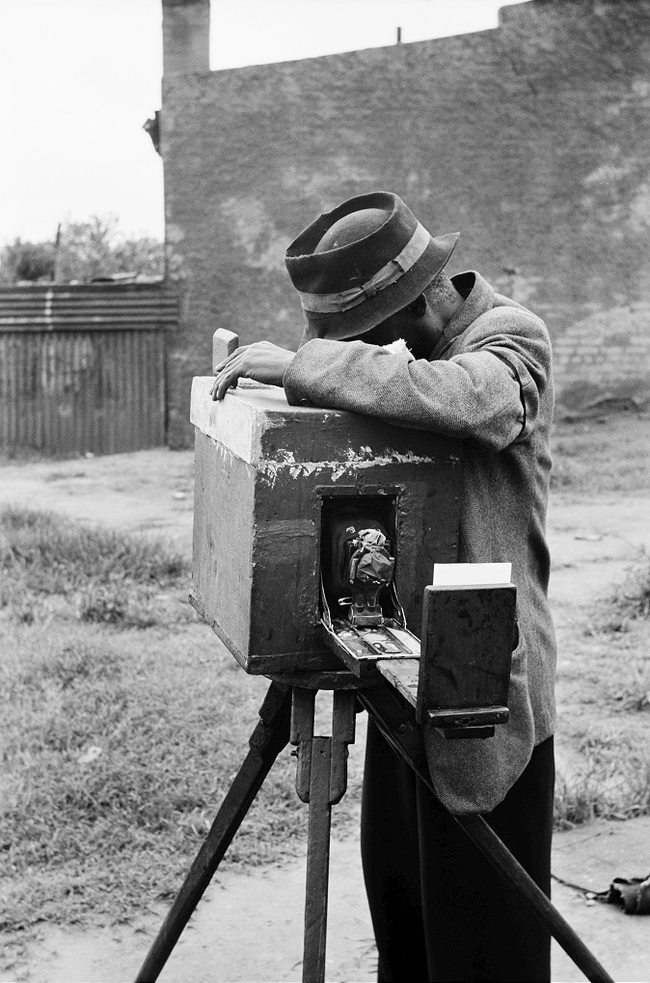

Fig 1. ‘Portrait photographer, Braamfontein 1955’, TJ p16

The cosmopolitanism character of world-literature is shot through with contradiction. It manifests in the symptoms of a normative socio-economic logic on the one hand – globally circulated commodities and commodity-signs that efface the material conditions of their production – whilst all the while promising or projecting a convivial subject position – “planetary humanism” (cf. Dominguez 2013) - that might escape this logic on the other. For those writers and artists who are ethically invested in the relationship between their work and the fractured or uneven social reality it addresses - but who also, eventually or possibly necessarily, produce this work for markets beyond this context – this presents a profound quandary. As Robert Spencer puts it: “Assuming that some form of political and institutional cosmopolitanism is both necessary and feasible, how are cosmopolitan sentiments to be engendered? How, in other words, are we to move from the uncosmopolitan present to a cosmopolitan future?” (37)

The question of how a globalizing culture might move from an uncosmopolitan present to a cosmopolitan future is central to the work of both David Goldblatt and Ivan Vladislavić. In their joint project TJ/Double Negative the vexed status of cosmopolitanism under conditions of capitalist globalization is distilled into a single, overriding concern: what does it mean, what does it take, to feel at home in a city as diverse but also as unevenly developed as Johannesburg? This is the question – or rather the challenge – we are presented with from the moment we encounter the book’s front cover (fig. 2).
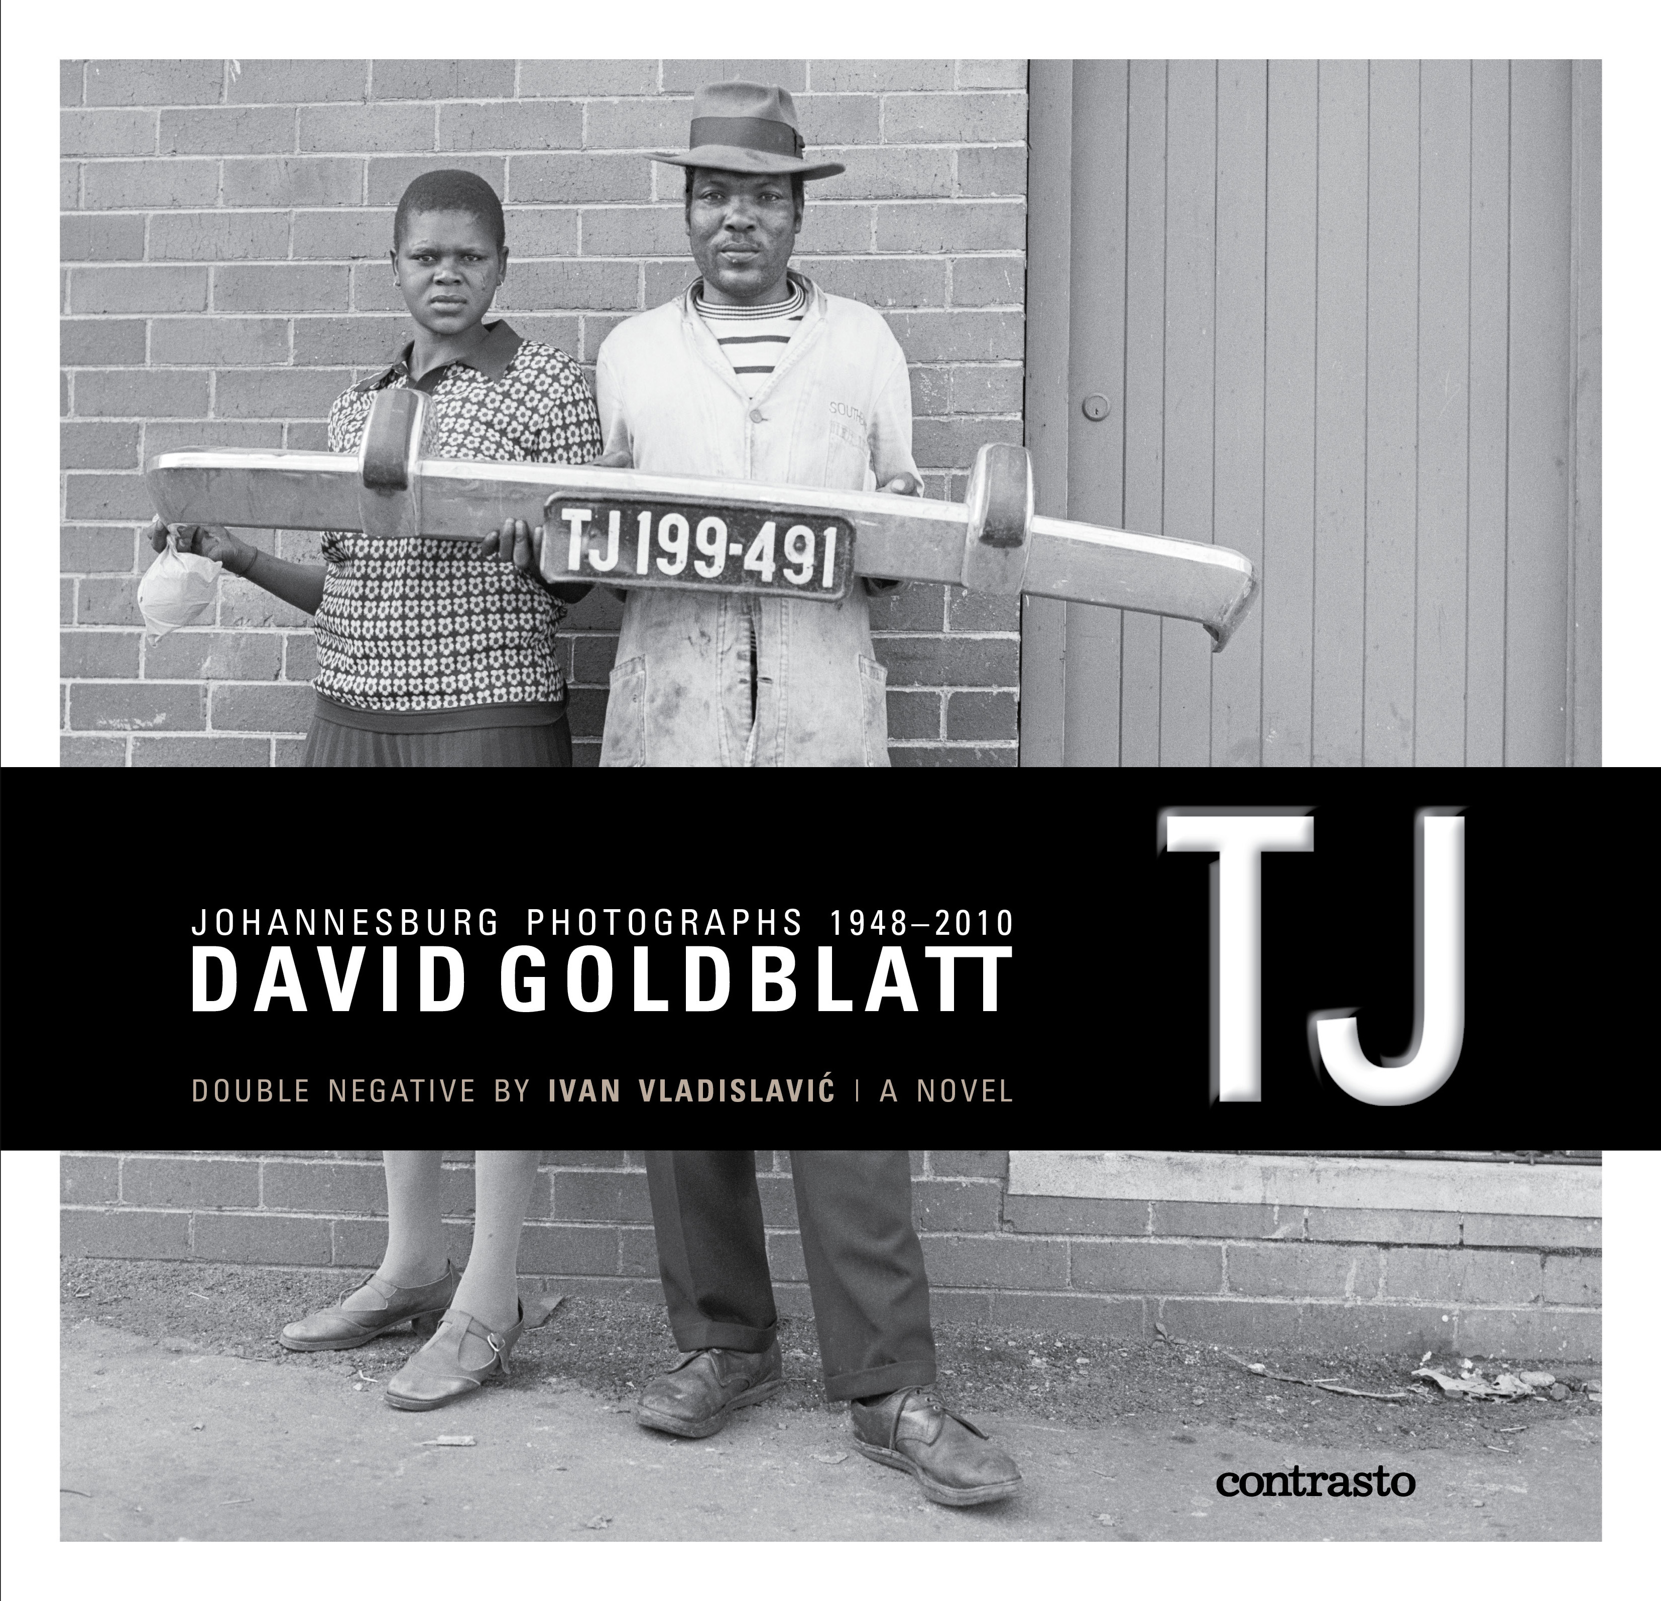
Fig.2 cover page of TJ/Double Negative, contrasto 2010

The cover photograph shows two black figures on a street, standing with their backs to a wall and staring mutely at the camera. They hold a detached car fender with a ‘TJ’ prefixed numberplate – the code for the Johannesburg area prior to its reinvention as Gauteng province in 1994 – with just enough care to suggest it has some kind of value for them, and that this in turn is something that might hold some kind of larger significance. They present it as if it were a totem, articulating a sense of place – yet not in a way that necessarily enables a sympathetic identification in the reader. It seems to represent something they wish to lay claim to; or perhaps it holds some claim over them. We are caught in a disconcertingly direct, yet impassive, gaze. There is something defensive about the stance of the two figures - shoulders held high, backs to the wall – which is in turn amplified by the guarded connotations of the fender. The numberplate affixed to the fender and held at the centre of the frame, hovering above the title box, communicates belonging whilst simultaneously establishing a boundary. It is a code that clearly means something important to the figures, at home in their world, yet this does not signify for anyone unfamiliar with the specific geographic and historic denotation of the area code. What does it mean to communicate a sense of place in such a challenging way, and why do Goldblatt and Vladislavić make this cryptic totem (and also this particular photograph, which reappears with explanatory caption in the front matter of TJ) so central to the experience of reading the book?

Interdiscursivity and estrangement

In his introduction to TJ: Johannesburg photographs 1948-2010 (the full title of this ‘part’ of the composite book, as it is paratextually announced) Goldblatt explains the origin of his title in a way that provides an interpretive frame not only for his own photographic material but also for its relationship to the books other part, Vladislavić’s novel Double Negative.

Johannesburg is a fragmented city. It is not a place of smoothly integrated parts. And it has a name that does not roll easily off the tongue. Unsurprisingly, the people of its fragments, which are severely divided by class, culture and, particularly, race, have their own names, elisions, diminutives and linguistic transliterations for the place. Some of these names are carried into this book. The ‘main name’ is TJ, but you are unlikely to hear it on the street or see it in any listing. It comes from our old motorcar licensing system. (Goldblatt 2012, np)

TJ/Double Negative documents the modern history of Johannesburg, sub Saharan Africa’s most global city with respect to international flows of commodities, ideas and people. But it is also a city of extremes, dominated, as Goldblatt tells us in his introduction, by an “almost irreversibly fractured geography resulting from a century of racist administration”(np). As such TJ/Double Negative is deeply concerned with the relationship between language and place, and in particular with the processes and politics of how such a fractured social experience is first “transliterated” and then “carried into” the world of the book: from the transformation of official discourses through everyday speech and practice, to the incorporation of this interdiscursive world through the photographic, literary and paratextual forms that comprise the book. As Stefan Helgesson stresses in his reading of the book,

it is through form, not despite it, that they [Goldblatt and Vladislavić] make distinct historical, social, and material aspects of Johannesburg apparent. Their collaboration could, therefore, be described as a double, triple, or even quadruple exposure of the visual and the verbal within the photographs, within the novel, between photos and captions, and between the paratext and main text. (54)

The critical premise of such experimental interdiscursivity is encapsulated by the title of the ‘fictional’ part of the book, Double Negative. Freighted with linguistic, philosophical and photographic connotations, perhaps the first image called to mind when one thinks of a double negative will be the distorted double exposure that hallmarks analogue-era photography. This image – typically the most memorable yet unloved in the family albums of this time – provides an apt metaphor for addressing the different ways in which both photography and fiction, as representational media, simultaneously capture and overwrite memory. The double exposure connotation is extended through the key narrative device that Vladislavić deploys in his response to Goldblatt’s photography: ekphrasis. The novel is narrated in the first person by Neville Lister, a commercial-turned-art photographer on the verge of national and international consecration in his field, and is structured around a series of descriptions of photographs and other artworks that have played a significant role in his own development as a photographer. His ekphrastic narrative superimposes additional layers of meaning and inference on those representations (ie. the double or multiple exposure of the photographic negatives), and in doing so provides an oblique but powerful engagement with realism as a highly politicised representational idiom in South African cultural history.

In an example of the kind of interdiscursive ekphrasis that for Helgesson typifies the book’s experimental aesthetic, Lister describes how his first encounter with Auerbach’s work as a young man (titled Accidental Portraits) defamiliarised his everyday world:

‘…To be honest, it was disturbing to see my own world presented so coldly. For the first time, the houses I lived in, the people I passed in the street were at the right distance to be grasped fully. They looked so solid, they were so there, I felt I knew them all…’ (Double Negative, 151)

This passage comes from Lister’s interview with a young web journalist in the final section of the book, “Small Talk” - the post-apartheid moment of the narrative telling to which I turn in more detail in the conclusion to this article – when he is on the cusp of being recognised as an art photographer in his own right. Lister’s interviewer is keen to draw out the influence of Auerbach in his work, but at this stage in his career a heightened, postmodern self-consciousness has taken hold and he is quick to question the assumption of a straightforward connection between the photographs, memory and historical fact:

But I’m speculating. I might be making it up. I must be making some of it up, because I can only imagine what I saw the first time I looked at an Auerbach. They’ve been stored in the darkroom of my memory for too long, reproduced a hundred times for a hundred different reasons, packed away again under the tissue papers of living, and I’m not sure at all what they revealed to my younger self. (Double Negative, 152)

Yet despite dismissing the influence of Auerbach’s work here, the uncanny, discomforting feelings Lister remembers in his encounter with the work in his youth are in turn transmitted to the reader when he goes on to recall his participation in one of Auerbach’s most iconic photographs from the apartheid era during his apprenticeship – a portrait of a women in her home, significant as much for the arbitrariness of how Auerbach and his companions on that day selected their subject as for the story contained within the photograph itself: the same story that we are told in full in the book’s opening section, “Available Light”.

This story constitutes a kind of ur-image/text. Retold in different configurations and contexts, Lister’s memory of the day it was taken but also his participation in the now iconic photograph that documented the event, haunts its narrative reconstruction. In the middle section of the book, ‘Dead Letters’, he describes his return to the location of the original photograph to take a portrait of the person living in the house that was not chosen by Auerbach on that first occasion. He recollects a series of events that becomes increasingly fabulous in the telling, culminating in a magical scene where a sheaf of unsent letters that had been saved by the husband of the women Lister wants to photograph from the other house are opened and their long-dead correspondents set free (“she unfolded a small girl into a shady corner of the garden” (131)). The segue from a seemingly ‘straight’ first person narrative to a magical realist crescendo at the end of the section seems to follow a logic internal to the situation being described. The surreal description issues naturally from Lister’s attempt to subject his memory of the original event – the negative imprint, the house that was not chosen by Auerbach, the story that was not preserved in the iconic form of Auerbach’s photography – to multiple exposures: through his own photographic enterprise but also its subsequent narrativisation.

When considered as a single book - TJ/Double Negative – the affective estrangement Lister remarks on and the surreal quality of his ekphrastic narrative are transmitted to the reader in the act of reading. As Vladislavić put it in an interview with Goldblatt and Bronwyn Law-Viljoen to promote the book:

If you’ve bought the package, you can’t read the novel without certain descriptions in it triggering memories of the photographs you’ve seen … What I wanted was to create a field of references to the photographs, to images produced by David or by other photographers, and in so doing create in the reader a certain discomfort.
(Ivan Vladislavić, interview with Bronwyn Law-Viljoen 2010)

The “certain discomfort” afforded by Double Negative’s uncanny interdiscursive relationship with TJ is integral to what I am arguing is the book’s critical cosmopolitanism. It is important to note however that the novel doesn’t insist on or even institute a critical space beyond or outside of its ‘negative’ (TJ specifically, but Goldblatt’s metier more generally) in order to articulate this. Rather, this affective strategy relies on the creation of the interdiscursive relationship between the separate parts of the book –its ‘visual’ and ‘fiction’ parts. In the interview with Law-Viljoen, Goldblatt states that

There is no doubt in my mind that literature –sometimes a piece of non-fiction, perhaps a sentence I’ve read somewhere, perhaps a whole book – continuously rubs off on the way I am working and what I am seeing […] I see my photographs as paragraphs of writing. They need to be as carefully considered, word for word, constructed and then finally put together as a good piece of writing.
(David Goldblatt, interview with Bronwyn Law-Viljoen 2010)

These comments return us to the choice of the cipher ‘TJ’ and of the corresponding photograph that introduces but also in a sense frames the complete book. As Jan Steyn (2012) remarks,

The book’s name thus resurrects one of the now-erased signs of the old divisions and dispensation. The cruelty of photographs is that they do not change over time. Their meanings may change, and we may choose which to display and which to keep in the drawer, or to discard completely. Nevertheless, barring physical destruction or decay, individual photographs retain their imprints better than memory: they do not change focus, reframe their object, or alter its details.(np)

In its resurrection of the discursive structures of apartheid culture, TJ explores and exposes their – often suppressed – legacy in contemporary life. But as Steyn points out, the “cruelty of photography” is that the very testimonial qualities that enable historical knowledge and might inform ethical action also threaten to trap the reader in what Goldblatt in his introduction to TJ calls the “almost irreversibly fractured geography” of the moment. How a ‘cosmopolitan future’ might emerge from this particular discursive form is thus fraught with difficulty.

On the cusp of the democratic transition Njabulo Ndebele (1994) examined the same dilemma – albeit in relation to the other discursive form under discussion, novel writing – in his essay ‘Guilt and Atonement: Unmasking History for the Future’,

At this time when the spirit of reconciliation is supposed to bring South Africans, South Africans don’t know one another as a people. Can we as a nation write the novel of the future under these conditions? If so, what are the preconditions for such novels to be written? What does it take for us to know one another? What will it take? (151)

What will it take? How can texts that address past iniquities – but also facilitate a discomfiting awareness of their continuity in the present moment – foster new forms of understanding? In an essay that accompanies Goldblatt’s first career retrospective exhibition and book Fifty-One Years: David Goldblatt, Okwui Enwezor argues that this body of work is suffused with “the immanence and imminence of conflict in much of what passes for the everyday in South Africa” (Enwezor, 27). For Enwezor, Goldblatt’s response to the dilemma facing photography is thus already in the (double) negative form of his published works: photographic series, complete with contextualising or counterpointing writings, that deliberately provide no means of escape from the discomfort that comes from a newfound consciousness of history and its immanent conflict. By distancing himself from this uncompromising project (whether we take this to refer to Auerbach’s work or that of Goldblatt), Neville Lister is eventually able to take some comfort from adopting a cool, postmodern attitude that reconciles him to a life lived on – or rather, with – the surface of things, as opposed to their unresolved or immanent conflicts. No such innocent comfort is afforded the reader of both parts of TJ/Double Negative, however. The interdiscursive traffic between the two parts of the book punctures the ideological surface of Lister’s narrative in the form of involuntary associations on the part of the reader – memories that cannot be suppressed or negated precisely because they are new.

TJ/Double Negative is by no means the first time Goldblatt has sought to amplify his photography by soliciting a literary counterpoint for inclusion with his own work in its published format. Vladislavić is the latest in a long line of literary interlocuters – just as Goldblatt is one of the many visual artists for and with whom Vladislavić has worked. However, in some of the talks and interviews that followed the publication of TJ/Double Negative it transpires that whilst Goldblatt gave Vladislavić an open brief with the TJ project and anticipated a significant creative response, he was nevertheless surprised that he take so long and eventually send an entire novel that pastiches both him and his métier (Gilbert; van Niekerk; “The Restless Derby”). Double Negative might accurately be described as a “situational metafiction” (Atwell 20) in this regard: a novel composed of intertextual references and interdiscursive devices which playfully refract Goldblatt’s life and work, but also the coterminous aesthetic and political debates during this period. Most notable here is the perspective this provides on the trajectory of South African photography during this period: from a local tradition of hard-hitting reportage that developed between the 1950s to the 1980s to its emergence and eventual consecration internationally as ‘art’ in the post-apartheid era (Law-Viljoen 2006). In this respect both parts of the book cover the same, uneven territory: their narratives reproduce Johannesburg’s social and geographic development from the apartheid era to the present day, echoing through their internal organisation as well as their proximate ‘apartness’ the fragmentation that Goldblatt writes of in the introduction to TJ. Although each works in a different and seemingly diametrically opposed register – crudely, TJ’s realism and Double Negative’s postmodernism – they both self-consciously seek to undermine such generic conventions. An estrangement effect is cultivated through both parts of the book and, as discussed, is amplified through the form of the interdiscursive ‘whole’. Such formal and aesthetic experimentation is intrinsic to what I describe as the critically cosmopolitan character of the book. Presented to the reader as a “beautifully produced book-as-object” (Law-Viljoen 2012, 434), TJ/Double Negative has been knowingly designed as an art-object to be experienced, indeed quite deliberately to be fetishized as such, as much as a book that might simply be read.

The art of the book

Puffily described as a “unique event in publishing” in the publisher’s marketing, TJ/Double Negative was knowingly produced for a niche international audience (“The Restless Derby”). It was not however conceived as yet another weighty and worthy volume documenting Johannesburg’s tragic/heroic struggle through and beyond the apartheid years. Rather it is an undeniably – and seemingly unashamedly – sexy book which has been designed to offer a new way of approaching this familiar narrative, and indeed of reading the city itself. A significant aspect of the book’s formal experimentation in this regard concerns the way it self-consciously mediates the affective experience of reading. I have previously discussed how the interdiscursivity of each part of the book effects what Vladislavić calls a ‘certain discomfort’ in the reader, and have argued that this is intended to facilitate a critical cosmopolitanism. Something similar is produced through the book’s paratextual design. Any attempt to thumb through TJ/Double Negative is necessarily prefaced by (or rather, begins with) what those working in the field of ‘emotional design’ refer to as the “unboxing” experience (Unboxing: the new geek porn”; Ambrose and Harris).

Simply getting to either of the main texts that comprise the book involves a level of visual and tactile engagement with the physical object that is significantly more attenuated than handling even the most lustrous or heavily embossed of traditional coffee table tomes. Perhaps even more to the point, it is another world away again from accessing a digital version via a networked device. The book is in fact a package. Or rather, a series of packages: the two separate parts of the book are contained in a tightly-fitting slip-case which, when removed, reveals two separate objects: a black and white photo-book of obviously high production value (though deliberately not bound in a coffee table-friendly hard cover), but also another meticulously designed card box – a “dummy book” as Vladislavić has approvingly referred to it in an interview (“The Restless Derby”) – that opens to reveal a nesting tray containing a compact paperback. Simply getting to the interior of this object – to what in the front matter are described as its “visual and fictional elements”(np) – is an event in itself, and all the more pleasurable for it.

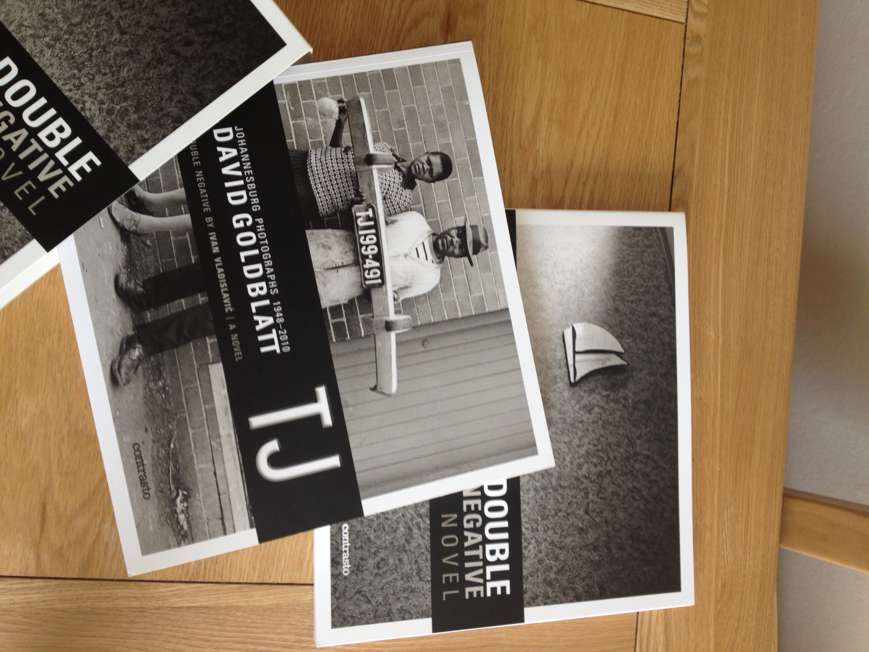

Fig 3. Unboxing TJ/Double Negative : front cover bottom, TJ: Johannnsburg Photographs in slip case centre, ‘dummy book’ containing Double Negative top.

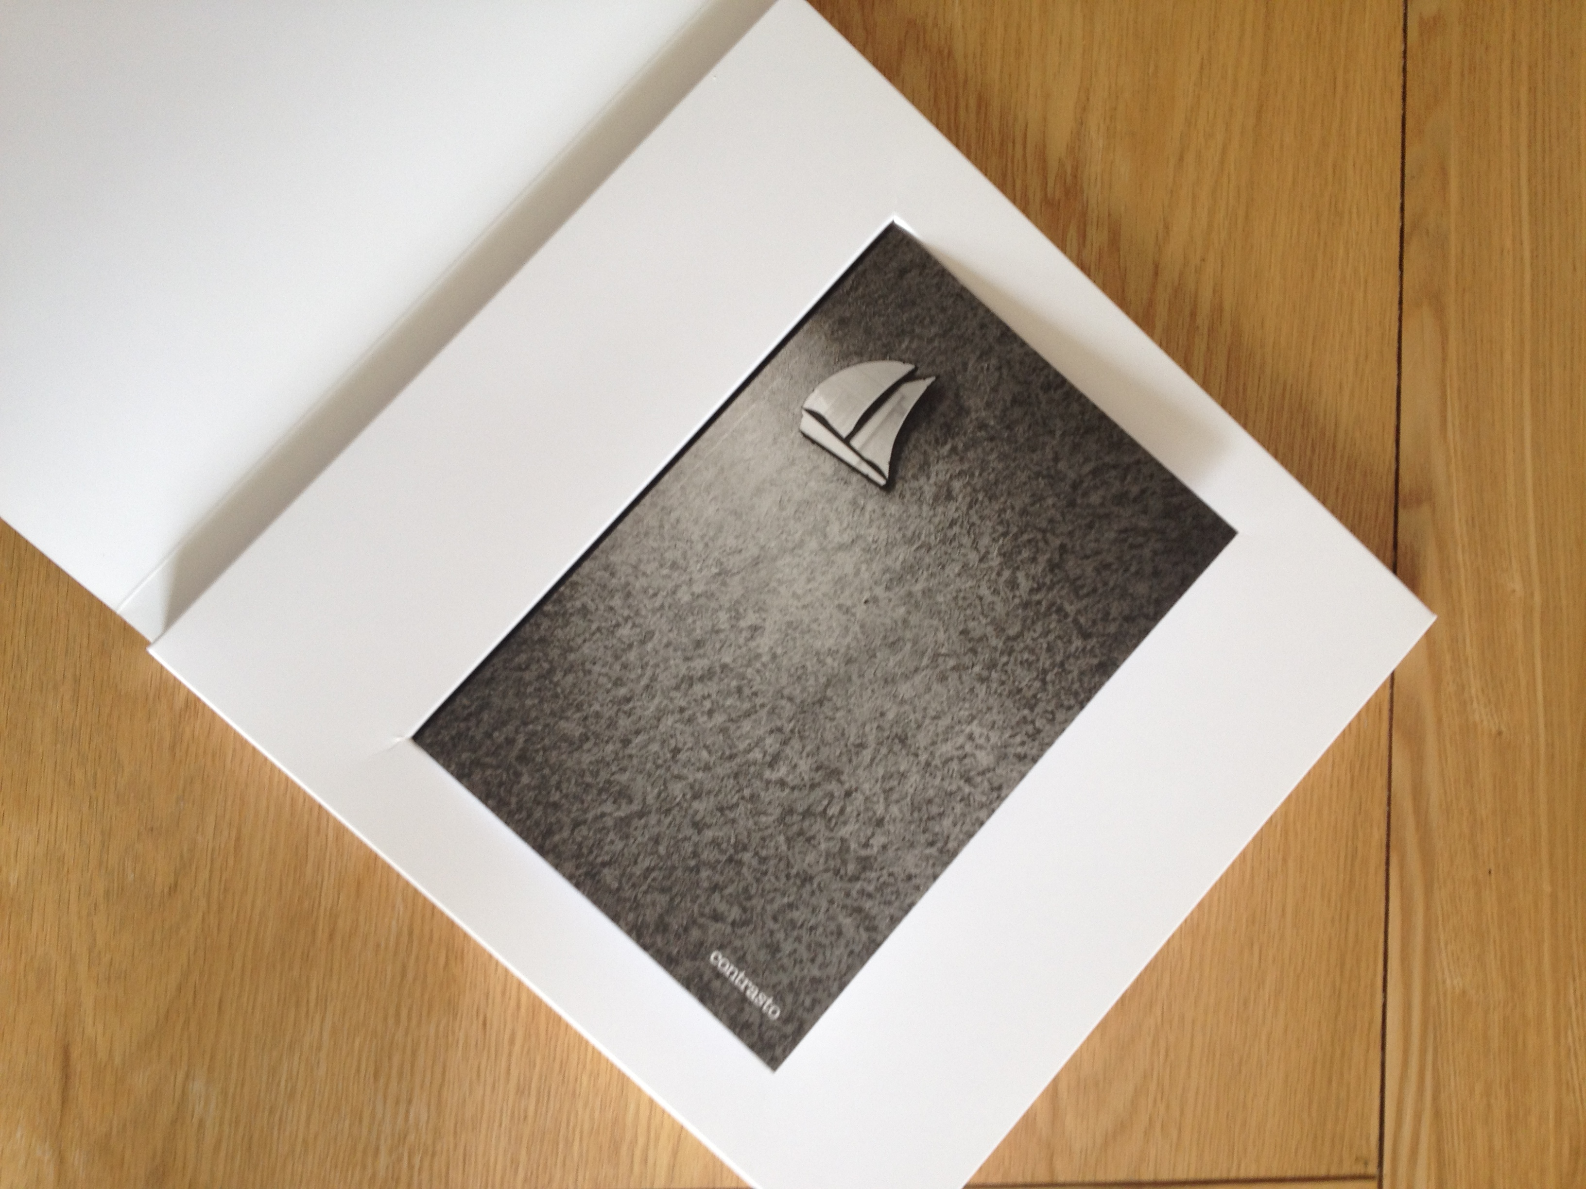
Fig 4. Double Negative inside the dummy book

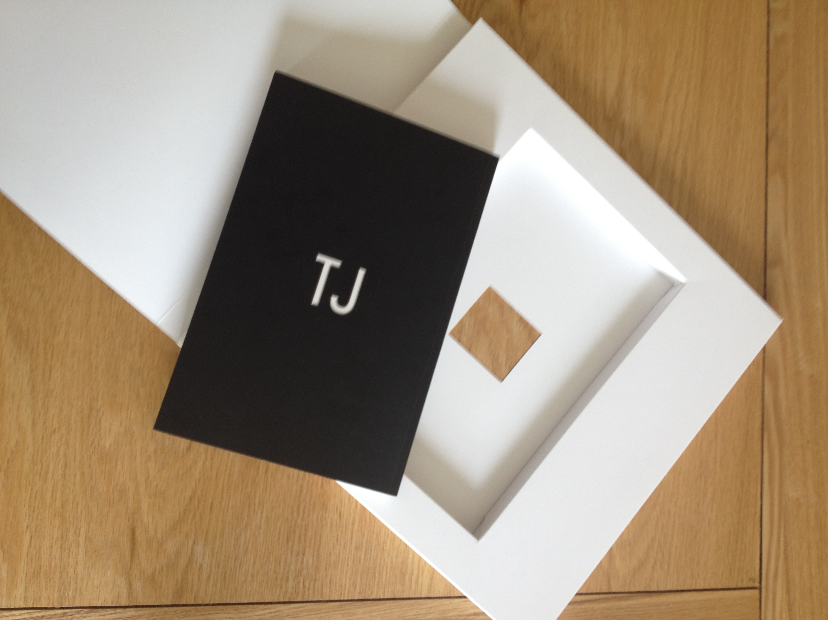

Fig 5. The back cover of Double Negative, the dummy book recess with peep-hole exposed (through which can be seen the ‘TJ’ that appears on the back cover of Double Negative).

The packaging of TJ/Double Negative has been designed to offer both tactile and scopic pleasures. The peep-hole in the dummy book (see fig 4.) seems to play on the idea that opening the book and its various components is tantamount to a bibliophilic strip-tease. For those familiar with Vladislavić’s own writing but also his editorial work and collaborations with other writers and visual artists, the presentation of TJ/Double Negative as an art-object that might be experienced as well as simply read will come as no surprise. As Sally-Ann Murray has argued, there is a case for considering Vladislavić’s entire literary ouvre as a form of “conceptual art” that reflexively explores the “world” of books:

Vladislavić’s writing career has developed in relation to a mobile disciplinary affiliation, and that this has enabled his imagination to write across visual and verbal ‘worlds’. And yet books, the product of the world of ‘writings’, continue to constitute the pre-eminent focus of his professional and creative attention. He makes a living in books, even lives to an extent inside books, although perhaps not by the book, and his interest in art is conveyed to his readers through the art of the book. (17)

Perhaps the best example of this interest in the “art of the book” is found in Vladislavić’s monograph on the artist Willem Boshoff, the viewer of whose art objects and installations Vladislavić (2005) argues

is better understood as a reader. Boshoff is a writer. Not only is much of his sculpture and installation centrally concerned with language and books, but he has also written concrete poetry and dictionaries, and extended commentaries on his own work and processes. The borders between these writings are porous and their meanings seep through and run together. All of them might be regarded as passages in a discontinuous text. For three decades he has been researching, writing and annotating a long shelf of books. (6)

Conversely, one might justifiably argue that for three decades Vladislavić has been researching, creating and curating a series of exhibitions – where readers as well as collaborating visual artists are all writerly participants in the performative art of his books (Graham). Despite having established an international reputation for working within a more confined, sober and sometimes quite stark documentary idiom, an audience familiar with Goldblatt’s work may have been only slightly less surprised to discover such an arch assemblage with the publication of TJ/Double Negative. The documentary label Goldblatt is typically associated with belies a similarly creative, but also a more forthrightly auteur-like, interest in the production and reception of his work through “the art of the book”.

In a discussion of the 1973 photo-book Some Afrikaners Photographed, Rory Bester argues that Goldblatt deliberately and precisely “orchestrates” (154) his photography through the medium of the book with the purpose of examining but also very deliberately unsettling the culture it addresses, as opposed to that which it documents. An approach that is primarily artistic as opposed to ethnographic in conception. What Some Afrikaners Photographed “makes visible” (153) is not so much a ‘hidden’ reality that is disclosed within the images of rural and suburban Afrikaners (as well as their black servants) going about their daily lives. Rather, it is the underlying conflicts and tensions that constitute the conflicted culture that is mediated through the book itself. Bester’s argument here is supported by the essay-responses from some of South Africa’s leading critics and writers Goldblatt commissioned to the 2007 reissue, Some Afrikaners Revisited:

As I recall my own early encounters with it – in all-night endless-cup coffee shops – it was all but incandescent with tension and revelation, with a sense of souls held up to scrutiny, of skins being peeled away. (Powell 22)

Goldblatt destabilizes. He suggests porous definitions. Initially the black people in the photographs seem nothing more than per chance presences – they are there because the whites are there. But suddenly a family walks from a church. They are coloured. But by using the same spatial grouping, with the same expressions as the Afrikaner family some pages before, they tear the membrane of the definition. (Krog 33)

Despite reviewing badly and failing to sell out its modest initial print run (even when remaindered at one tenth the original price) the fact the photographs in Some Afrikaners Photographed were published in book form was vital for that set of photographs – and Goldblatt’s photographic project more generally – to assume iconic status in the post-apartheid period:

The book form enabled Goldblatt’s photographs to lie quietly pulsating in the public domain, pressing down into the public sphere, refusing to evaporate. It is a testament to Goldblatt’s huge investment in the form of the book – including design and layout, paper, printing and editing – that Some Afrikaners Photographed itself became hard to dismiss over the archive of time. (Bester 164)

What Bester argues to be the unique achievement of Goldblatt’s work therefore derives not just from its testimonial power as reportage, but rather from the way in which it is imbued with a “ruminatory” quality that works to “destabilize and unhinge the viewer’s expectations”, creating a “disturbance that demands the viewers engagement rather than simply their consumption.”(156)) The forms of “rumination” that Goldblatt orchestrates through the art of his books is thus integral to the affective estrangement afforded by TJ/Double Negative: it is a book that requires its reader constantly to pause, reflect and enter into a conversation with the photographed culture, as it is mediated through the book.

Writing for a world market

Towards the end of his article on the design of Goldblatt’s books, Bester comments on the significance of the changes and additions to the 2007 reissue of Some Afrikaners Revisited. His paratextual reading suggests a major shift in Goldblatt’s attitude to his international reception:

it is perhaps not surprising that Goldblatt’s refiguring of a local archive for global consumption includes internationally renowned intellectual and writer Krog, whose Country of my Skull (1998) was not only a widely acclaimed personal account of reporting on the TRC process, but was also published by Random House.(163)

Bronwyn Law-Viljoen suggests that Goldblatt’s entry into the world art market comes sooner than this, following a series of international exhibitions in the 1990s (Law-Viljoen 2012 433), and I would agree. In 1998 South Africa: The Structure of Things Then was published: the culmination of a 15 year project to document the physical and symbolic structures underpinning South African life from its colonial beginnings to the post-apartheid present. The publication accompanied a solo exhibition at the Museum of Modern Art in New York, the first time a South African had been given this privilege. The exhibition afforded Goldblatt unprecedented global exposure but also marks a turning point with regard to the previously anti-cosmopolitan character of his books. The rationale for this approach is emerges in an explanatory note Goldblatt added to the 2007 reissue of Afrikaners:

The New York experience [pitching the original Afrikaners to publishers there] was crucial to a deeper understanding of what I was doing in my photographs and, indeed, what I was doing in South Africa. It became clear that the photographs I was interested in making were a kind of dialogue with my compatriots, with people who were steeped in what I have called ‘the life, the ways, obsessions, graces, laws and particulars of this place and people’. If that dialogue was not accessible to other people – mostly those ‘overseas’ – then so be it. (2007b, 14)

Given that international eyes were drawn so keenly to the travesty of apartheid in this period, his early books are thus boldly uncompromising in their design and subject matter: the grainy murk of On The Mines; the banal matter-of-factness of Some Afrikaners Photographed and In Boksburg (1982); the interjected fragments of Gordimer’s stories in Lifetiemes under Apartheid that thicken rather than explain the world of the photographs – none of these books invites the outside world in. Goldblatt’s South Africa is either obtusely parochial or forbiddingly dark and different.

Where his books had previously been produced without compromise with regard to their viability for international publication, The Structure of Things Then registers South Africa’s re-emergence into the world market through precisely such a compromise. The orchestration of material for publication in this book is a rather attenuated affair. Goldblat’s introduction is lengthy, recapitulating his personal biography but also offering an abridged history of the Rainbow Nation, from 1652 to the present day. His signature captions are appended to the rear of the book – but occupy almost a third of the page count and in many cases come in significantly extended versions that are closer to essay than traditional caption length. And while it is not the first time any of his books has included a glossary, the extent of this is once again telling. In the following paragraph from the introduction Goldblatt remarks on his reticence to provide this extra detail – and in doing so it also registers a palpable discomfort:

Although this introduction and extended captions are more explicit and detailed than I would like, they are no more than an attempt to give, for the reader who wishes it, an extremely condensed, highly selective insight into the ‘structural context’, the densely complex matrix of cultural, social, political and economic interaction from which the subjects photographed emerged and in which they had their ‘being’.(10)

Goldblatt is evidently uneasy with some of the compromises imposed by marketing considerations for a global audience, yet that these are accepted and incorporated in the book would seem to suggest that Goldblatt found that the end of apartheid was an opportunity – perhaps even a duty – to open up the internal dialogue with South African culture he had long orchestrated through his work. The 1994 elections and the subsequent dismantling of the apartheid state represents a cosmopolitan moment in South African history which might be interpreted in Goldblatt’s work as a (structure of) feeling that the time had come to open the world of his books to international readers. And so if South Africa: The Structure of Things Then marks a shift in the cosmopolitan character of Goldblatt’s photographic orchestration – engaging an international audience rather than challenging a national one – the playfulness of TJ/Double Negative signals a further shift to more properly cooperative and interdiscursive forms of cultural production on the one hand, as well as a more reflexive mediation of cosmopolitanism as a structure of feeling on the other. TJ/Double Negative frames a dialogue that is no longer confined within the reading public of a national culture but instead has – for over 20 years – been carried out across a global mediascape.

The story told through Goldblatt’s photography books of South Africa’s globalization in the immediate aftermath of apartheid is integral to Lister’s narrative in Double Negative. Reflecting on the experience of voting at the 1994 elections at South Africa House, London – with symptomatic irony, not in South Africa itself – ‘we became a tourist attraction.’(76)

The end of apartheid put my nose out of joint, I must confess. Suddenly the South Africans were talking to one another. They wouldn’t shut up … After a decade of willfully excluding myself, I felt left out of the club. (75)

With this burgeoning cosmopolitanism – as everyday experience but also as a mediatised spectacle – so to come its attendant contradictions:
Now that South Africa had rejoined the global community, Auerbach’s reputation was on the rise. He had become collectable. The experts were beginning to say he was more than a photographer; he was an artist.(113)
It is this contrary aspect of South Africa’s globalization – market incorporation subtending cultural recognition and eventually artistic consecration - that provides the narrative rationale for Double Negative. The occasion of Lister’s kunstleroman narrative is the moment his work – but also his personal life, and the influence of Aurbach – is about to be projected into the global mediascape, and possibly also the world market, by a young art blogger, Janie Amanpour. All of the questions concerning the relationship between photography, memory and public culture that Lister raises in the course of his ekphrastic reminiscing are in a sense profoundly rhetorical, and arguably derive from the observation that leads Janie’s initial interview:
‘…I’m with Neville Lister at his home in Kensington, Johannesburg. Just to fill you in, you’re part of a work-in-progress series – we call it Riding Shotgun, not my idea – so I’d like to focus on what you’re up to now. But seeing that people won’t necessarily have heard of you, I though we’d start with some basic stuff about your background. I googled you but didn’t find much.’ (143)

Lister is still barely a digital trace at the point in his career, yet ironically it is his contribution to a group exhibition called ‘Public/Private’ (comprising pictures of walls) that sees his imminent projection into a vastly expanded and variegated public sphere. Just as photography represents one of the most important (and of course, as Lister points out repeatedly, problematic) cultural prisms for a pre-digital generation, throughout his narrative he also refers somewhat resignedly to the emergence of the internet and its potential for opening previously closed worlds whilst at the same time flattening the vastly expanded cultural archive it mediates. The kind of informational culture this gives rise to is, on the surface of things, more cosmopolitan in its restless search for new audiences than the more materially as well as politically constrained print culture during apartheid. And yet this discussion is conveyed through an exclusive art-object that confounds the imperative for digital dissemination. As Bronywn Law-Viljoen observes in her 2012 survey of the art book market in South Africa: “…it would seem – perhaps paradoxically – that it is precisely the digitisation of books in general that is making art books in particular more desirable.”(423) Goldblatt and Vladislavić are not only alive to the irony of their work being incorporated as ‘art’ within international markets – they make of this a position for reflexive critique.

Lister’s conversation with Janie in ‘Small Talk’, the final section of the novel, seems quite deliberately to refract the cultural flatness that attends technologies of digital reproducibility, but also the emergence of a consumer culture that has allegedly become more protean as a consequence. It is perhaps not surprising that a large part of this conversation involves both the ‘artist’ and the ‘critic’ reflecting on the way their interactions with other artists and critics inevitably informs their work, most particularly in relation to the work of Simeon Majera, an artist contemporary with Lister (profiled by Janie the year previously, she tells him) but who, in a playful intertextual sleight, first appeared in Vladislavić’s 2004 novella The Exploded View. The interdiscursive relationship between Majera’s art and the photography of Lister and Auerbach anticipates (and so arguably participates in) recent debates on the relationship between depth and surface in South African culture (cf. Nutall, de Kock). What do you like about his work? Janie asks: “‘slight, light and minimal, quote unquote as if you don’t know”(157) is Lister’s knowingly ‘meta’ reply, before explaining how Majera combines and reconstitutes art and non-art objects in his work in a way that incorporates the often violent history embodied within objects and practices so that their deeper significance is subordinated to their surface appearance. This conversation and the ‘Small Talk’ section seems to anticipate the concerns Sarah Nuttall raises ‘The Rise of the Surface: Emerging Questions for Reading and Criticism in South Africa’. She calls to task both critics and writers who she argues have yet to grasp the changing zeitgeist, and in particular the work of young black artists for whom consumerism and the perceived depthlessness of popular culture are no longer held as some kind of ‘original sin’:

While a younger generation of artists and writers draws increasingly on notions of the literal, the surface and the skin, an older generation remains at times wedded to a depth hermeneutic that considers current aesthetic languages to be degraded forms, rather than different kinds of conceptual vocabularies. (416)

Nuttall cites Vladislavić alongside the likes of Nadine Gordimer, William Kentridge and J.M. Coetzee as members of this ‘older generation’, all of whom write in the ‘mode of the symptom’ (415). Kentridge’s Mine (1999) and Gordimer’s The Conservationist (1974) exemplify this mode, working “along a continuum, moving between metaphors of descent into the earth and the idea of death as having risen to just below the surface.”(415) Intriguingly Goldblatt is not named among this group, despite his well known private as well as public connections with them and the similar concerns of his own work, whereby the social conflict immanent within apartheid surfaces through the juxtaposition of photographic and literary frames – most memorably in his collaborations with Gordimer, cf. figures 6 and 7 original from On the Mines (1973) and reproduced in the first section of TJ.

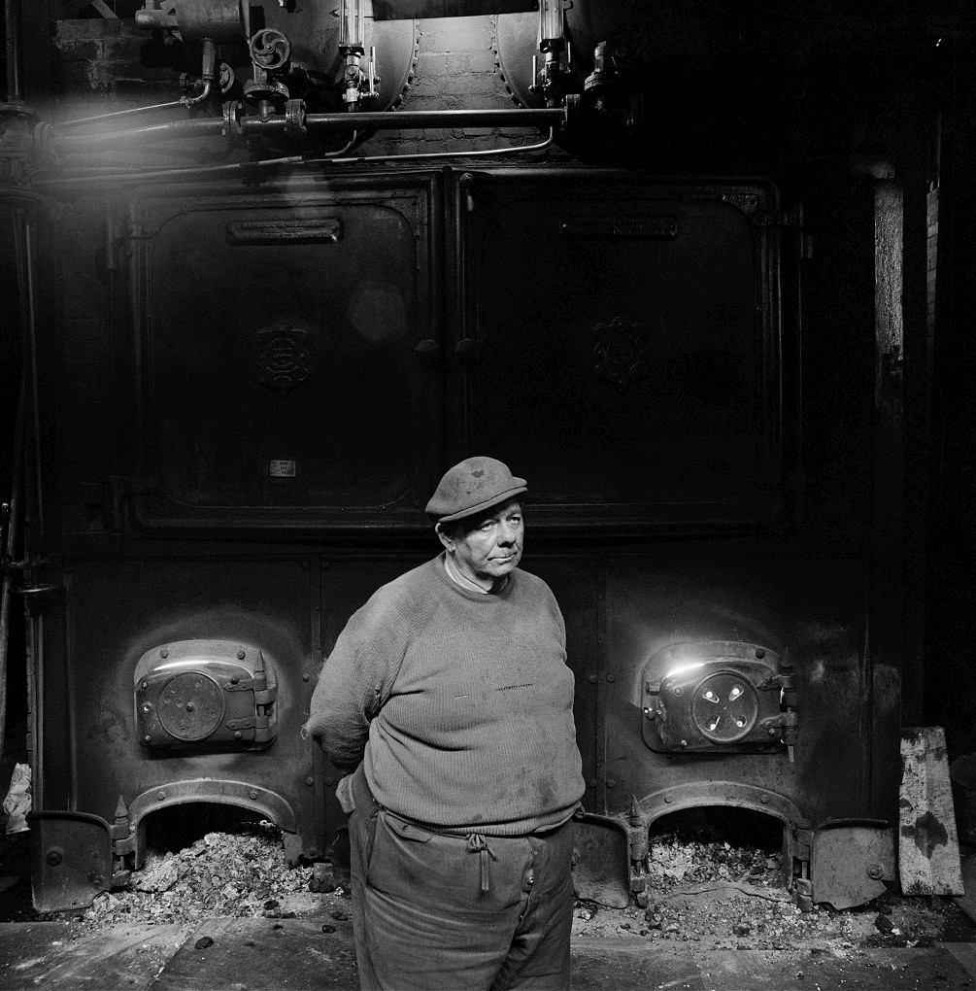

Fig. 6 ‘Boiler-house attendant, City Deep Gold Mine. 1966’ TJ, p.52, reproduced opposite ‘Mine captain’

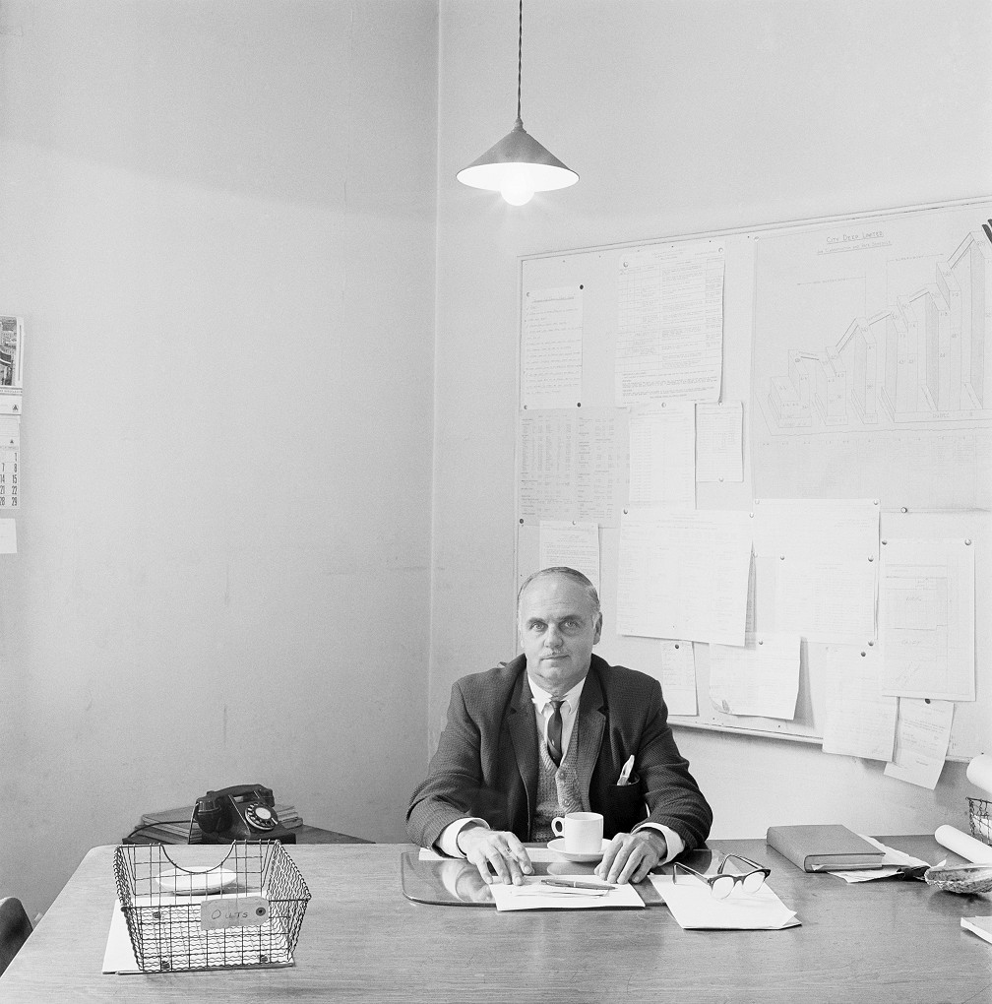

Fig. 7 ‘Mine captain, City Deep Gold Mine. 1966’ TJ p.53 – reproduced opposite ‘Boiler-house attendant’

In the orchestration of the TJ part of TJ/Double Negative Goldblatt evidently ‘remains wedded’ to a technique that alloys formal composition and paratextual design to facilitate a ruminatory awareness of the social, economic and political ‘symptom’ of apartheid, which could not be more manifest in the contrasts drawn between these two photographs, arranged on facing pages. In the former the corporeality of the attendant mimics the voracious appetite of the furnaces that loom behind him. It is a brutal metaphor for the white-controlled industry’s appetite for undifferentiated black labour – what Achille Mbembe (2004) has termed Johannesburg’s “aesthetics of superfluity” – the presence of which is absent in the image itself yet called to mind through the metaphorical extension. The mine captain’s office presents an absolute contrast. This is the industry as it wished to be viewed: a spartan ‘surface’ belying the dirty and dangerous work being carried out deep underneath: prim, trim and proper – except for the neat set of lists and charts on the wall where the symptoms of apartheid and capitalism present in the forms of a seemingly benign and neutral bureaucracy.

It is strange that Nuttall ignores Goldblatt in her discussion given this; even more so that her particular argument for Vladislavić and his work exemplifying this outmoded mode is itself buried in a footnote:

Even as Vladislavić examines the surfaces of the city, its truth lies in all that is hidden and unrecoverable, and in a lens that for all its sophistication, amounts to a nostalgic vision of the Johannesburg of his childhood. For Vladislavić, the truth of the city is largely to be found in its underneath – a literal underneath, its history, his own memory, its figures of marginality, its psychic effects and an archaeology of words in its written texts. His is a vocabulary of critical excavation. (n.8 420)
Against what she perceives to be the dominance of the ‘symptom’ in such work, Nuttall proposes that the ‘rise of the surface’ in South African culture might be more appropriately mediated and criticized on the same terms – but also with the same forms:
It would be worth thinking, for example, of the many possibilities that the lives of things might carry in twenty-first century South Africa: might some of the pre-eminent voices than can cross some of our constitutive disjunctures be the voices of commodity objects (the narratives of a cell phone, for instance)? (417)
The forms and practices Nuttall I think has in mind are in fact anticipated by Vladislavić’s fictional artist-figure, Majera, and further elaborated in the conversation between Lister and Janie in “Small Talk”. Such work, so this argument goes, unreflectively inhabits the contradictions of a consumer culture, whether that be the commodity fetishism that enables individuals to stylize their selves, or the flattening of difference in its endlessly protean cosmopolitanism. In his response to Nuttall’s claim that literature fails “to capture the reach and affective charge of ‘surface’” (8), Leon de Kock refers to how Double Negative

rather uncannily does precisely what Nuttall suggests ‘the literary’ cannot do – it invokes the hunger for ‘surface reality’, indulges it in its characters and in the novel’s reader-spectators, and then goes one step further by placing such (perceived) surface reality effects into an implicit dialogue with issues of representation.(8)

In this article I have argued that, as a joint project, TJ/Double Negative goes even further than this. Goldblatt and Vladislavić have set out to produce a fetishisable art-object that, through its experimental interdiscursive form, acts out the cosmopolitan character of a cultural product designed for the world market. But rather than eschew the ‘depth hermeneutics’ of supposedly outmoded forms of creative practice, TJ/Double Negative demonstrates how the surface of the culture it mediates has become its own symptom; how Johannesburg remains a fractured geography; how just as some things may appear to change, much still stays the same.

References

Ambrose, Gavin and Paul Harris. Packaging the Brand: Exploring the Relationship Between Packaging Design and Brand Identity. London: AVA Publishing, 2011.
Atwell, David. J.M. Coetzee: South Africa and the Politics of Writing. Berkely and Los Angeles: University of California Press, 1993.
de Kock, Leon. “So, What Should Academic Critics be Doing, on the Edge of the Now – Skimming the Surface or Plumbing Those Depths?” English Studies in Africa 55:2 (2012): 3-17.
Disrens, Corinne and Okwui Enwezor eds. Fifty-One Years: David Goldblatt. Barcelona: Museu d’Art Contemporani de Barcelona, 2001
Disrens, Corinne. “Shifting Perceptions of Reality.” Fifty-One Years: David Goldblatt. Barcelona: Museu d’Art Contemporani de Barcelona, 2001. 5-12.
Dominguez, Cesar. “World Literature and Cosmopolitanism Studies.” Theo D’haen, David Damrosch and Djelal Kadir, eds. The Routledge Companion to World Literature. New York and London: Routledge, 2011. 245-252.
Enwezor, Okwui. “Matter and Consciousness: An Insistent Gaze from a not Disinterested Photographer.” Fifty-One Years: David Goldblatt. Barcelona: Museu d’Art Contemporani de Barcelona, 2001. 15-45.
Gilbert, Harriet. “World Photography Awards Book Winners.” The Strand. BBC World Service. 28 April 2011. URL: http://www.bbc.co.uk/programmes/p00gmv3s last accessed 7 October 2014.
Goldblatt, David and Nadine Gordimer. On the Mines. Cape Town: Struik, 1975.
Goldblatt, David and Ivan Vladislavić. TJ/Double Negative. Italy: Contrasto, 2010.
Goldblatt, David. Some Afrikaners photographed. Sandton: Murray Crawford, 1975.
____. Lifetimes Under Apartheid. London: Cape, 1986.
____. South Africa: The Structure of Things Then, with an essay by Neville Dubow. Oxford: Oxford University Press, 1998.
____. Some Afrikaners revisited, with essays by Antjie Krog and Ivor Powell. Roggebaai: Umuzi, 2007a.
____. “Some Afrikaners Photographed and Some Afrikaners Revisited: Notes on how they came to be.” Some Afrikaners revisited, with essays by Antjie Krog and Ivor Powell. Roggebaai: Umuzi, 2007b, 11-17.
____. “Early.” Fifty-One Years: David Goldblatt. Barcelona: Museu d’Art Contemporani de Barcelona, 2001. 47-48.
Graham, James. “Ivan Vladislavić and the Possible City.” Journal of Postcolonial Writing 44:4 (2008): 333-344.
Graham, James, Michael Niblett and Sharae Deckard. “Postcolonial studies and world literature.” Journal of Postcolonial Writing 48:5 (2012): 465-471.
Helgesson, Stefan. “Johanesburg Sighted: TJ/Double Negative and the Temporality of the Image/Text.” Safundi: The Journal of South African and American Studies 16:1 (2014): 51-63.
Krog, Antjie. “‘…between the nose and the mouth. Perhaps more towards the eyes…”’ Some Afrikaners revisited, with essays by Antjie Krog and Ivor Powell. Roggebaai: Umuzi, 2007. 29-34.

Bronwyn Law-Viljoen Interviews David Goldblatt and Ivan Vladislavić.” Umuzi Books Live. URL: http://umuzi.bookslive.co.za/blog/2010/12/06/tj-double-negative-bronwyn-law-viljoen-interviews-david-goldblatt-and-ivan-Vladislavić/ last accessed 7 October 2014.
Law-Viljoen, Bronwyn. “South Africans in the global art market.” Scrutiny2: issues in English Studies in Southern Africa. 13:1 (2006): 68-81.
_____. “Sailing a Smaller Ship: Publishing Art Books in South Africa.”Andrew van der Vlies, ed. Print, Text and Book Cultures in South Africa. Johannesburg: Wits University Press, 2012: 422-435.

Lazarus, Neil. “Cosmopolitanism and the Specificity of the Local in World Literature.” Journal of Commonwealth Literature 46:1 (2011): 119-137.
Mbembe, Achille. “Aesthetics of Superfluity.” Public Culture 16:3 (2004): 373-405.
Moretti, Franco. “Conjectures on World Literature.” New Left Review 1 January-February (2000): 54-68.
Murray, Sally-Ann. “On Ivan Vladislavić on Willem Boshoff on conceptual art.” Current Writing: Text and Reception in South Africa 20:1 (2008): 16-37.
Ndebele, Njabulo S. “Guilt and Atonement: Unmasking History for the Future.” South African Literature and Culture: The Rediscovery of the Ordinary. Manchester: Manchester UP, 1994.
Nutall, Sarah. “The Rise of the Surface: Emerging Questions for Reading and Criticism in South Africa.” Andrew van der Vlies, ed. Print, Text and Book Cultures in South Africa. Johannesburg: Wits University Press, 2012. 408-421.
Powell, Ivor. “The anxiety of identity and Some Afrikaners.” Some Afrikaners revisited, with essays by Antjie Krog and Ivor Powell. Roggebaai: Umuzi, 2007. 19-28.
Spencer, Robert. “Cosmopolitan criticism.” Rerouting the Postcolonial: New directions for the new millennium. Janet Wilson, Cristina Sandru, Sarah Lawson Welsh, eds. Abingdon and New York: Routledge, 2010: 36-47.
Steyn, Jan. “Unlearning the art of getting lost: the fiction of Ivan Vladislavić.” The Quarterly Conversation March 5 2012. URL: http://quarterlyconversation.com/unlearning-the-art-of-getting-lost-the-fiction-of-ivan-Vladislavić Last accessed 7 October 2014.
Subotzky, Mikhael and Patrick Waterhouse, with Ivan Vladislavić. Ponte City. Göttingen: Steidl, 2014.
“Unboxing: the new geek porn.” The Independent, 14 Jan 2009. URL: http://www.independent.co.uk/life-style/gadgets-and-tech/features/unboxing-the-new-geek-porn-1333955.html last accessed 7 October 2014.
“The Restless Derby.” Promotional event to support the UK publication of The Restless Supermarket and Double Negative, with Ivan Vladislavić in conversation with Katie Reid, held at the University of Sussex. 24 June 2014.
van Niekerk, Marlene. “Double Exposure.” British Journal of Photography, 158 (2011): 44-49
Vladislavić, Ivan. The Exploded View. Johannesburg: Random House.
____. Willem Boshoff (Taxi Art Series). Johannesburg: David Krut Publishing, 2005.
Walkowitz, Rebecca. Cosmopolitan Style: Modernism beyond the Nation. Columbia: Columbia University Press, 2006.
WReC (Warwick Research Collective). Combined and Uneven Development: Towards and New Theory of World-Literature. Liverpool: Liverpool University Press, 2015.

Since TJ/Double Negative won the Kraszna-Krausz best photography book award in 2011, Ivan Vladislavić has gone on to win the prestigious $150,000 Windham Campbell Prize in 2015 for work that “explores the uncomfortable aftermath of apartheid through inventive meditations on the complex intersection of history, politics, and art” (http://windhamcampbell.org/2015/winner/ivan-vladislavić). He was also closely involved in the production of the 2015 Deutsche Börsche-winning photography book Ponte City by Mickael Subotsky and Patrick Waterhouse (describing himself as its “creative editor”, see “Restless Derby”).
World-literature (with a hyphen) describes a literary work "in which the world-system is not a distant horizon only unconsciously registered in immanent form, but rather consciously or critically mapped – that is, to literature that is in some way world-systemic in its perspective.” (Graham, Niblett and Deckard 468).
This oblique commentary is further elaborated in the tensions and differences, as they are reported by Lister, between himself (lists being the most basic and naturalistic form of realism) and his mentor Saul Auerbach (Auerbach, who operates as a cipher for Goldblatt but also a more sophisticated variant of realism via the intertextual reference to Erich Auerbach and his canonical work of comparative literary criticism Mimesis: The Representation of Reality in Western Literature).
A deliberate strategy more obviously communicated in the title of the original exhibition from which the photographs in the book were selected: TJ: somethings old, some things new and some things much the same.
See Helgesson’s article on TJ/Double Negative for a fuller list of Goldblatt’s collaborations, and the forthcoming special issue of Journal of Commonwealth Literature on ‘Ivan Vladislavić and Visual Culture’ for details and discussion of Vladislavić’s work with visual artists.
Speaking in the semi-formal context of a research seminar that also served to promote both the UK publication of The Restless Supermarket by the publisher And Other Stories as well as the international publication of Ponte City, a collaboration with the photographers Mikheal Subotsky and Patrick Waterhouse that subsequently won the 2015 Deutsche Borse prize, Vladislavić noted that Goldblatt was able to use his international reputation and personal contacts to secure publication with the high-end photo-book publisher contrasto. Neither Vladislavić nor Goldblatt are on record as having confirmed this, but it is reasonable to assume that – at that point in Vladislavić’s career – without being able to leverage Goldblatt’s symbolic capital in the world art market it is unlikely that any publisher would have been prepared to carry the risk of a project with such high production costs.

