

College of Education and Human Development
4400 University Drive, MS 4B3, Fairfax, Virginia 22030
Phone: 703-993-6559 Fax: 703-993-2013

July 4, 2013

Dr. Gregory P. Thomas
University of Alberta, Canada
Alberta Journal of Educational Research, editor

Dear Dr. Thomas:

We would like to submit the manuscript, “A Multi-Case Study of Two Teachers’ Instructional Adaptations,” to the Alberta Journal of Educational Research for review. This paper provides a detailed description of two teachers’ adaptive instruction, which is frequently associated with teacher effectiveness. This manuscript has not been previously published and is not under consideration at any other outlet. Thank you for your time and consideration.

Sincerely,

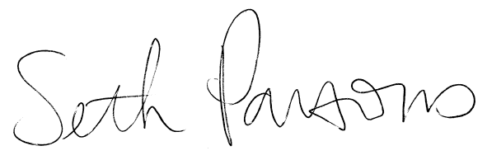

Seth A. Parsons, PhD
George Mason University
sparson5@gmu.edu

Margaret Vaughn, PhD
University of Idaho
mvaughn@uidaho.edu

