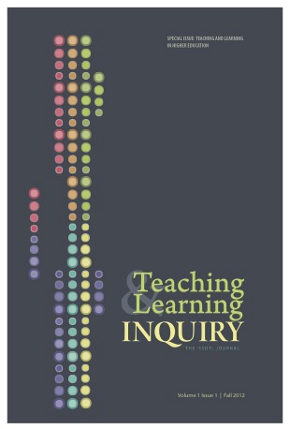
Teaching & Learning Inquiry
Graduate Student Reviewer Information Form

Thank you for your interest in providing reviews for manuscripts submitted to Teaching & Learning Inquiry (TLI). TLI is always in need of reviewers who work in the field of SoTL and who demonstrate sufficient familiarity with and commitment to its tenets. TLI encourages reviewers to hold high standards, be constructively critical, and practice collegiality and a sense of mentorship in the writing of their reviews. In this spirit of mentorship, TLI invites new scholars (e.g., graduate students) who wish to work with SoTL-experienced mentors in reviewing articles for the journal. Please complete this form so that we can do our best to match manuscripts with reviewers.

Name:

New Scholar Status:

Discipline:

Institution:

Email Address:

Full Mailing Address:

Three areas of academic expertise and/or interest:
1.
2.
3.

SoTL-Experienced Mentor for Reviewing in TLI (If you don’t have one, please indicate so here, and TLI’s co-editors will try to match you with one of our regular reviewers.):

TLI sends manuscripts out for review throughout the calendar year. Are there any time periods for which providing reviews is infeasible for you?

Given the number of submissions to TLI and the assignment of three reviewers per manuscript, TLI is always in need of additional reviewers who work in the field of SoTL and who demonstrate sufficient familiarity with and commitment to its tenets. To this end, and given the broad scope of SoTL, reviewers may be asked to read submissions from outside of their disciplinary expertise, recognizing the journal’s multidisciplinary readership and the need for multiple perspectives that can transcend subject expertise.
We’ll do our best to avoid sending you a manuscript during this time, but occasionally the complexity of the reviewer selection process may result in unintentionally sending a request. If this happens, of course, please feel free to decline.

